NODE JS
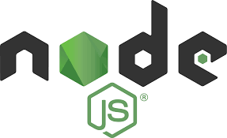
-Node.js was initially written by Ryan Dahl in 2009, about 13 years after the introduction of the first server-side JavaScript environment, Netscape's LiveWire Pro Web. The initial release supported only Linux and Mac OS X
-Node.js is a server-side runtime environment built on Google Chrome's JavaScript Engine (V8 Engine).
-The chrome V8 Engine is written in C++.
-The NodeJs Helps to run Your JavaScript externally in your machine.

HISTORY
-Dahl criticized the limited capability of Apache HTTP Server to handle many (10,000+) concurrent connections, as well as the dominant programming paradigm of sequential programming, in which applications could block entire processes or cause the creation of multiple execution stacks for simultaneous connections.^{[13]}
-Dahl demonstrated the project at the inaugural European JSConf on November 8, 2009.^{[14][15][16]} Node.js combined Google's V8 JavaScript engine, an event loop, and a low-level I/O API.^{[17]}
-In January 2010, a package manager was introduced for the Node.js environment called npm.^{[18]} The package manager allows programmers to publish and share Node.js packages, along with the accompanying source code, and is designed to simplify the installation, update and uninstallation of packages.^{[17]}
-In June 2011, Microsoft and Joyent implemented a native Windows version of Node.js.^{[19]} The first Node.js build supporting Windows was released in July 2011.
-In January 2012, Dahl yielded management of the project to npm creator Isaac Schlueter.^{[20]} In January 2014, Schlueter announced that Timothy J. Fontaine would lead the project.^{[21]}
-In December 2014, Fedor Indutny created io.js, a fork of Node.js created because of dissatisfaction with Joyent's governance as an open-governance alternative with a separate technical committee. The goal was to enable a structure that would be more receptive to community input, including the updating of io.js with the latest Google V8 JavaScript engine releases, diverging from Node.js's approach at that time.^{[22]}
-The Node.js Foundation, formed to reconcile Node.js and io.js under a unified banner, was announced in February 2015.^{[23]} The merger was realized in September 2015 with Node.js v0.12 and io.js v3.3 combining into Node v4.0.^{[24]} This merge brought V8 ES6 features into Node.js and started a long-term support release cycle.^{[25]} By 2016, the io.js website recommended returning to Node.js and announced no further io.js releases, effectively ending the fork and solidifying the merger's success.^{[26]}
-In 2019, the JS Foundation and Node.js Foundation merged to form the OpenJS Foundation.
-On September 6, 2023, Node.js 20.6.0 was released. The update brought the addition of built-in support for .env files, the unflagging of import.meta.resolve, the introduction of a new node:module API register for module customization hooks and a new initialize hook. Additionally, the module customization load hook now supports CommonJS, and Node.js C++ add-ons have gained experimental support for cppgc (Oilpan), which is a C++ garbage collection library for V8.^{[27]}
Node.js history
-Here are some key events in the history of Node.js:
  - 2009: Ryan Dahl wrote Node.js, which was initially released for Linux and Mac OS X. Dahl was concerned about the limitations of Apache HTTP Server and the sequential programming paradigm.
  - 2010: The npm package manager was introduced for Node.js.
  - 2011: Microsoft and Joyent released a Windows version of Node.js.
  - 2014: Fedor Indutny created io.js, a fork of Node.js.
  - 2015: The Node.js Foundation was announced to reconcile Node.js and io.js.
  - 2019: The Node.js Foundation merged with the JS Foundation to form the OpenJS Foundation.
  - 2023: Node.js 20.6.0 was released.

FULL STACK DEVELOPEMENT
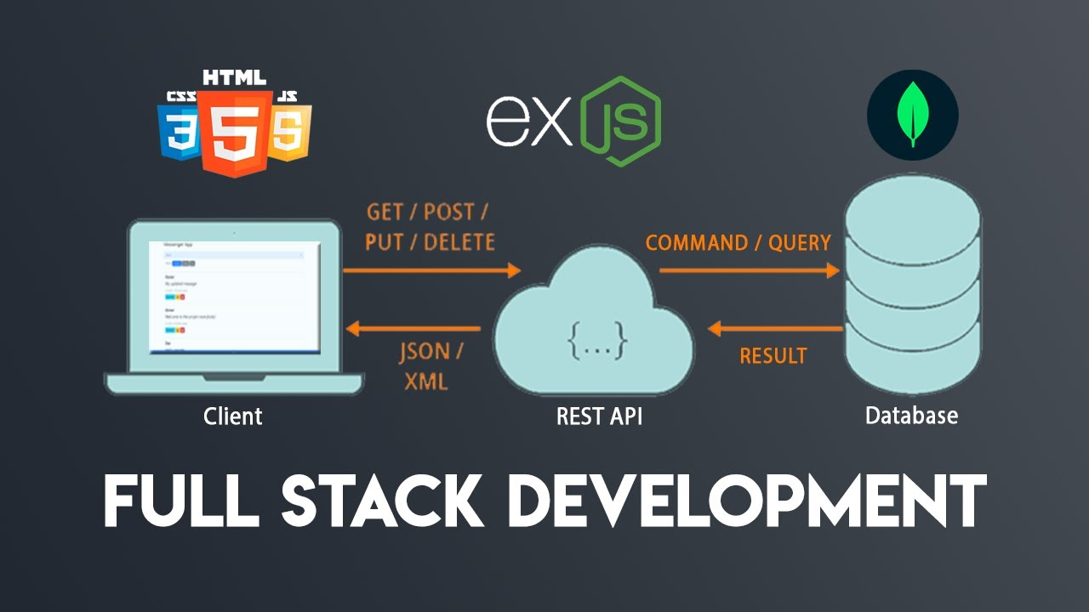
-Full stack development refers to the process of building both the front-end (client-side) and back-end (server-side) portions of a web application. A full stack developer is skilled in both these areas, making them capable of developing an entire application from start to finish.
Components of Full Stack Development:
- Front-End Development (Client-Side):
  - Focuses on the user interface and experience.
  - Technologies include:
    - HTML (Structure)
    - CSS (Styling)
    - JavaScript (Interactivity)
    - Frameworks/Libraries: ReactJS, Angular, Vue.js, etc.
- Back-End Development (Server-Side):
  - Handles the business logic, database operations, and server communication.
  - Technologies include:
    - Programming languages: Java, Python, Node.js, PHP, etc.
    - Frameworks: Express.js, Django, Spring, etc.
- Database Management:
  - Involves storing, retrieving, and managing data.
  - Types of databases:
    - Relational (e.g., MySQL, PostgreSQL)
    - Non-relational (e.g., MongoDB, Redis)
- Version Control:
  - Tracks changes in codebases.
  - Tools: Git, GitHub, GitLab, etc.
- API Development and Integration:
  - Enables communication between front-end and back-end.
  - Commonly uses REST APIs or GraphQL.
- DevOps and Hosting:
  - Ensures smooth deployment and maintenance.
  - Tools/Platforms: Docker, AWS, Heroku, Netlify, etc.
Why Full Stack Development is Important:
- Versatility: A full stack developer can work on both the front-end and back-end, making them valuable in small teams or startups.
- Cost-Efficiency: Companies often hire full stack developers to reduce costs compared to hiring separate front-end and back-end specialists.
- Complete Ownership: Full stack developers can understand and manage the entire application, leading to better integration and fewer bottlenecks.

Technology Related to Full Stack Development
Front-end Development
-It is the visible part of website or web application which is responsible for user experience. The user directly interacts with the front end portion of the web application or website.
Front-end Technologies
The front end portion is built by using some languages which are discussed below:
- HTML: HTML stands for Hyper Text Markup Language. It is used to design the front end portion of web pages using markup language. HTML is the combination of Hypertext and Markup language. Hypertext defines the link between the web pages. The markup language is used to define the text documentation within tag which defines the structure of web pages.
- CSS: Cascading Style Sheets, fondly referred to as CSS, is a simply designed language intended to simplify the process of making web pages presentable. CSS allows you to apply styles to web pages. More importantly, CSS enables you to do this independent of the HTML that makes up each web page.
- JavaScript: JavaScript is a famous scripting language used to create the magic on the sites to make the site interactive for the user. It is used to enhancing the functionality of a website to running cool games and web-based software.
Front End Libraries and Frameworks
- AngularJS: AngularJs is a JavaScript open source front-end framework that is mainly used to develop single page web applications(SPAs). It is a continuously growing and expanding framework which provides better ways for developing web applications. It changes the static HTML to dynamic HTML. It is an open source project which can be freely used and changed by anyone. It extends HTML attributes with Directives, and data is bound with HTML.
- React.js: React is a declarative, efficient, and flexible JavaScript library for building user interfaces. ReactJS is an open-source, component-based front end library responsible only for the view layer of the application. It is maintained by Facebook.
- Bootstrap: Bootstrap is a free and open-source tool collection for creating responsive websites and web applications. It is the most popular HTML, CSS, and JavaScript framework for developing responsive, mobile-first web sites.
- jQuery: jQuery is an open source JavaScript library that simplifies the interactions between an HTML/CSS document, or more precisely the Document Object Model (DOM), and JavaScript. Elaborating the terms, jQuery simplifies HTML document traversing and manipulation, browser event handling, DOM animations, Ajax interactions, and cross-browser JavaScript development.
- SASS: It is the most reliable, mature and robust CSS extension language. It is used to extend the functionality of an existing CSS of a site including everything from variables, inheritance, and nesting with ease.
- Some other libraries and frameworks are: Semantic-UI, Foundation, Materialize, Backbone.js, Ember.js etc.
Other Important Points
- Work with text editors to use shortcuts and its facilities i.e. Visual studio, Atom, Sublime etc.
- Make UI responsible using grid system.
- Git and git commands like init, add, commit etc for version control and to work with team.
- Other tools like npm & yarn package managers, sass css pre-processor, browser DevTools i.e. chrome devtools.
- Understand using HTTP, JSON, GraphQL APIs to fetch data using axios or other tools.
- It also requires some design skill to make layout and look better.
Back-end Technologies
It refers to the server-side development of web application or website with a primary focus on how the website works. It is responsible for managing the database through queries and APIs by client-side commands. This type of website mainly consists of three parts front end, back end, and database. The back end portion is built by using some libraries, frameworks, and languages which are discussed below:
- PHP: PHP is a server-side scripting language designed specifically for web development. Since, PHP code executed on server side so it is called server side scripting language.
- C++ It is a general purpose programming language and widely used now a days for competitive programming. It is also used as backend language.
- Java: Java is one of the most popular and widely used programming language and platform. It is highly scalable. Java components are easily available.
- Python: Python is a programming language that lets you work quickly and integrate systems more efficiently.
- Node.js: Node.js is an open source and cross-platform runtime environment for executing JavaScript code outside of a browser. You need to remember that NodeJS is not a framework and it’s not a programming language. Most of the people are confused and understand it’s a framework or a programming language. We often use Node.js for building back-end services like APIs like Web App or Mobile App. It’s used in production by large companies such as Paypal, Uber, Netflix, Walmart and so on.
- Back End Frameworks: The list of back end frameworks are: Express, Django, Rails, Laravel, Spring etc.
- The other back end program/scripting languages are: C#, Ruby, REST, GO etc.
Other Important Points
- Structuring the data in efficient way.
- Handle request-response of APIs for storing and retrieve data.
- Security of data is important.
Note: JavaScript is essential for all stacks as it is dominant technology on Web.
Database: Database is the collection of inter-related data which helps in efficient retrieval, insertion and deletion of data from database and organizes the data in the form of tables, views, schemas, reports etc.
- Oracle: Oracle database is the collection of data which is treated as a unit. The purpose of this database is to store and retrieve information related to the query. It is a database server and used to manages information.
- MongoDB: MongoDB, the most popular NoSQL database, is an open source document-oriented database. The term ‘NoSQL’ means ‘non-relational’. It means that MongoDB isn’t based on the table-like relational database structure but provides an altogether different mechanism for storage and retrieval of data.
- SQL: Structured Query Language is a standard Database language which is used to create, maintain and retrieve the relational database.
Popular Stacks
- MERN Stack: MongoDB, Express, ReactJS and Node.js
- MEAN Stack: MongoDB, Express, AngularJS and Node.js.
- Django Stack: Django, python and MySQL as Database.
- Rails or Ruby on Rails: Uses Ruby, PHP and MySQL.
- LAMP Stack: Linux, Apache, MySQL and PHP.

WHAT IS FULL STACK DEVELOPER
-A full-stack web developer is a person who can develop both client and server software.
OR
-A full-stack developer is a professional who builds and maintains both the front end and back end of applications and websites.
OR
-A Full Stack Developer is a software developer skilled in working with both the frontend and backend parts of a web application.
Client Software  (Front-end) | Server Software  (Back-end)
- HTML | - PHP
- CSS | - ASP
- Bootstrap | - C++
- W3.CSS | - C#
- JavaScript | - Java
- ES5 | - Python
- HTML DOM | - Node.js
- JSON | - Express.js
- XML | - Ruby
- jQuery | - REST
- Angular | - Go
- React | - SQL
- Backbone.js | - MongoDB
- Ember.js | - Sass
- Redux | - Less
- Storybook | - Firebase.com
- GraphQL | - Parse.com
- Meteor.js | - PaaS (Azure and Heroku)
- Grunt
- Gulp

Key Areas of Expertise:
- Frontend Development
  - Deals with the user interface (UI) and user experience (UX).
  - Skills include:
    - HTML, CSS, JavaScript
    - Frameworks/Libraries: ReactJS, Angular, Vue.js
    - Styling tools: Bootstrap, TailwindCSS
- Backend Development
  - Manages server-side logic, databases, and APIs.
  - Skills include:
    - Programming languages: Node.js, Python, Java, PHP, Ruby, etc.
    - Frameworks: Express.js, Django, Spring, etc.
    - Database management: SQL (MySQL, PostgreSQL) or NoSQL (MongoDB).
- Version Control & Collaboration Tools
  - Git/GitHub or other version control systems.
  - Tools like Docker, CI/CD pipelines, or cloud services.
- APIs and Communication
  - Proficiency in creating and consuming RESTful or GraphQL APIs.
- DevOps and Deployment
  - Basic knowledge of deploying applications on platforms like AWS, Azure, or Heroku.
  - Understanding of server management and CI/CD practices.

Why Full Stack?
A Full Stack Developer can manage all layers of a web application, making them highly versatile and in demand. They can handle:
- Building a complete product from scratch.
- Debugging issues across the stack.
- Collaborating efficiently with both frontend and backend teams.
Some of the responsibilities of a full-stack developer include:
- Working with clients to understand their preferences
- Designing and building websites and applications
- Developing and maintaining web services and interfaces
- Building new product features or APIs
- Testing, troubleshooting, and fixing bugs
- Collaborating with other departments on projects
Popular Stacks
- LAMP stack: JavaScript - Linux - Apache - MySQL - PHP
- LEMP stack: JavaScript - Linux - Nginx - MySQL - PHP
- MEAN stack: JavaScript - MongoDB - Express - AngularJS - Node.js
- Django stack: JavaScript - Python - Django - MySQL
- Ruby on Rails: JavaScript - Ruby - SQLite - Rails
Advantages
The advantage of being a full-stack web developer is:
- You can master all the techniques involved in a development project
- You can make a prototype very rapidly
- You can provide help to all the team members
- You can reduce the cost of the project
- You can reduce the time used for team communication
- You can switch between front- and back-end development based on requirements
- You can better understand all aspects of new and upcoming technologies

Disadvantages
- The solution chosen can be wrong for the project
- The solution chosen can be dependent on developer skills
- The solution can generate a key person risk
- Being a full stack developer is increasingly complex

FRONT MIDDLEWARE DATABASE
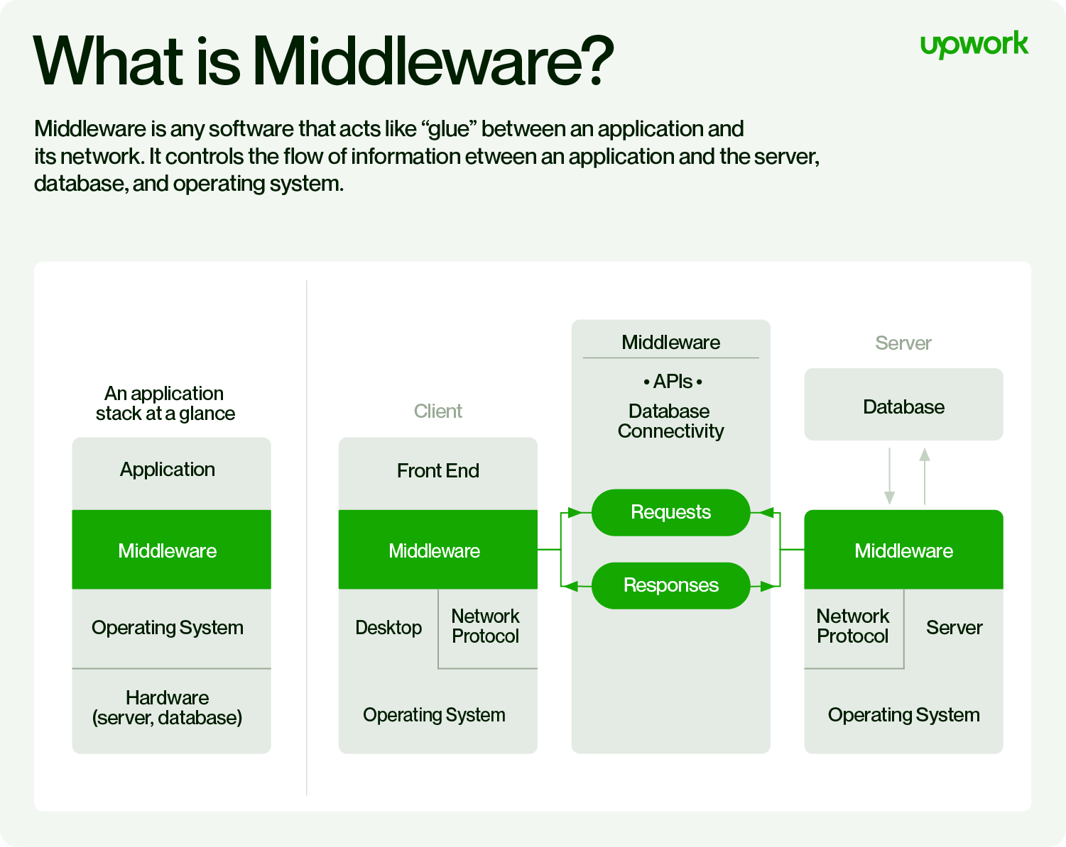
Breakdown:
1. Frontend
The frontend is the part of a web application that users interact with directly. It includes everything users see and engage with on their screens, such as buttons, forms, images, and layouts.
- Key Focus: User Interface (UI) and User Experience (UX).
- Technologies:
  - Languages: HTML, CSS, JavaScript.
  - Frameworks/Libraries: React, Angular, Vue.js.
  - Styling: Bootstrap, TailwindCSS, Material-UI.
- Example:
  - A login page with input fields and a "Submit" button.

2. Middleware
-Middleware acts as a bridge between the frontend and backend. It is responsible for handling communication, data processing, and business logic before sending data between the two layers.
- Key Focus: Facilitate smooth data transfer and enforce business logic.
- Technologies:
  - Express.js (Node.js), Spring Boot (Java), Django Middleware (Python).
  - Handles:
    - Authentication and Authorization (e.g., verifying login tokens).
    - Logging and error handling.
    - API routing and input validation.
- Example:
  - A user logs in, and the middleware checks their credentials with the backend database before granting access.

3. Backend
The backend is the server-side part of a web application. It stores and processes data, handles business logic, and communicates with the frontend via APIs.
- Key Focus: Data management, logic, and server operations.
- Technologies:
  - Languages: Node.js, Python, Java, PHP, Ruby.
  - Frameworks: Express.js, Django, Spring, Laravel.
  - Databases:
    - SQL: MySQL, PostgreSQL.
    - NoSQL: MongoDB, Firebase.
- Example:
  - When a user submits the login form, the backend checks the database for the username and password.

How They Work Together:
- Frontend:
A user fills out a form on a web page and clicks "Submit."
- Middleware:
The form data is sent to the middleware, which validates the input and forwards it to the backend.
- Backend:
The backend processes the request (e.g., checks the database) and sends a response (e.g., success or error) back to the middleware.
- Frontend:
The frontend receives the response and updates the UI accordingly (e.g., "Login successful" message or error).

Difference between Frontend and Backend
Feature | Frontend | Backend
Definition | It is the part of the website users see and interact with. | The server-side part that processes data and ensures everything works behind the scenes and not visible to users.
Main Languages | HTML, CSS, JavaScript | Java, Python, Ruby, PHP, Node.js
Focus | User interface and experience | Server logic, databases, APIs, and performance of application.
Frameworks | React, Angular, Vue.js, Bootstrap | Django, Express, Ruby on Rails, Spring
Role | Design, layout and responsiveness of UI. | Data processing, server-side logic, security of the applicaion.
Accessibility | Directly accessible to users | Not directly accessible; interacts through frontend.
Objective | Looks and feels of the application | Functionality, security, and performance
Tools | Browsers, frontend libraries | Servers, databases, backend frameworks
Examples | Menus, buttons, forms, visuals | User authentication, database interactions
Testing | User experience, layout, responsiveness | Server-side testing, API endpoints, logic

Difference between Node.js and JavaScript
SrNo | JavaScript | NodeJS
- 1 | Javascript is a programming language that is used for writing scripts on the website. | NodeJS is a Javascript runtime environment.
 | Javascript can only be run in the browsers. | We can run Javascript outside the browser with the help of NodeJS.
 | It is used on the client side. | It is mostly used on the server side.
 | Javascript is capable enough to add HTML and play with the DOM. | Nodejs does not have capability to add HTML tags.
 | Javascript can run in any browser engine as like JS core in Safari and Spidermonkey in Firefox. | V8 is the Javascript engine inside of node.js that parses and runs Javascript.
 | Javascript is used in front-end development. | Nodejs is used in server-side development.
 | Some of the javascript frameworks are RamdaJS, TypedJS, etc. | Some of the Nodejs modules are Lodash, express etc. These modules are to be imported from npm.
 | It is the upgraded version of the ECMA script that uses Chrome's V8 engine written in C++. | Nodejs is written in C, C++ and Javascript.

Web Applications

-A web application, as you may already know, is a program that runs on a server and is rendered by a client browser, using the internet to access all the resources of that application. It usually can be easily broken down into three parts:
- Client
- Server
- Database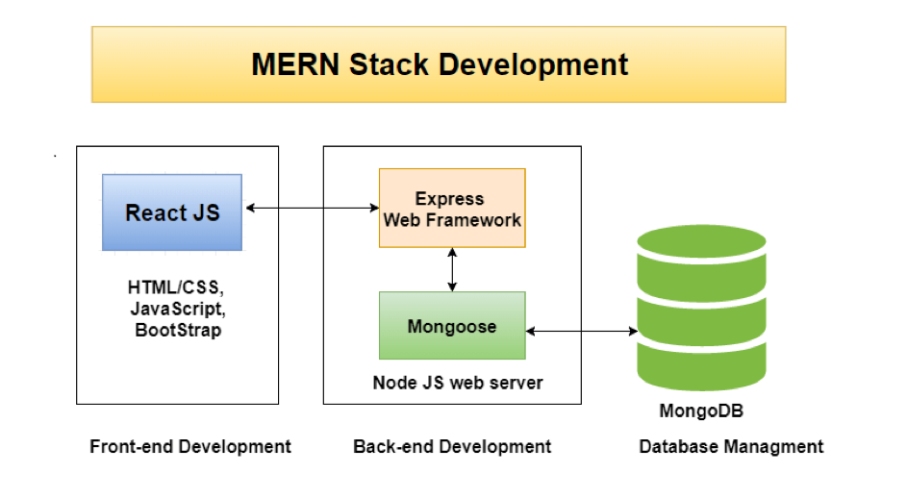
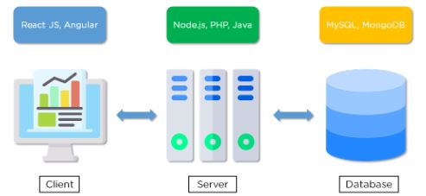
Fig: Web application

1.Client

-Client is the person to send request to the server.
-The user interacts with the front-end part of a web application. The front-end is usually developed using languages like HTML and CSS styles, along with extensive usage of JavaScript-based frameworks like ReactJS and Angular, which help with application design.
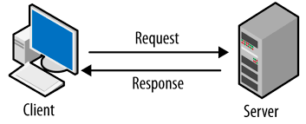
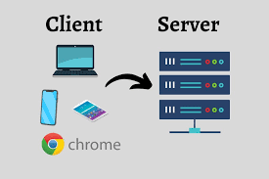

2.Server

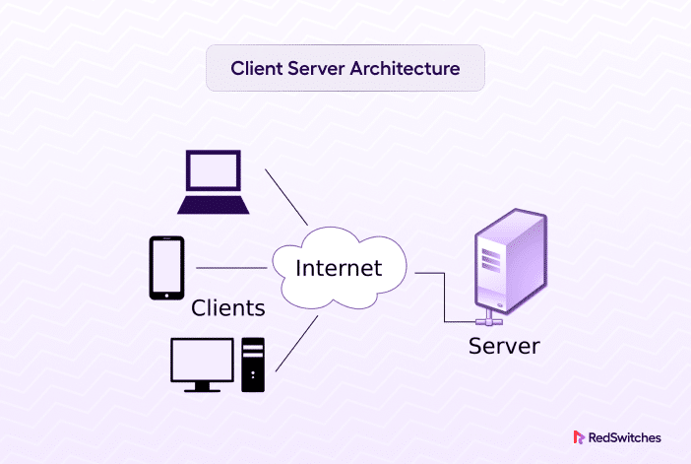
-A server is a computer system that provides services, data, and programs to other computers, or clients, over a network.
Servers can be hardware or software, and can perform a variety of functions, including:
-Web hosting, Network storage, Application processing, Database management, Name resolution, and Communication interface.
-The server is responsible for taking the client requests, performing the required tasks, and sending responses back to the clients.
-It acts as a middleware between the front-end and stored data to enable operations on the data by a client. Node.js, PHP, and Java are the most popular technologies in use to develop and maintain a web server.
-Some types of servers include:
Web server, File server, Application server, Print server, Mail server, DNS server, Proxy server, and Database server.

3. Database

-A database is an organized collection of data or a type of data store based on the use of a database management system (DBMS)
-The database stores the data for a web application. The data can be created, updated, and deleted whenever the client requests. MySQL and MongoDB are among the most popular databases used to store data for web applications.

NODE.JS RELEASES

-Major Node.js versions enter Current release status for six months, which gives library authors time to add support for them. After six months, odd-numbered releases (9, 11, etc.) become unsupported, and even-numbered releases (10, 12, etc.) move to Active LTS status and are ready for general use. LTS release status is "long-term support", which typically guarantees that critical bugs will be fixed for a total of 30 months. Production applications should only use Active LTS or Maintenance LTS releases.
Release Schedule
-Full details regarding Node.js release schedule are available on GitHub.
Looking for latest release of a version branch?
Node.js Version | Codename | Release Date | npm
v23.0.0 | - | 2024-10-16 | v10.9.0 | ReleasesChangelogDocs
v22.10.0 | - | 2024-10-16 | v10.9.0 | ReleasesChangelogDocs
v21.7.3 | - | 2024-04-10 | v10.5.0 | ReleasesChangelogDocs
v20.18.0 | Iron | 2024-10-03 | v10.8.2 | ReleasesChangelogDocs
v19.9.0 | - | 2023-04-10 | v9.6.3 | ReleasesChangelogDocs
v18.20.4 | Hydrogen | 2024-07-08 | v10.7.0 | ReleasesChangelogDocs
v17.9.1 | - | 2022-06-01 | v8.11.0 | ReleasesChangelogDocs
v16.20.2 | Gallium | 2023-08-08 | v8.19.4 | ReleasesChangelogDocs
v15.14.0 | - | 2021-04-06 | v7.7.6 | ReleasesChangelogDocs
v14.21.3 | Fermium | 2023-02-16 | v6.14.18 | ReleasesChangelogDocs
v13.14.0 | - | 2020-04-29 | v6.14.4 | ReleasesChangelogDocs
v12.22.12 | Erbium | 2022-04-05 | v6.14.16 | ReleasesChangelogDocs
v11.15.0 | - | 2019-04-30 | v6.7.0 | ReleasesChangelogDocs
v10.24.1 | Dubnium | 2021-04-06 | v6.14.12 | ReleasesChangelogDocs
v9.11.2 | - | 2018-06-12 | v5.6.0 | ReleasesChangelogDocs
v8.17.0 | Carbon | 2019-12-17 | v6.13.4 | ReleasesChangelogDocs
v7.10.1 | - | 2017-07-11 | v4.2.0 | ReleasesChangelogDocs
v6.17.1 | Boron | 2019-04-03 | v3.10.10 | ReleasesChangelogDocs
v5.12.0 | - | 2016-06-23 | v3.8.6 | ReleasesChangelogDocs
v4.9.1 | Argon | 2018-03-29 | v2.15.11 | ReleasesChangelogDocs
v0.12.18 | - | 2017-02-22 | v2.15.11 | ReleasesChangelogDocs

NODE JS INSTALLATION
-Node.js can be installed in multiple ways on a computer. The approach used by you depends on the existing Node.js development environment in the system. There are different package installers for different environments.
-You can install Node.js by grabbing a copy of the source code and compiling the application. Another way of installing Node.js is by cloning the Node.js GIT repository in all three environments and then installing it on the system
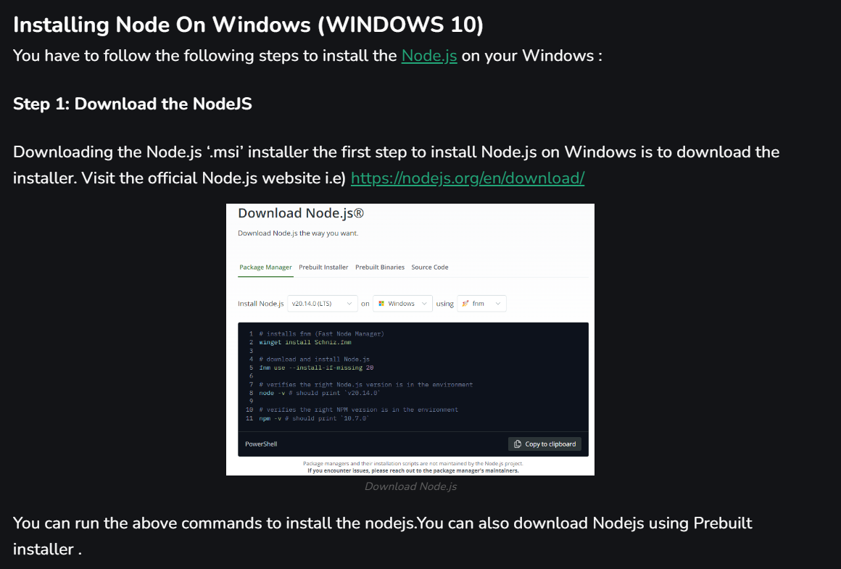
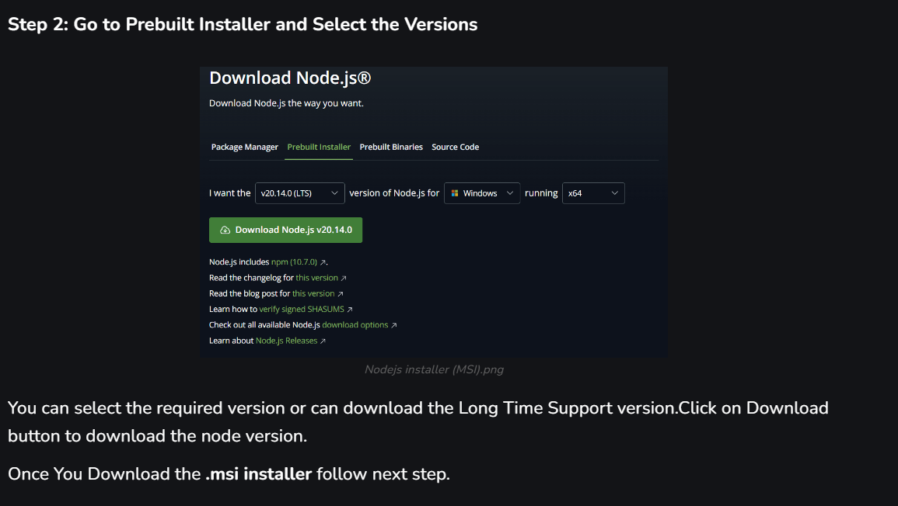

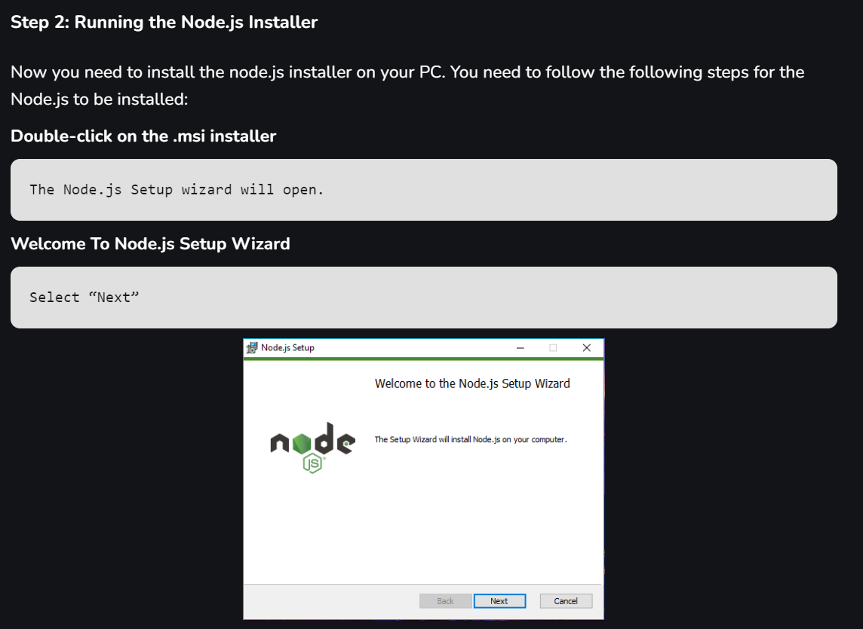

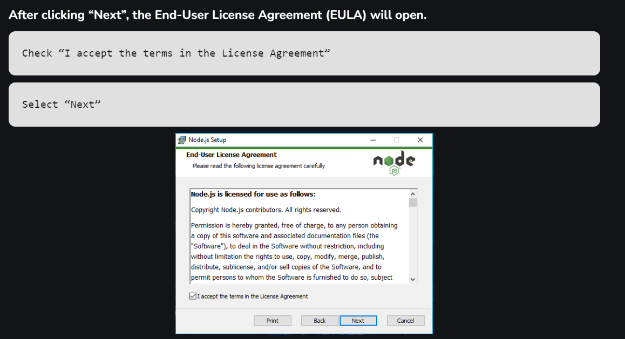
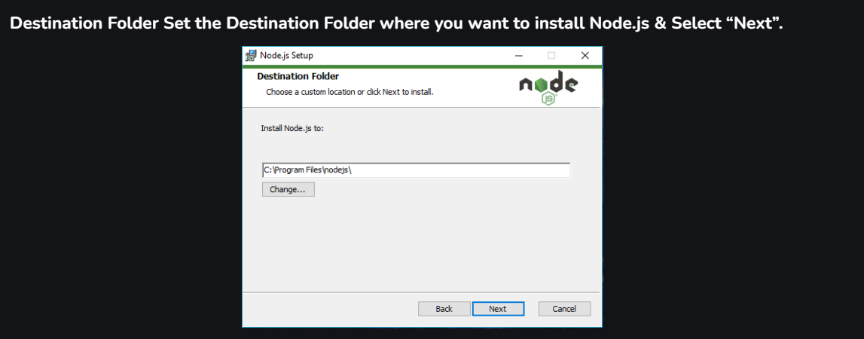
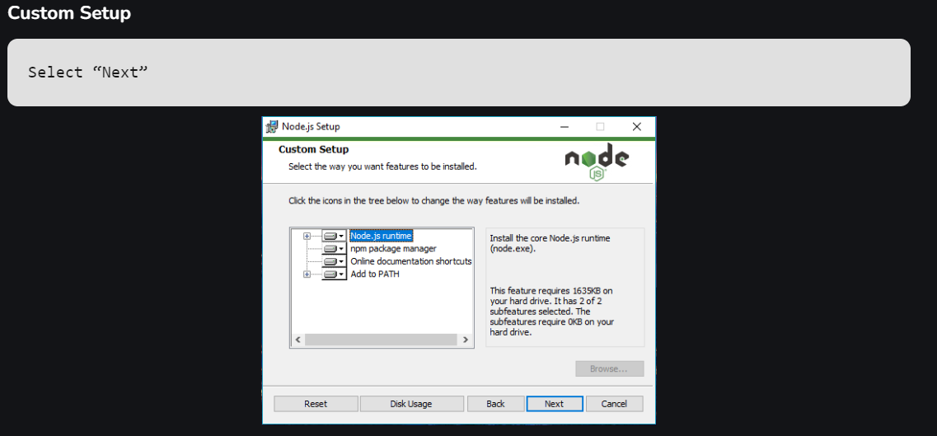
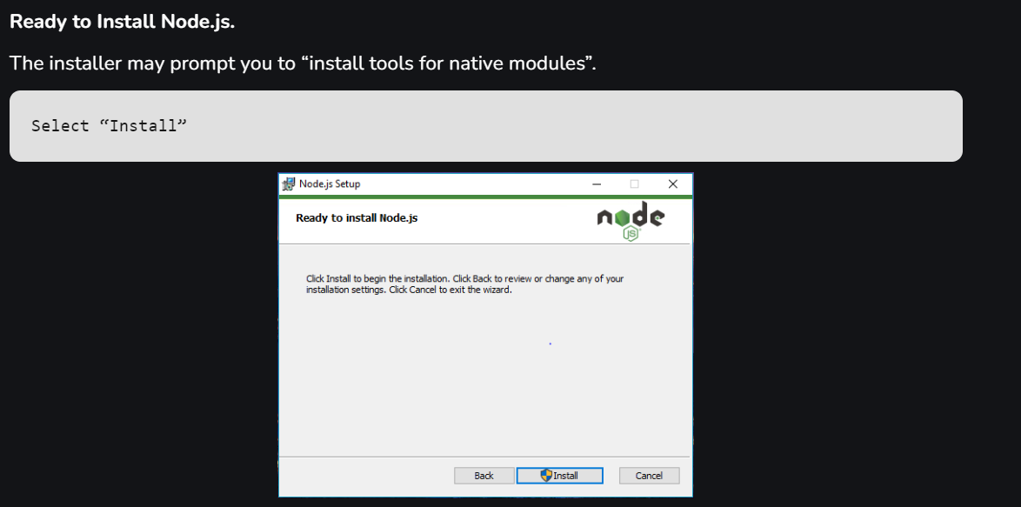
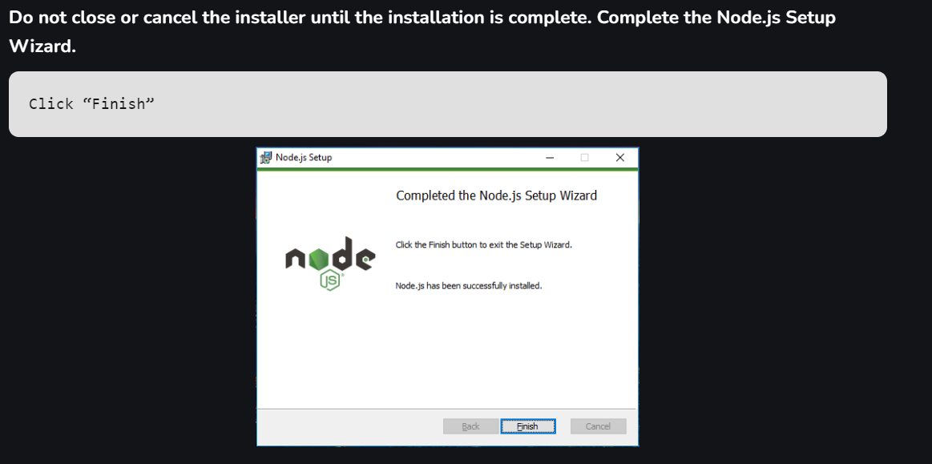
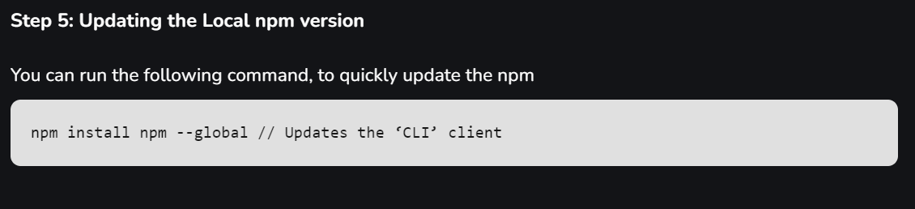

WHY LEARN NODEJS?

- Build End To End Javascript applications means you have learn one language i.e Javascript work on NodeJs also and Front End also.
- A number of major companies like Facebook, LinkedIn, Netflix, PayPal have all migrated from other backend technologies to NodeJs.
- Full Stack Development is one of the most sought out skill sets by companies in nowadays it takes one step to closure to landing your dream job.
- Huge Community Support.

Is Node.js a Programming Language?
-Node.js is not a programming language; it is a runtime environment allowing you to execute JavaScript code on the server side, outside a web browser.
-Built on the V8 JavaScript engine from Chrome, Node.js compiles JavaScript into machine code for efficient execution. It extends JavaScript capabilities by providing additional features and libraries for server-side development, such as file system access, network communication, and asynchronous I/O operations.
-While JavaScript is the programming language used with Node.js, the runtime environment provides the tools and frameworks to build scalable and high-performance server applications.
-Node.js’s non-blocking, event-driven architecture makes it ideal for real-time applications, web servers, APIs, and more. In summary, Node.js is a robust environment that leverages JavaScript to enable server-side programming, but it is not a programming language

TOOLS
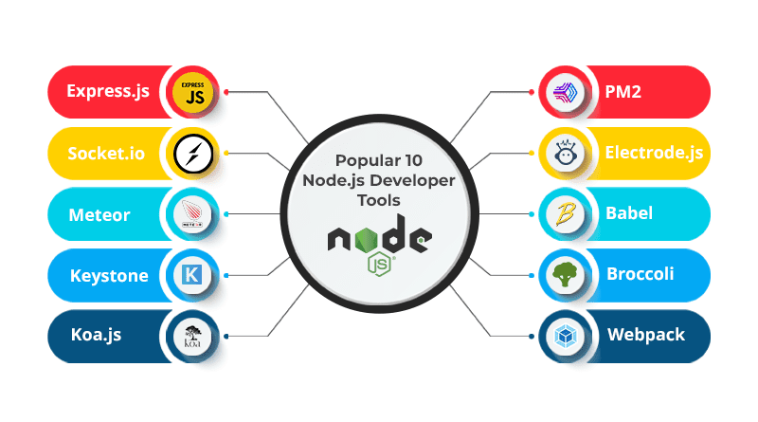

Why Do We Use NodeJs?

-There are many reasons for which we prefer using NodeJs for the server side of our application, some of them are discussed in the following:
- NodeJs is built on Google Chrome’s V8 engine, and for this reason its execution time is very fast and it runs very quickly.
- There are more than 50,000 bundles available in the Node Package Manager and for that reason developers can import any of the packages any time according to their needed functionality for which a lot of time is saved.
- As NodeJs do not need to wait for an API to return data , so for building real time and data intensive web applications, it is very useful. It is totally asynchronous in nature that means it is totally non-blocking.
- The loading time for an audio or video is reduced by NodeJs because there is better synchronization of the code between the client and server for having the same code base.
- As NodeJs is open-source and it is nothing but a JavaScript framework , so for the developers who are already used to JavaScript, for them starting developing their projects with NodeJs is very easy.

WHAT IS NODE JS
-Node.js is a runtime that allows you to run JavaScript outside the browser (on server side).
OR
-Node.js is a server-side runtime environment built on Google Chrome's JavaScript Engine (V8 Engine).
-Node JS is not a Programming language or not Server.
-NodeJS is Asynchronous.
-NodeJs is an open-source Cross Platform Javascript Runtime Environment.
-Open-Source: - Source code s publicly available for sharing and modification.
-Cross-Platfrom: - available on Mac, Windows and Linux.
-Javascript Runtime Environment: - Provide all the necessary Components in order to use and run Javascript program outside the browser.
-Node.js is not a programming language like Python, Java or C/C++. Node.js is a runtime, similar to Java virtual machine, that converts JavaScript code into machine code. It is , widely used by thousands of developers around the world to develop I/O intensive web applications like video streaming sites, single-page applications, and other web applications.
-With Node.js, it is possible to use JavaScript as a backend. With JavaScript already being a popular choice for frontend development, application development around MERN (MongoDB, Express, React and Node.js.) and MEAN (MongoDB, Express, Angular and Node.js) stacks is being increasingly employed by developers.
What can you build with NodeJs?
1]Traditional Websites
2]Backend Services like API.
3]Real Time Applications
4]Streaming Services
5]Multiplayer Games.
-NodeJs allows you to build complex and powerful applications.
-Node Js is open source so code is available on GitHub.

NODEJS OPEN SOURCE
NODE JS GITHUB REPO
-Node Js Code is Publicly available in GITHUB.
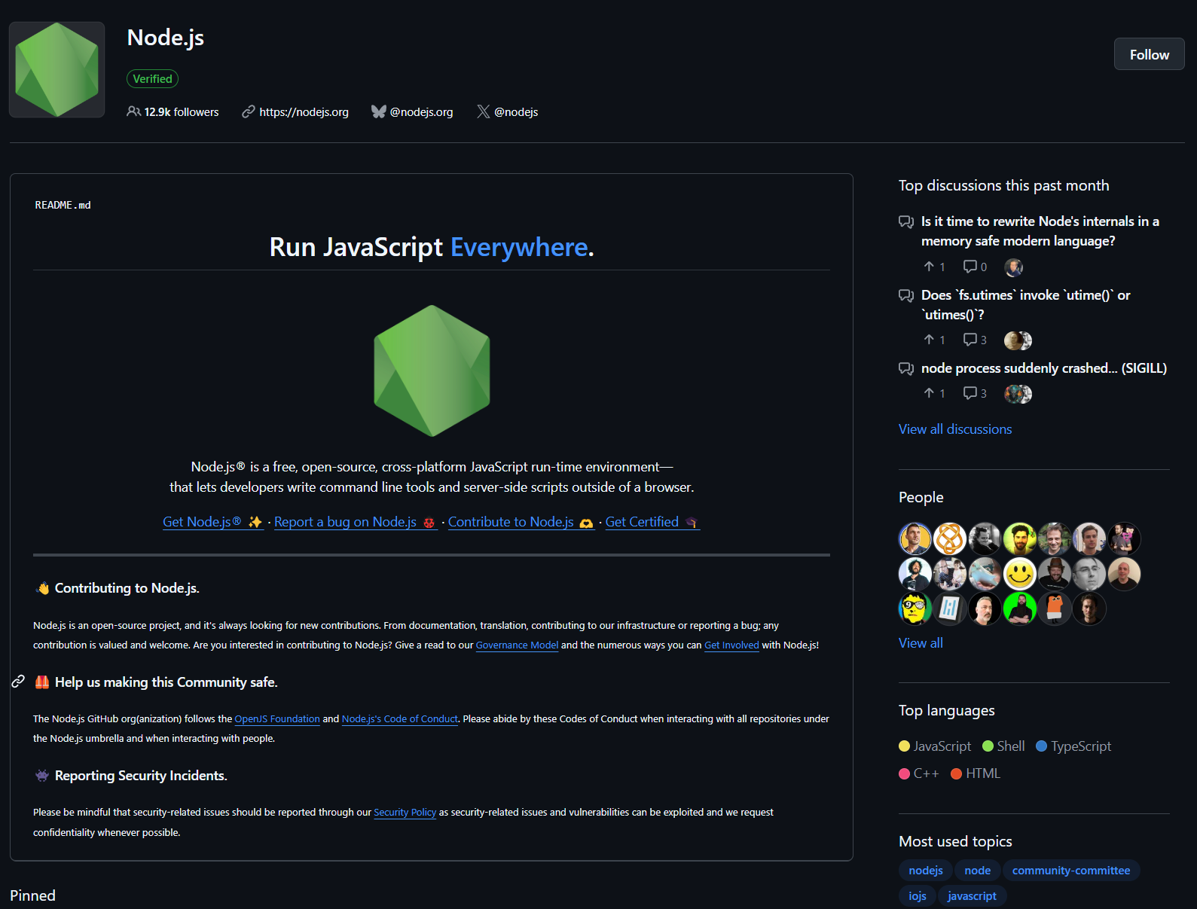

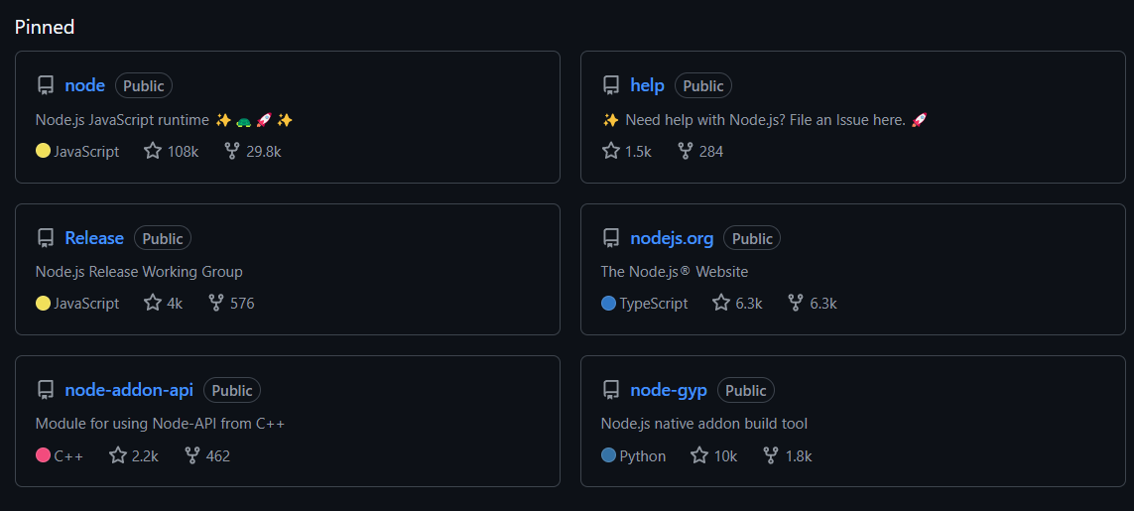

NODE JS SRC

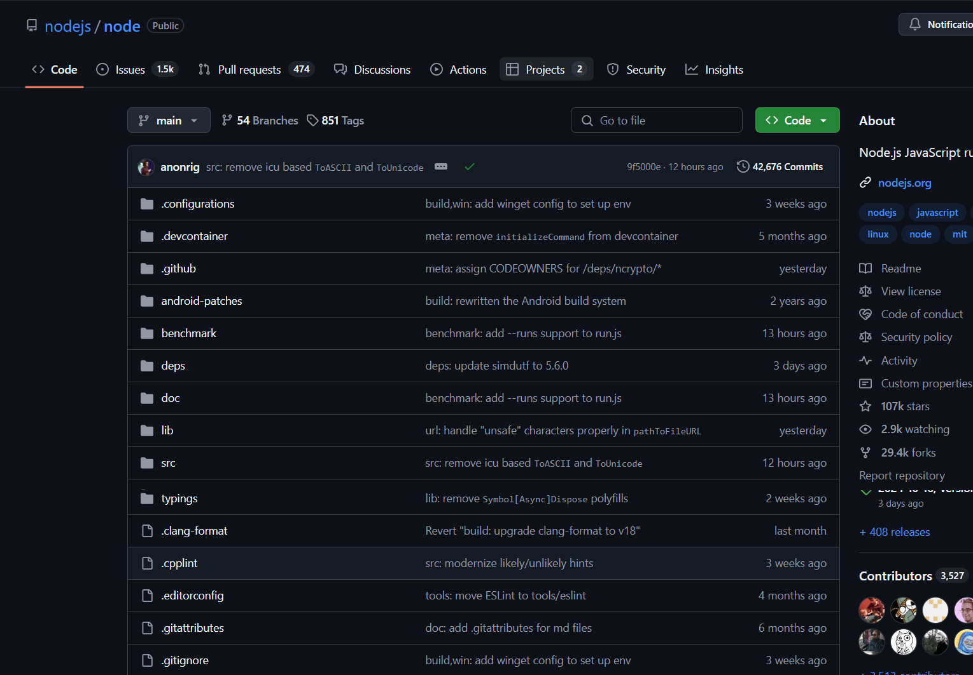

NODE JS DEPENDENCIES
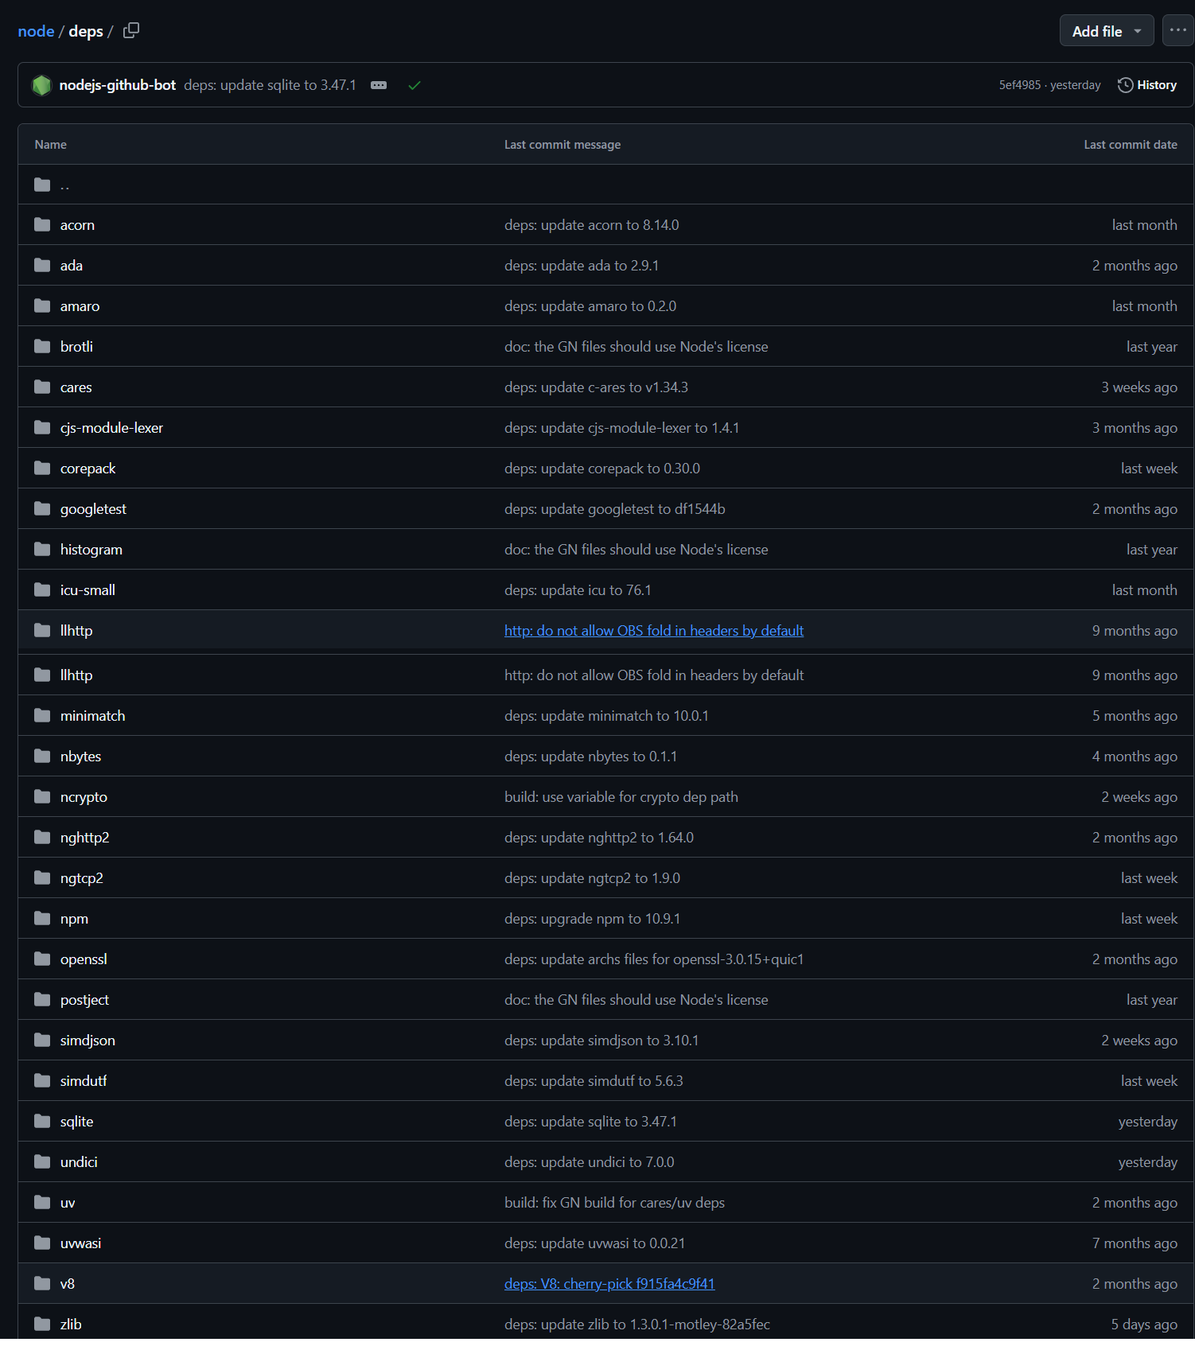

V8 DEPENDENCIES IN NODE JS REPO
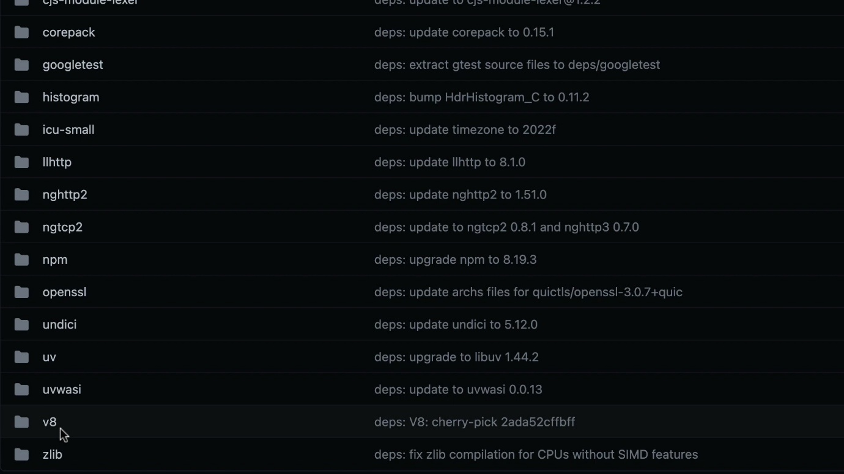
-This same Javascript engine present inside the browser.
UV(libuv) DEPENDENCIES IN NODE REPO
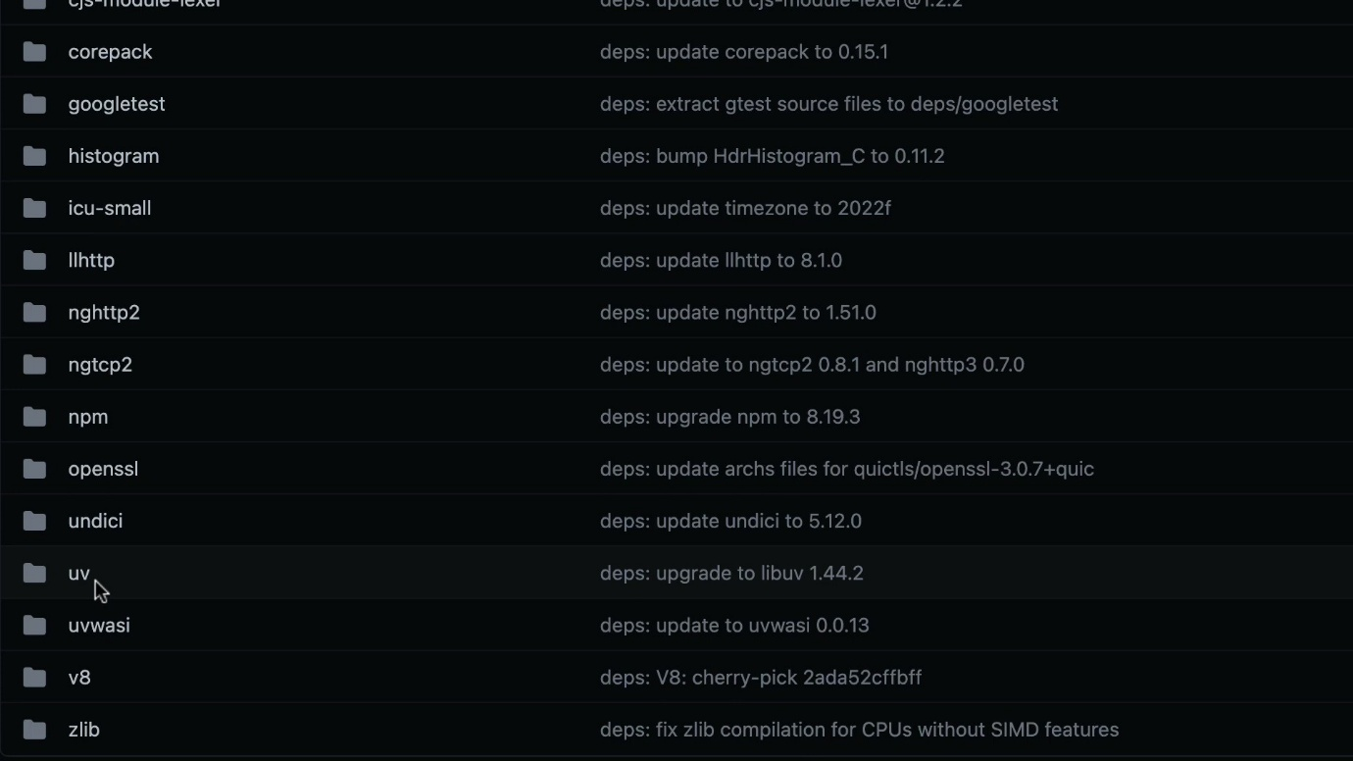
-This is another most important dependency providing nodejs access to the underlying operating system features such as File System and Networking.

NODE JS SOURCE CODE LOW LEVEL
-Node is not designed to perform the low level operation like File I/O, Networking So the To Perform the low level operation we uses the C++ language with the help of C++ language we can perform the Low Level Operation.So that’s why it is called the Runtime.
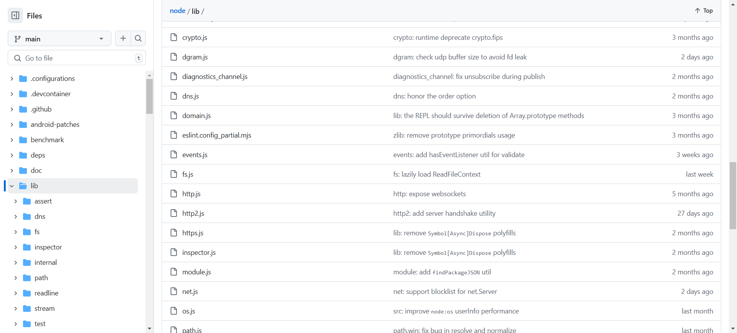

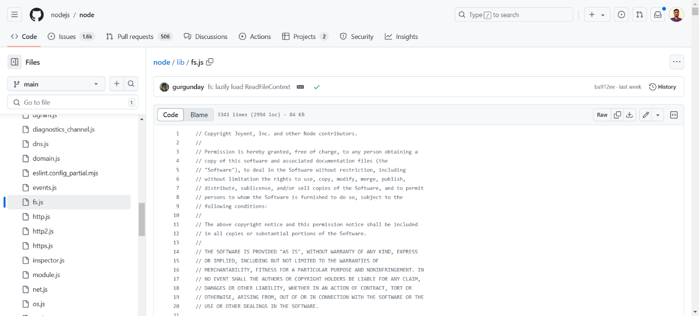
-Inside the lib (libuv) folder have C++ code.
-The NodeJs adds the C++ feature in the Javascript.
-So the question come in mind how does Javascript Developer access those C++ features. Should they know C++?
-The Answer in libuv folder. The libuv folder contain Javascript Code that written for you to easily get access C++ Features.
EXAMPLE:-
-The fs.js contain Javascript Code that we write access to access file system. The code internally calls corresponding C++ features which further rely on libuv to access the Operating System
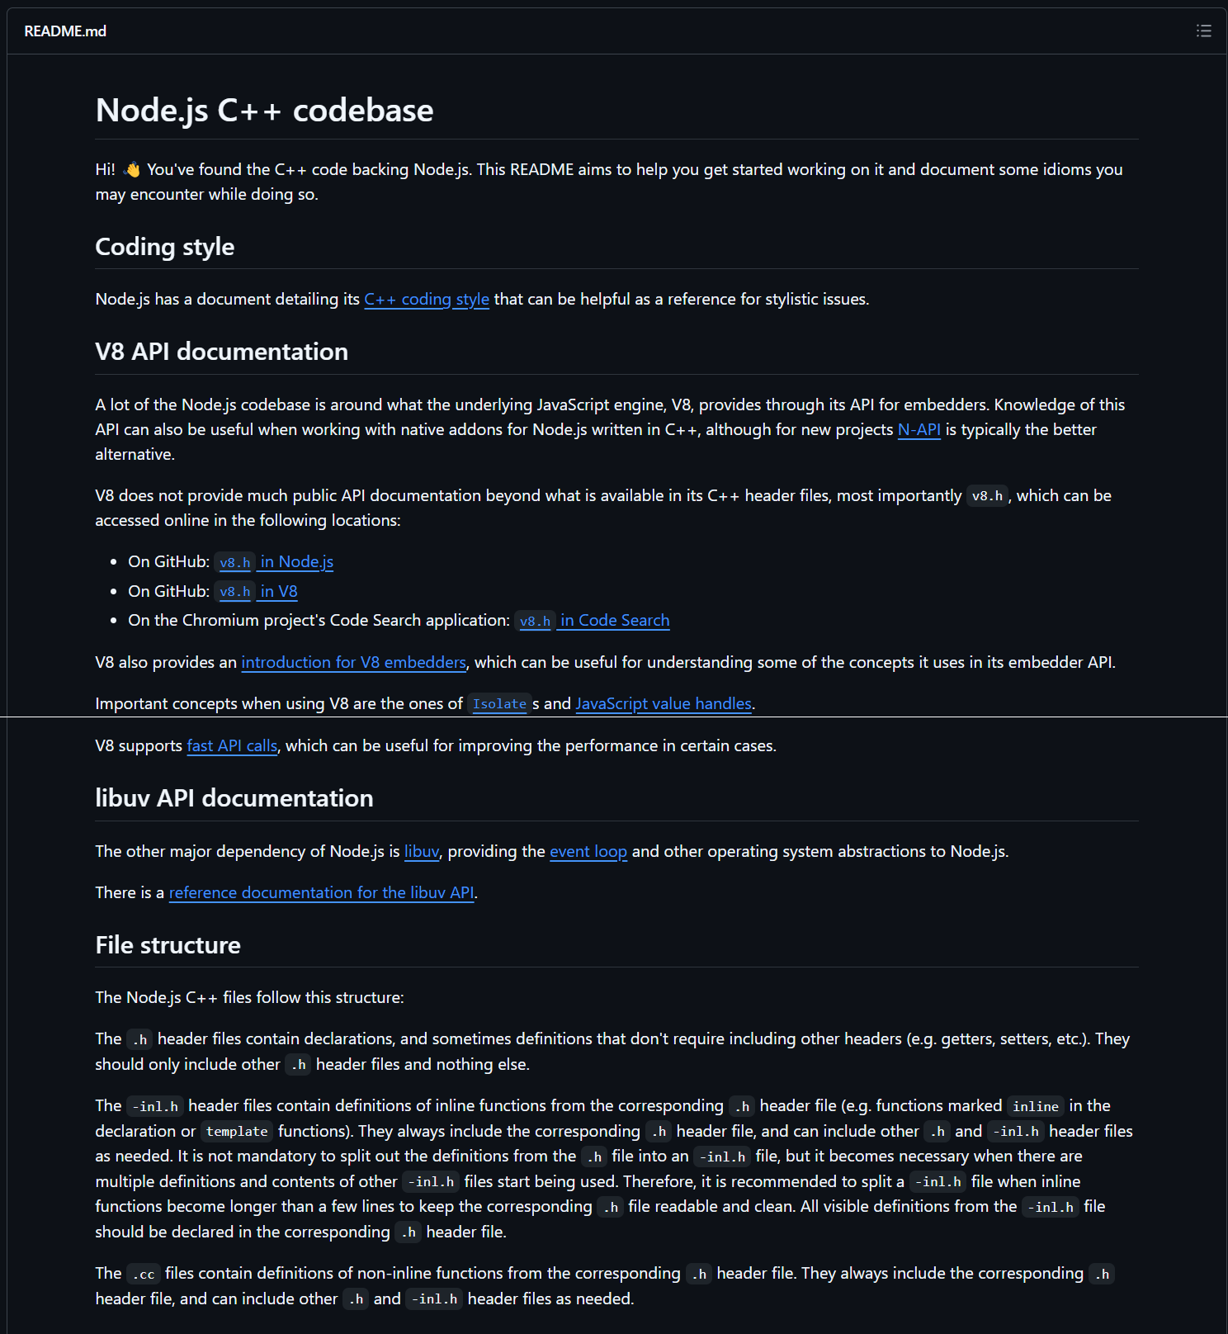

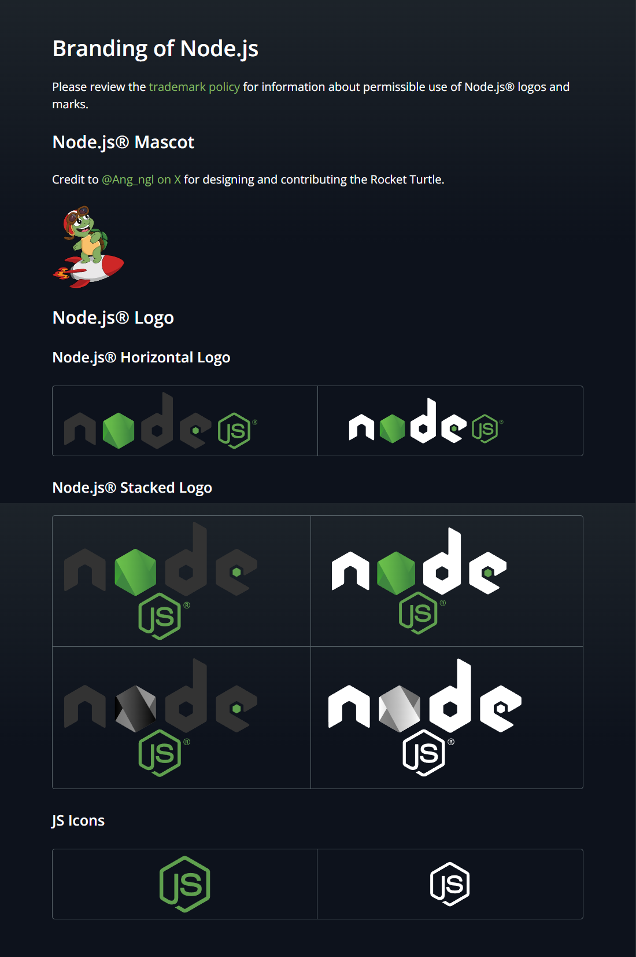
NODEJS FEATURES

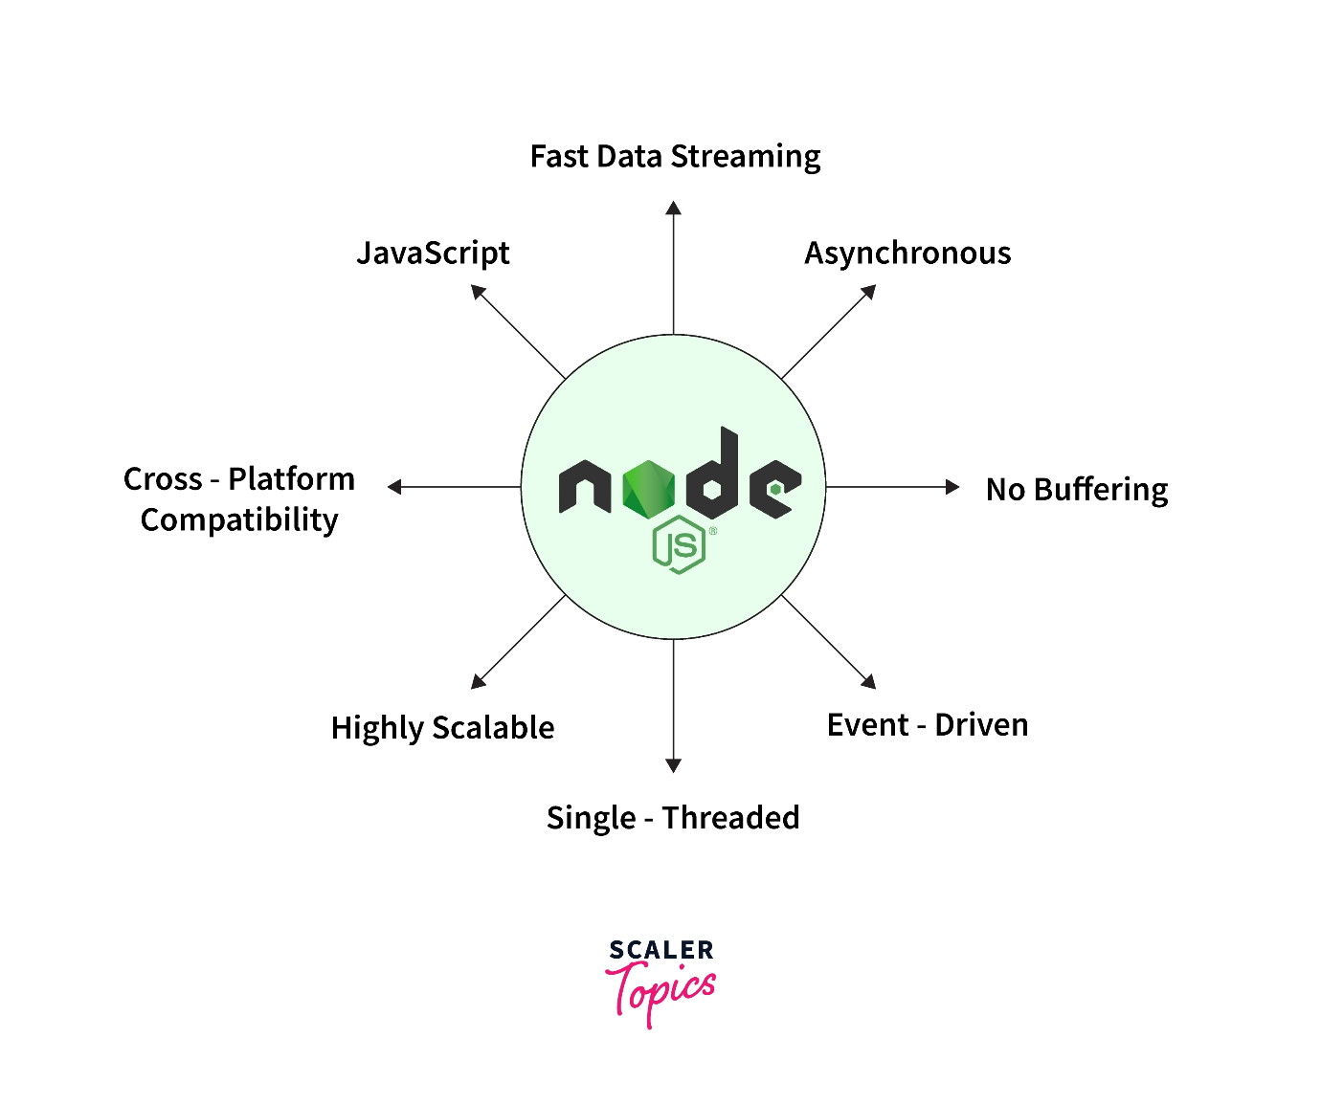

1.Asynchronous / Non-Blocking IO

-Node.js uses a non-blocking, event-driven architecture.
-Benefit: Efficient handling of multiple concurrent requests without waiting for any single operation to complete.
-Example: Handling file I/O or database queries without blocking other tasks.
-Asynchronous and non-blocking I/O enable programs to handle multiple tasks concurrently without waiting for slow operations (like file reads or network requests) to finish.
-The servers made with the NodeJs never waits for the from an API. Without waiting for the data from the API, it directly moves to the next API.
-So all the APIs of NodeJS are totally non-blocking in nature. In order to receive and track all the responses of the previous API requests, it follows an event driven mechanism.
-Hence we can say that all the NodeJs API are non-blocking in nature.
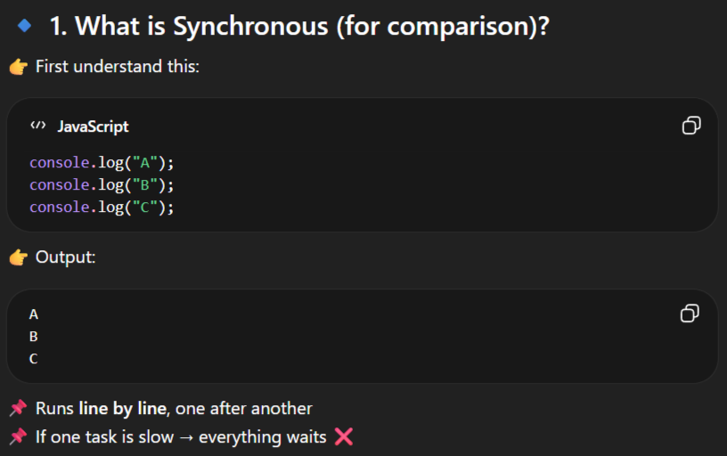
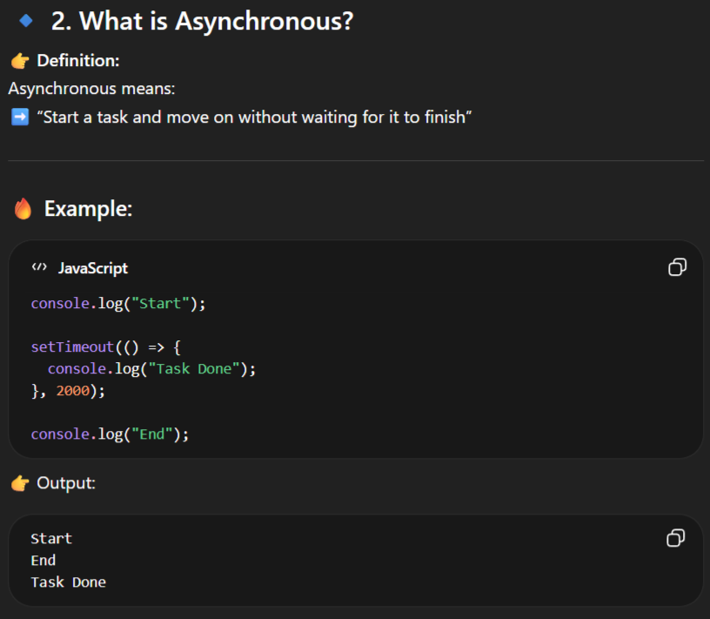
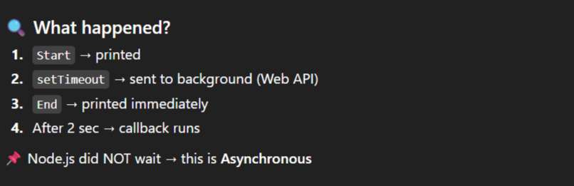

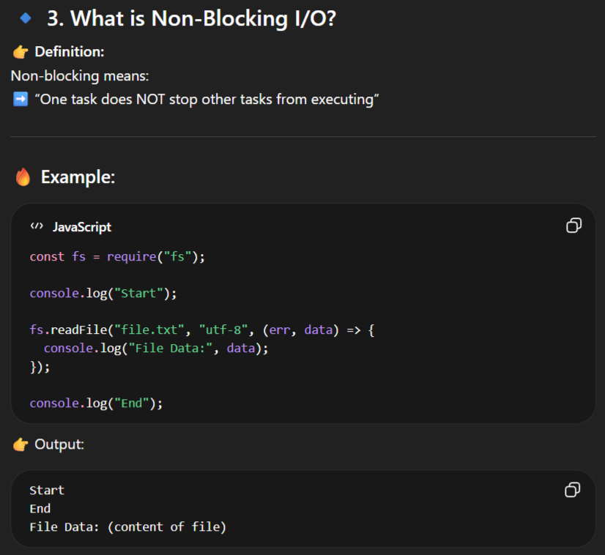
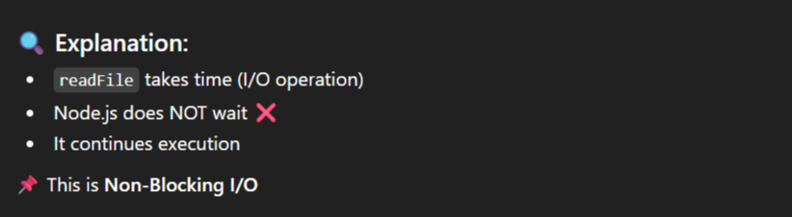

2.Single Threaded Architecture

-👉 Single-threaded = only ONE main thread executes JavaScript code
📌 That means:
- One call stack
- One execution flow
- One task handled at a time (in the main thread)
-Node.js operates on a single thread but handles multiple connections using an event loop.
-Benefit: Scales efficiently without creating additional threads for every client request.
-Suitable for I/O-heavy operations rather than CPU-intensive tasks.
-With event looping, a single threaded architecture is followed by NodeJs and for this architecture makes NodeJs more scalable.
-In contrast to other servers, limited threads are created by them for processing the requests. Whereas for the event driven mechanism, the NodeJS servers reply in a non-blocking or an asynchronous manner and for this reason NodeJS becomes more scalable.
-If we compare NodeJs with other traditional servers like Apache HTTP servers, then we can say NodeJs handles a larger number of requests.
-A single threaded program is followed by NodeJS and this allows NodeJs to process a huge amount of requests.
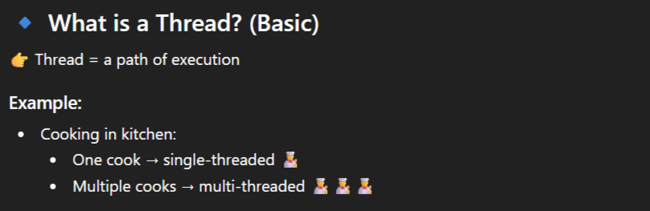
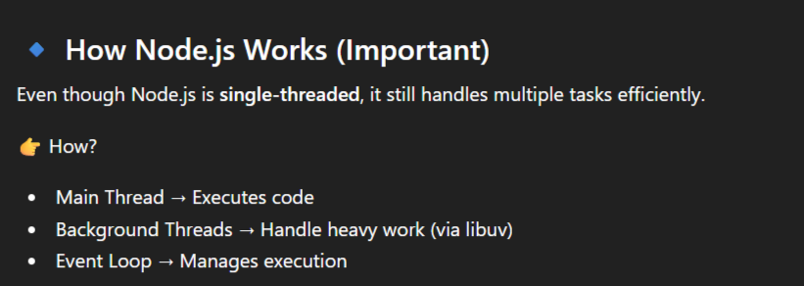
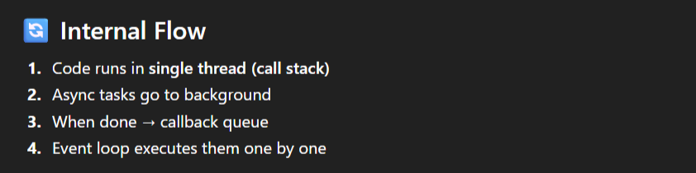
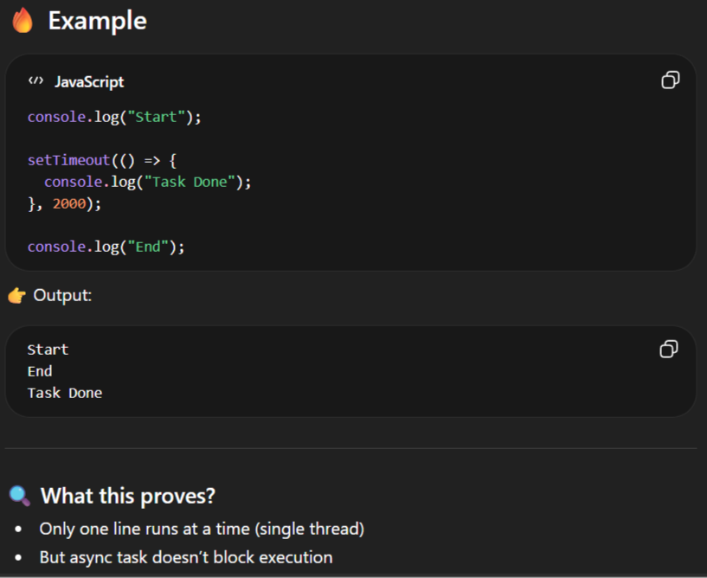

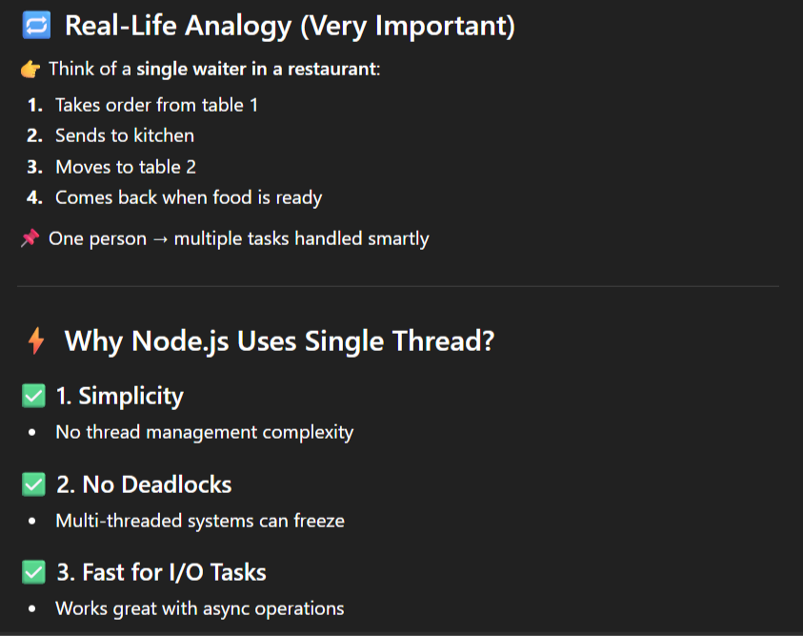

3.Scalable
-In Node.js, scalability means:
👉 Handling a large number of users/requests efficiently without slowing down
-Node.js is designed to build scalable network applications by using an asynchronous, event-driven architecture that handles many connections concurrently without the overhead of creating a new thread for every request.
-Nowadays, scalable software is demanded by most of the companies. One of the most pressing concerns in Software Development is addressed by NodeJs and that is scalability.
-Concurrent requests can be handled very efficiently using NodeJs. A cluster module is used by NodeJs for managing the load balancing for all the active CPU cores.
-The most appealing feature of NodeJs is that it can partition the applications horizontally and this partition procedure is mainly achieved by it due to the use of child processes.
-Using this feature, the distinct app versions are provided to the different target audiences and also for customization it allows them for catering to the client preferences.
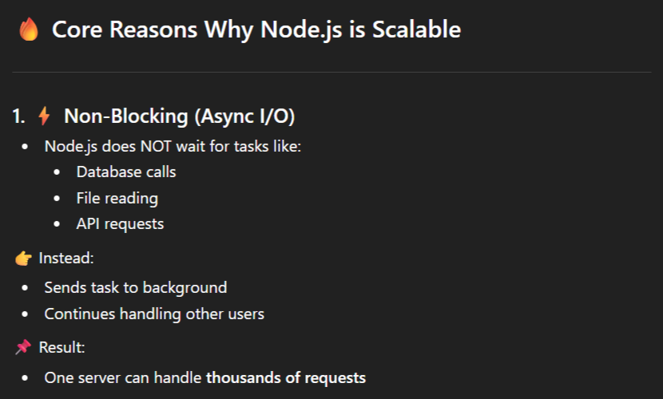

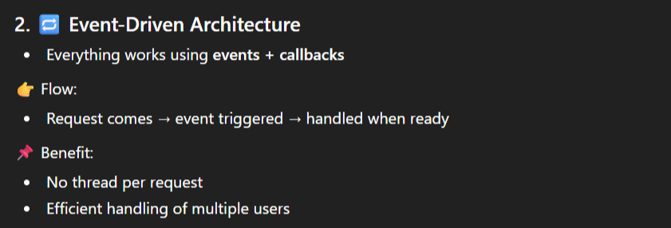
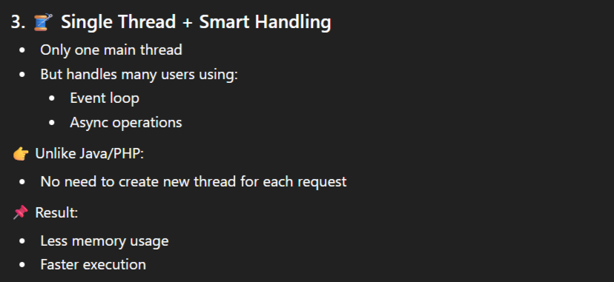
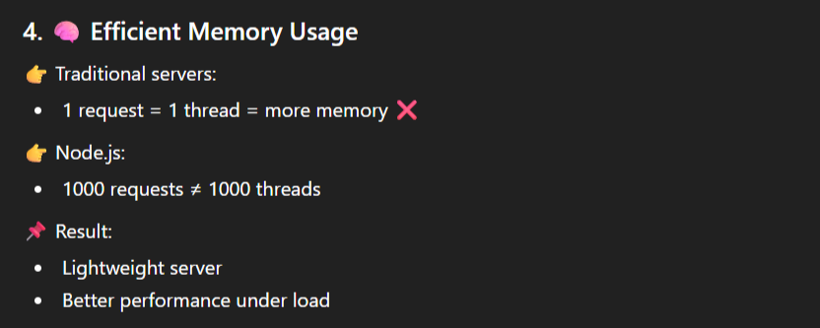
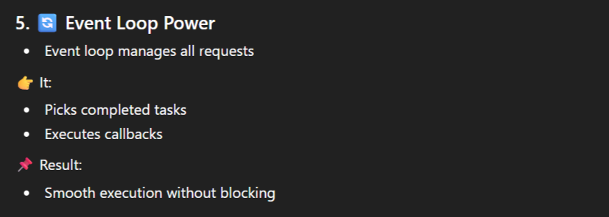
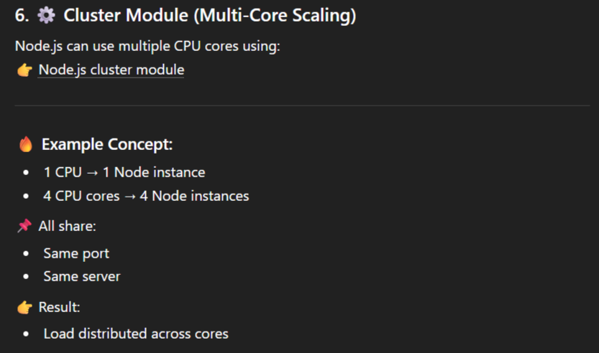
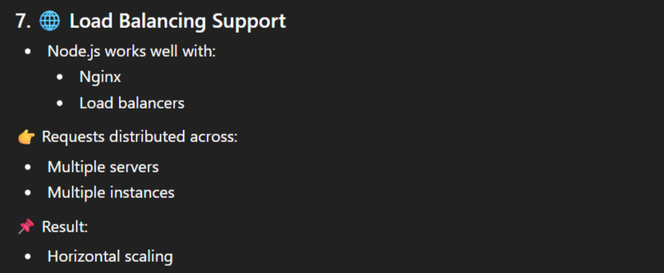
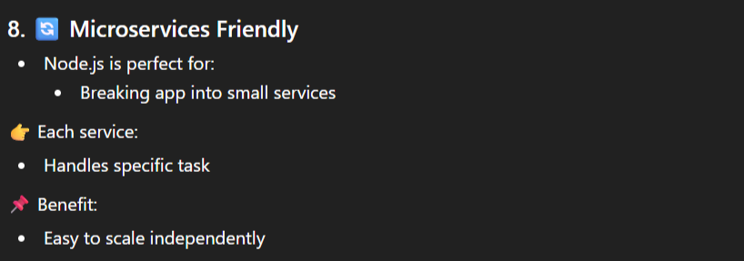
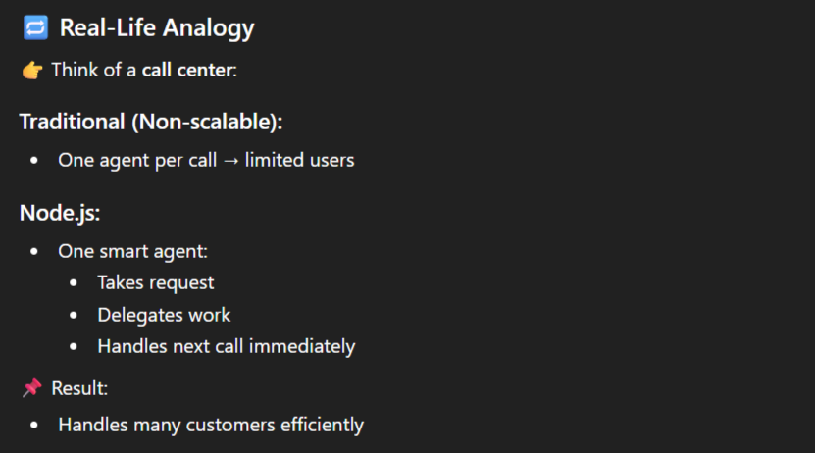

4.Fast Execution

-Powered by Google’s V8 JavaScript engine, Node.js converts JavaScript into highly optimized machine code.
-Benefit: Provides high speed and performance, making it ideal for real-time applications.
-V8 JavaScript runtime motor is used by NodeJs and this is also used by Google chrome.
-A wrapper is provided for the JavaScript by the hub and for that reason the runtime motor becomes faster and for this reason inside NodeJs, the preposition process of the requests also become faster.
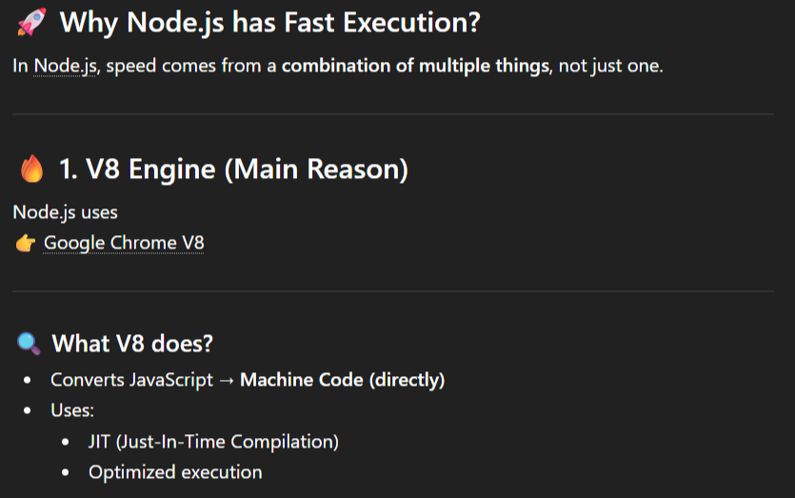
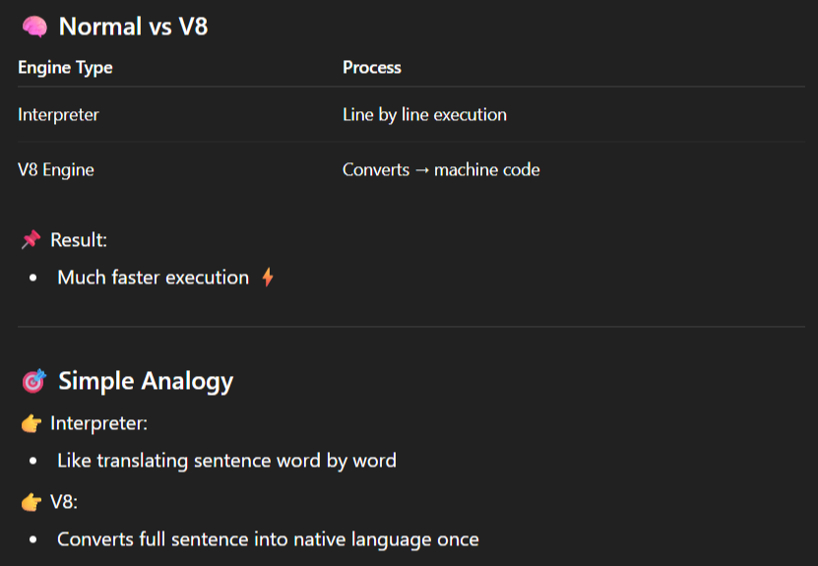
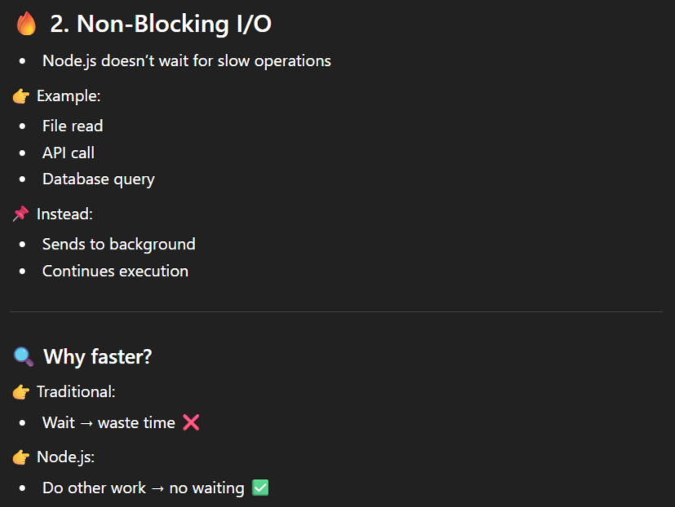
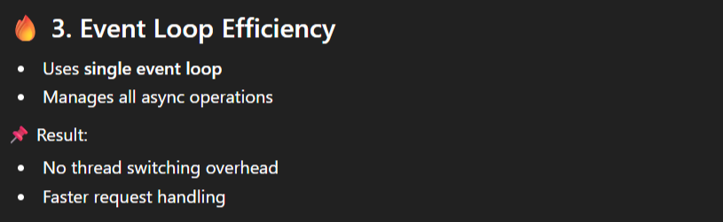
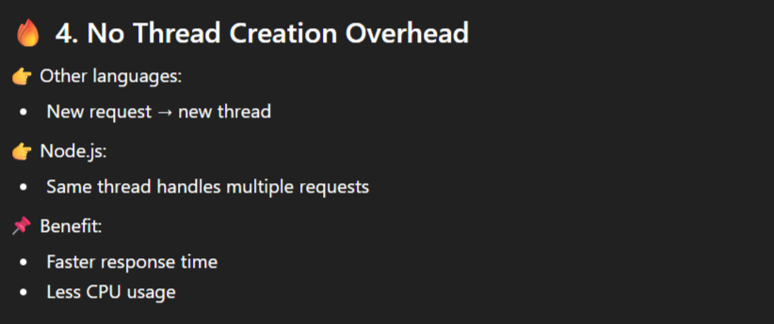
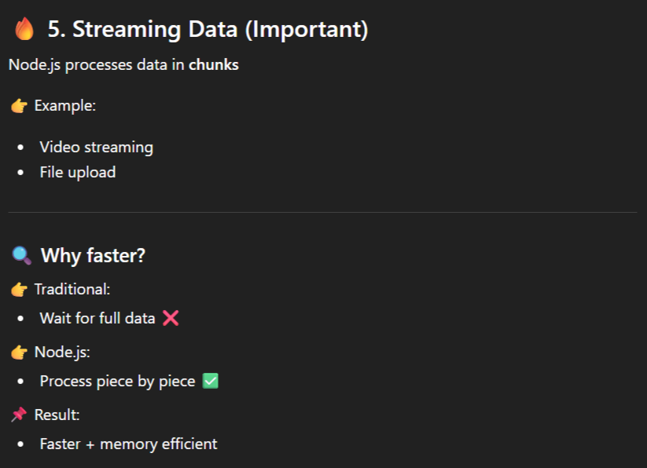
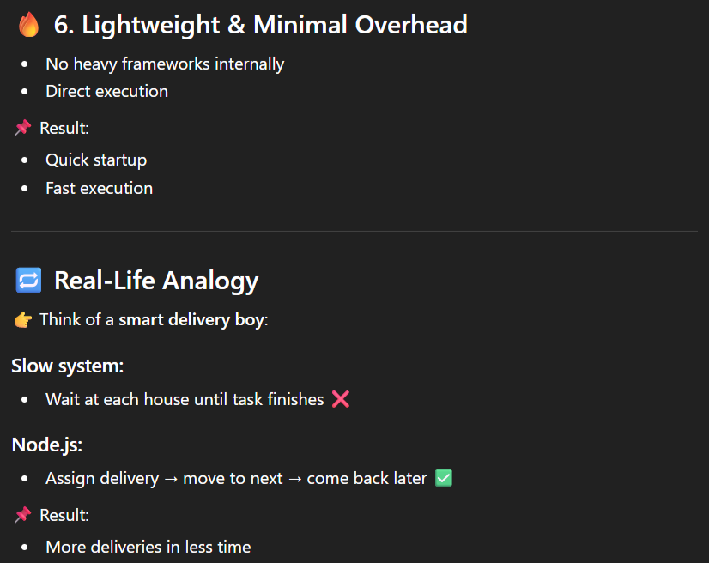

5.Compatibility on the Cross Platforms

-Applications built with Node.js can run on various platforms (Windows, Linux, macOS).
-With tools like pkg or nexe, developers can package their apps as executables.
-Different types of systems like Windows, UNIX, LINUX, MacOS and other mobile devices can use NodeJs. For generating a self-sufficient execution, it can be paired with any appropriate package.

6.Uses JavaScript

-From an engineer's perspective, it is a very important aspect of NodeJs that this framework uses JavaScript Most of the developers are familiar with JavaScript, so for them it becomes very easier to grab NodeJs.

7.Real-Time Capabilities

-Node.js is ideal for building real-time applications like chat apps, gaming servers, and collaborative tools.
-Supports WebSockets for two-way communication between the server and the client.
8. Stream Handling

-Node.js supports streams, which enable efficient handling of large files (e.g., video or audio).
-Benefit: Processes files in smaller chunks rather than loading them entirely into memory
-The processing time of the data that have been transmitted to different streams takes a long time. Whereas for processing the data, NodeJs takes a very short amount of time and it does it at a very fast rate.
-NodeJs saves a lot of time because the files are processed and uploaded simultaneously by NodeJs. So as a result, the overall speed of data and video streaming is improved by NodeJs.

9. Microservices and API Development

- Node.js excels in creating RESTful APIs and lightweight microservices.
- Frameworks like Express.js make it easy to build robust backend systems.

10. Event-Driven I/O Model

- Its architecture is built around an event loop, making it well-suited for I/O-bound applications.
- Benefit: Ideal for data-intensive applications like streaming platforms.
11.No Buffering

-The data is never buffered in NodeJs application.
12.NPM (Node Package Manager)

- Node.js comes with NPM, a package manager that provides access to thousands of libraries and modules.
- Benefit: Simplifies the process of adding new features and functionalities to applications.
13.JSON-Friendly

-Node.js uses JavaScript, which natively supports JSON, simplifying data exchange between the frontend and backend.
-Benefit: Reduces parsing overhead and boosts compatibility with REST APIs.

14.Community Support

-Node.js has a large and active community, offering extensive documentation, tools, and third-party modules.
-Benefit: Faster troubleshooting and access to ready-made solutions.

NODE JS ADVANTAGES
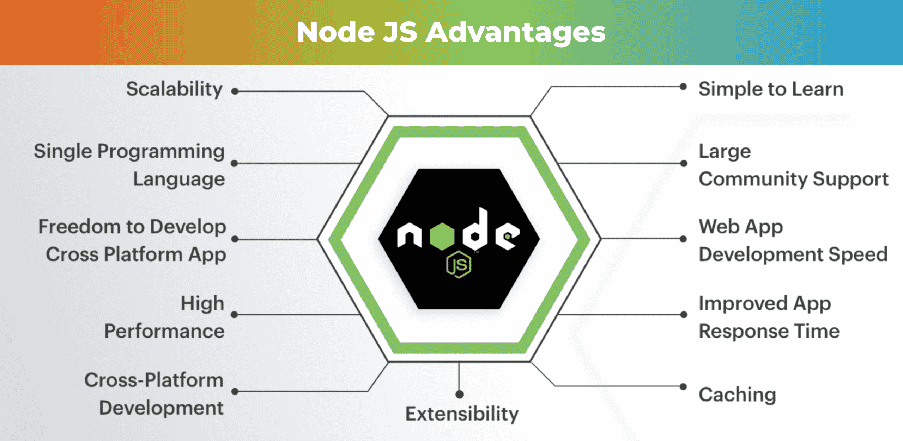

1. Faster Development
-Developers can use the same language for both client-side and server-side work with Node.js, which speeds up development and lowers learning curves. The development process is also made simpler and takes less time thanks to this functionality.
2. High Performance
-A high-performance platform like Node.js can manage lots of data and traffic without stuttering or crashing. It is the best platform for developing real-time applications that need great performance and scalability because of this characteristic.
3. Scalability
-It can be easily horizontally scaled by adding extra servers and is made to handle handling large-scale applications. Developers can easily scale their apps as their user base expands thanks to this functionality.

4. Cost-Effective
-It is an economical platform that can be used with cheap servers and cloud computing services. This makes it the perfect option for new companies and small organizations with tight budgets.
5. Asynchronous Programming
-Because Node.js relies on an event-driven, non-blocking I/O mechanism, programmers can create extremely responsive and effective programs. Because of this, it is perfect for creating real-time applications like chat programs and gaming platforms.
6. Single-Threaded
-Because Node.js is single-threaded, it can process numerous requests concurrently without starting a new thread for each one. Compared to other programming languages that need several threads to handle numerous requests, this makes it more effective and simpler to manage.
7. Large Ecosystem
The Node Package Manager (npm) makes it simple for developers to add functionality to their apps without having to create new code because It has a large library of modules and packages accessible.
8. Easy to Learn
-JavaScript, a popular programming language, is the foundation upon which Node.js is constructed. This implies that JavaScript-experienced developers can pick up Node.js rapidly and begin creating applications.
9. Community Support
-There is a sizable and vibrant community of developers who work on Node.js and contribute to its development. As a result, developers can cooperate on projects with other developers and receive answers to their queries as well as assistance with problem-solving.
10. Easy to Deploy
-Applications written with Node.js can be quickly deployed to cloud infrastructures like AWS, Azure, and Google Cloud. Developers can now deploy their apps with ease and without having to worry about infrastructure thanks to this.
11. Real-time Applications
-Building real-time applications like chat programs, online gaming platforms, and collaboration tools is best done using Node.js. Because of its non-blocking I/O approach, developers can create extremely responsive and effective code, which makes it perfect for real-time applications.
12. Flexibility
-t is adaptable and suitable for a variety of tasks, including data streaming, IoT (Internet of Things), and web development. Because of its adaptability, developers frequently choose it for a range of applications.

NODE JS DISADVANTAGES
-Some of the key disadvantages of Node.js are:
1. Single-Threaded
-Because it is a single-threaded platform, only one job can be carried out at a time. For some multi-threading-required application types, this functionality can impede performance.
2. Not Suitable for CPU-bound Applications
-Heavy computation-intensive apps that are CPU-bound should not use Node.js. This is because Node.js employs a single thread and cannot benefit from multi-core CPUs.
3. Asynchronous Programming Model
Even while asynchronous programming can be an effective technique for creating real-time systems, some developers can find it difficult to comprehend and use. Asynchronous programming necessitates a different approach to how code is executed, which can result in more difficult debugging and sophisticated code.

Challenges and Limitations
-While Node.js offers many advantages, it is not without its challenges and limitations.
1. Single-Threaded Nature
- Challenge: Node.js’s single-threaded event loop can struggle with CPU-intensive tasks, such as complex computations or heavy data processing.
- Workaround: Use worker threads or offload CPU-bound tasks to separate processes.
2. Callback Hell
- Challenge: The heavy use of callbacks in asynchronous programming can lead to deeply nested code, making it difficult to read and maintain.
- Solution: Use Promises or async/await for better readability.
3. Lack of Strong Typing
- Challenge: Node.js uses JavaScript, which lacks strong typing, leading to potential runtime errors.
- Solution: Use TypeScript to add static typing and improve code robustness.
4. Frequent Changes and Updates
- Challenge: While the Node.js core remains stable and reliable, certain areas of the ecosystem—particularly frontend and developer experience (DX)-related libraries—evolve rapidly, sometimes introducing breaking changes or deprecations.
- Solution: Keep track of updates in the libraries you use, especially those in fast-moving areas like frontend frameworks or DX tooling. Regularly update dependencies and stay informed about Node.js release schedules to ensure compatibility and performance improvements.

Applications of Node.js
-Node.js is a versatile runtime environment widely used for building various applications due to its efficiency and scalability. Here are some typical applications of Node.js:
- Web Servers: Node.js is ideal for building fast and scalable web servers that handle numerous simultaneous connections with high throughput.
- Real-Time Applications: It excels in real-time applications like chat applications, online gaming, and live collaboration tools, where real-time data updates are crucial.
- APIs and Microservices: Node.js is commonly used to create RESTful APIs and microservices, facilitating communication between services in a distributed architecture.
- Single-Page Applications (SPAs): Node.js serves and handles the backend logic for single-page applications, enhancing user experience with smooth, dynamic content updates.
- Streaming Applications: Its asynchronous nature makes Node.js suitable for data streaming applications, such as video streaming services or real-time data processing.
- Command-Line Tools: Developers use Node.js to create command-line tools and scripts that automate various tasks, leveraging its rich ecosystem of packages.
- Internet of Things (IoT): Thanks to its event-driven architecture, Node.js is used in IoT applications to handle data from numerous devices in real time.

Who Uses NodeJs?

-Well in 2024 , there are 15+ popular companies who are using NodeJs .
Companies like NASA, Trello, Netflix, PayPal, LinkedIn, Walmart, Uber, Twitter, Yahoo, eBay, GoDaddy etc are using NodeJs.
Node.js Use Cases
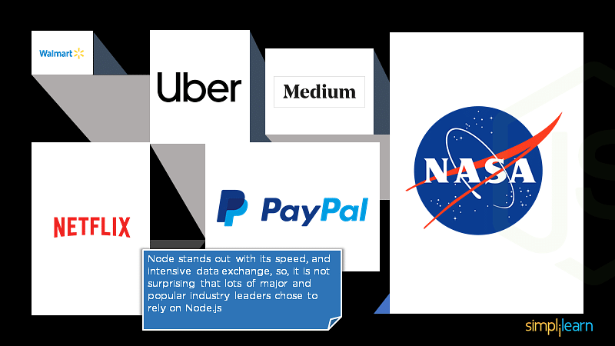
Fig: Node.js use cases

1.Netflix

Fig: Netflix
-Netflix, the world's leading online entertainment network with more than 167 million users, is one of many top companies trusting Node.js for their servers. The reasons why the company chose to use Node.js include:
- Application scalability
- Data-intensive application
2.Walmart

Fig: Walmart
-Walmart is the world's largest company by revenue, with US$ 559 billion in 2020, according to Forbes. Walmart chose Node.js because of the following attributes:
- Asynchronous I/O
- Efficient handling of concurrent requests
Want a Top Software Development Job? Start Here!
Full Stack Developer - MERN StackExplore Program
3.Uber
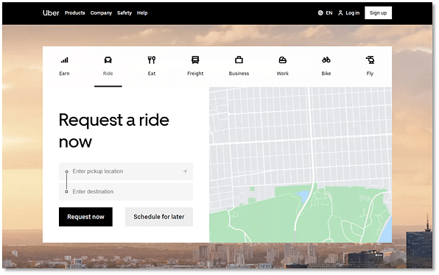
Fig: Uber
Uber is a U.S.-based, multinational ride-hailing company offering services that include peer-to-peer ridesharing, ride service hailing, and food delivery. The reasons why the company chose to use Node.js include:
- Asynchronous I/O
- Quick iterations
- Active open-source community

4.NASA

Fig: NASA
NASA, an independent agency of the United States Federal Government, is responsible for the civilian space program, as well as aerospace and aeronautics research. NASA chose to use Node.js for the following reasons:
- Reduced access times
- Ability to handle data-intensive tasks
- Capability to keep the server active 24/7
5.Paypal

Fig: Paypal
PayPal is a U.S.-based company operating a global online payment system that supports online money transfers, that is serving as an electronic alternative to traditional paper methods like checks and money orders. PayPal chose to use Node.js for the following reasons:
- Extremely fast build times
- Fewer lines of code
- Ability to handle large amounts of data
6.Medium

Fig: Medium
Medium is a popular online publishing platform developed by Evan Williams and launched in August 2012. The reasons why the company chose to use Node.js include the following:
- Data-driven applications
- Ability to run A/B tests
- Simple server maintenance

NODE JS INSTALLATION
-Node.js can be installed in multiple ways on a computer. The approach used by you depends on the existing Node.js development environment in the system. There are different package installers for different environments.
-You can install Node.js by grabbing a copy of the source code and compiling the application. Another way of installing Node.js is by cloning the Node.js GIT repository in all three environments and then installing it on the system












NodeJs Architecture

-Now that we established what is Node, let’s dig into its architecture. Node.js operates on a single-thread, allowing it to handle thousands of simultaneous event loops. Here’s a diagram, provided by Sinform.com, that best illustrates Node.js architecture.
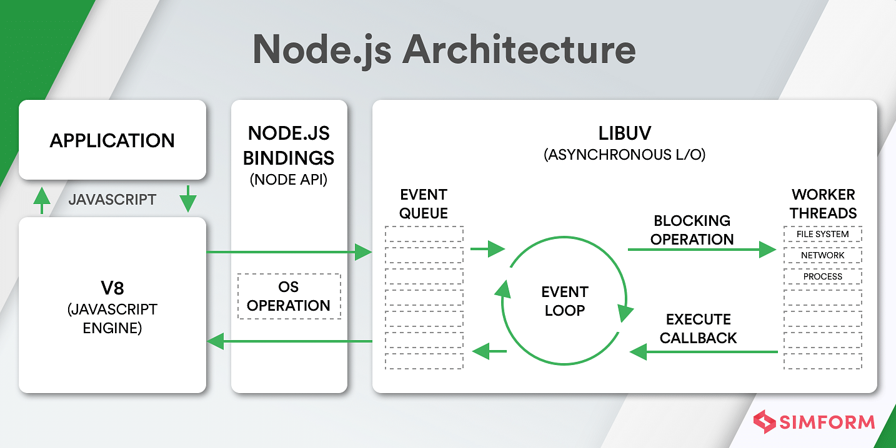
-Node.js uses the “Single Threaded Event Loop” architecture to handle multiple concurrent clients. Node.js Processing Model is based on the JavaScript event-based model along with the JavaScript callback mechanism.
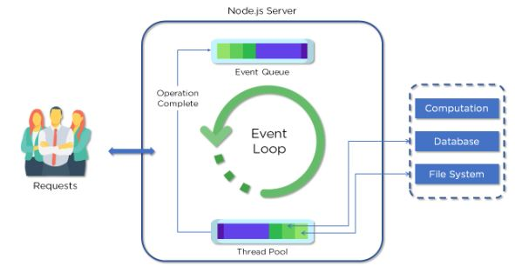
Fig: Node.js architecture
-Now let’s understand each part of the Node.js architecture and the workflow of a web server developed using Node.js.
Parts of the Node.js Architecture:

- Requests
-Incoming requests can be blocking (complex) or non-blocking (simple), depending upon the tasks that a user wants to perform in a web application
- Node.js Server
-Node.js server is a server-side platform that takes requests from users, processes those requests, and returns responses to the corresponding users
- Event Queue
-Event Queue in a Node.js server stores incoming client requests and passes those requests one-by-one into the Event Loop
- Thread Pool
-Thread pool consists of all the threads available for carrying out some tasks that might be required to fulfill client requests
- Event Loop
-Event Loop indefinitely receives requests and processes them, and then returns the responses to corresponding clients
- External Resources
-External resources are required to deal with blocking client requests. These resources can be for computation, data storage, etc.

The Workflow of Node.js Architecture:

-A web server developed using Node.js typically has a workflow that is quite similar to the diagram illustrated below. Let’s explore this flow of operations in detail.
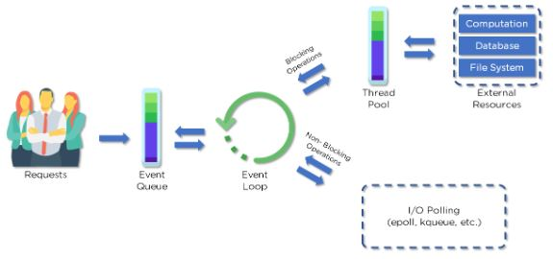
Fig: Node.js Architecture Workflow
- Clients send requests to the webserver to interact with the web application. Requests can be non-blocking or blocking:
-Querying for data
-Deleting data
-Updating the data
- Node.js retrieves the incoming requests and adds those requests to the Event Queue
- The requests are then passed one-by-one through the Event Loop. It checks if the requests are simple enough to not require any external resources
- Event Loop processes simple requests (non-blocking operations), such as I/O Polling, and returns the responses to the corresponding clients
-A single thread from the Thread Pool is assigned to a single complex request. This thread is responsible for completing a particular blocking request by accessing the external resources, such as compute, database, file system, etc.
-Once, the task is carried out completely, the response is sent to the Event Loop that in turn sends that response back to the Client.

Advantages of Node.js Architecture

-Node.js Architecture comes with several advantages that give the server-side platform a distinct upper-hand when compared to other server-side languages:
- Handling multiple concurrent client requests is fast and easy
-With the use of Event Queue and Thread Pool, the Node.js server enables efficient handling of a large number of incoming requests.
- No need for creating multiple threads
-Event Loop handles all requests one-by-one, so there is no need to create multiple threads. Instead, a single thread is sufficient to handle a blocking incoming request.
- Requires fewer resources and memory
-Node.js server, most of the time, requires fewer resources and memory due to the way it handles the incoming requests. Since the requests are processed one at a time, the overall process becomes less taxing on the memory.
Disadvantages of Node.js Server Architecture

-here are the disadvantages of Node.js server architecture in a more concise format:
- Single-Threaded: Limited to one thread; can be a bottleneck for CPU-intensive tasks.
- Callback Hell: Complex nesting of callbacks can lead to hard-to-maintain code.
- Performance Bottlenecks: Not optimal for heavy computational tasks due to non-blocking I/O model.
- Dependency on Outside Libraries: Heavy reliance on third-party libraries can impact stability and security.
- Inconsistent API: Frequent API changes can lead to backward compatibility issues.
- Lack of Strong Typing: JavaScript’s lack of strong typing can lead to runtime errors and bugs.

PARTS OF NODE.JS

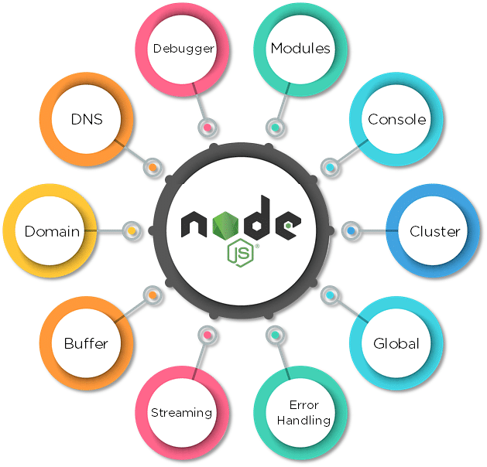

1.Modules

-Modules are like JavaScript libraries that can be used in a Node.js application to include a set of functions. In order to include a module in a Node.js application, use the require() function with the parenthesis containing the name of the module.
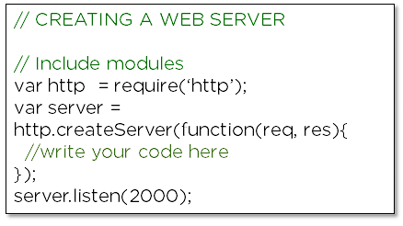
Fig: Include a module in Node.js
-Node.js has many modules that provide the basic functionality needed for a web application. Some of them are mentioned in this table:
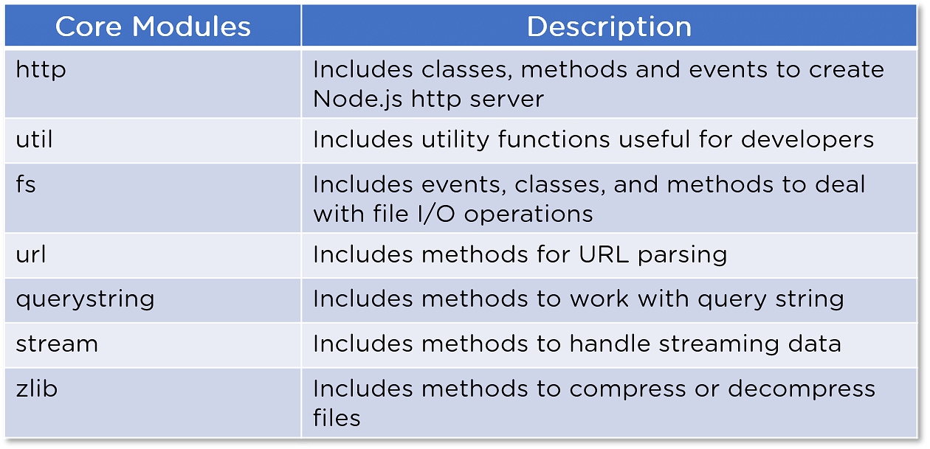
Fig: Node.js modules table

2.Console

-The console is a module that provides a method for debugging that is similar to the basic JavaScript console provided by internet browsers. It prints messages to stdout and stderr.
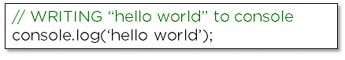
Fig: Node.js console

3.Cluster

-Node.js is built-on on the concept of single-threaded programming. Cluster is a module that allows multi-threading by creating child processes that share the same server port and run simultaneously.
-A cluster can be added to an application in the following way:
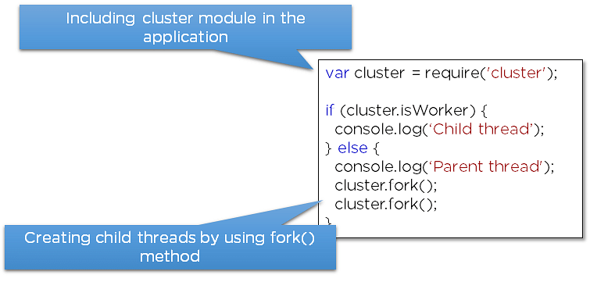
Fig: Add cluster in Node.js

4.Global

-Global objects in Node.js are available in all modules. These objects are functions, modules, strings, etc. Some Node.js global objects are mentioned in the table below:
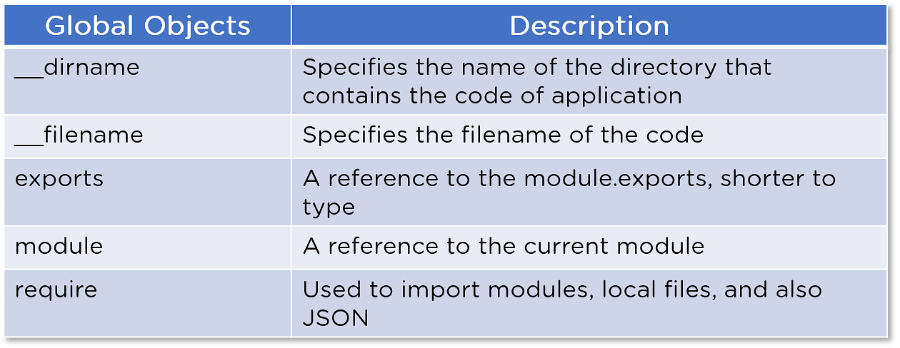
Fig: Global objects table
5.Error Handling

-Node.js applications experience four types of errors.
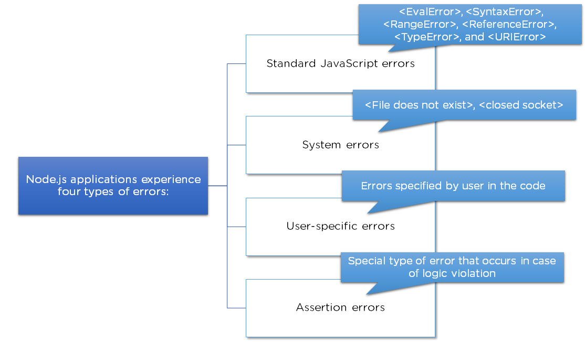
Fig: Node.js errors
-Errors in Node.js are handled through exceptions. For example, let's handle the error that would occur when we divide a number by zero. This error would crash the Node.js application, so we should handle this error to continue with the normal execution of the application./l
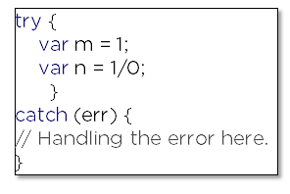Fig: Node.js error handling
6.Streaming

-Streams are the objects that let you read data or write data continuously. There are four types of streams:
- Readable: These are the types of streams from which data can be read
- Writable: These are the types of streams to which data can be written
- Duplex: These are both readable and writable streams
- Transform: Streams that can manipulate the data while it is being read or written.
7.Buffer

-Buffer is a module that allows the handling of streams that contain only binary data. An empty buffer of length '10' can be created by this method:
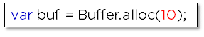
Fig: Node.js buffer
8.Domain

-The domain module intercepts errors that remain unhandled. Two methods are used for intercepting these errors:
- Internal Binding: Error emitter executes its code inside the run method
- External Binding: Error emitter is explicitly added to a domain via its add method
9.DNS

-DNS module is used to connect to a DNS server and perform name resolution by using the following method:
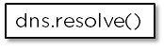
Fig: DNS resolve
-DNS module is also used for performing name resolution without a network communication by using the following method:

Fig: DNS lookup
10.Debugger

-Node.js includes a debugging utility that can be accessed by a built-in debugging client. Node.js debugger is not feature-packed but supports the simple inspection of code. The debugger can be used in the terminal by using the 'inspect' keyword before the name of the JavaScript file. In order to inspect a file—myscript.js, for example—you can follow this method:

Fig: Node.js debugger
-Now that we are familiar with the main parts of Node.js let's go ahead and learn about the Node.js Express framework.

JAVASCRIPT ENGINES
-JavaScript is a scripting language and is not directly understood by computer but the browsers have inbuilt JavaScript engine which help them to understand and interpret JavaScript codes.
-These engines help to convert our JavaScript program into computer-understandable language.
-A JavaScript engine is a computer program that executes JavaScript code and converts it into computer understandable language.
List of JavaScript Engines:
Browser | Name of Javascript Engine
Google Chrome | V8
Edge (Internet Explorer) | Chakra
Mozilla Firefox | Spider Monkey
Safari | Javascript Core Webkit

1. V8: V8 is a JavaScript engine developed by the Chromium Project for Google Chrome and Chromium web browsers. It is a JavaScript engine that can run standalone, or be embedded into any C++ application. Using its own parser, it generates an abstract syntax tree. Then, Ignition generates bytecode from this syntax tree using the internal V8 bytecode format. Bytecode is compiled into machine code by TurboFan. It also handles memory allocation for objects, and garbage collects objects it no longer needs. Optimization techniques such as elision of expensive runtime properties, and inline caching. The garbage collector is a generational incremental collector.
-V8 provides an edge as it allows JavaScript to run much faster, which improves users’ experience of the web, paves the way for the development of web applications, and spurs rapid growth of server-side JavaScript through projects like Node.js.
2. Chakra: Chakra is a JScript engine developed by Microsoft. It is proprietary software. It is used in the Internet Explorer web browser. A distinctive feature of the engine is that it JIT compiles scripts on a separate CPU core, parallel to the web browser.
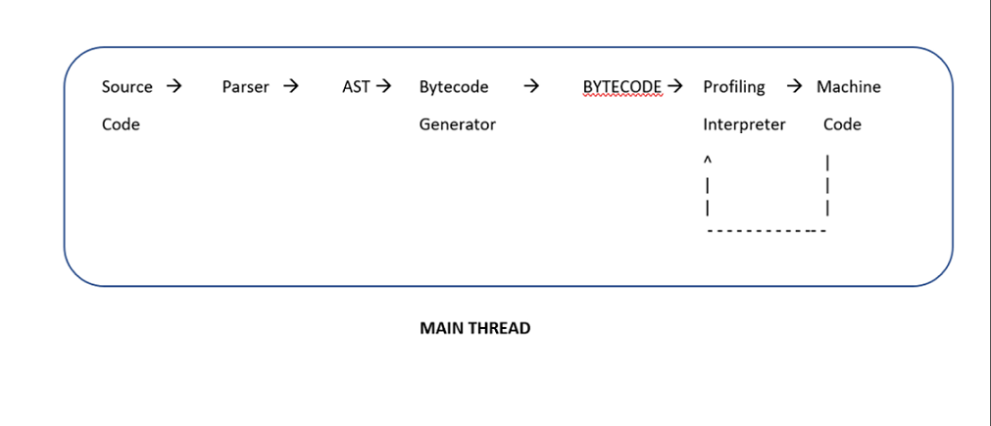
3. Spider Monkey: SpiderMonkey is the first JavaScript engine, written by Brendan Eich at Netscape Communications, later released as open-source and currently maintained by the Mozilla Foundation. It is still used in the Firefox web browser.
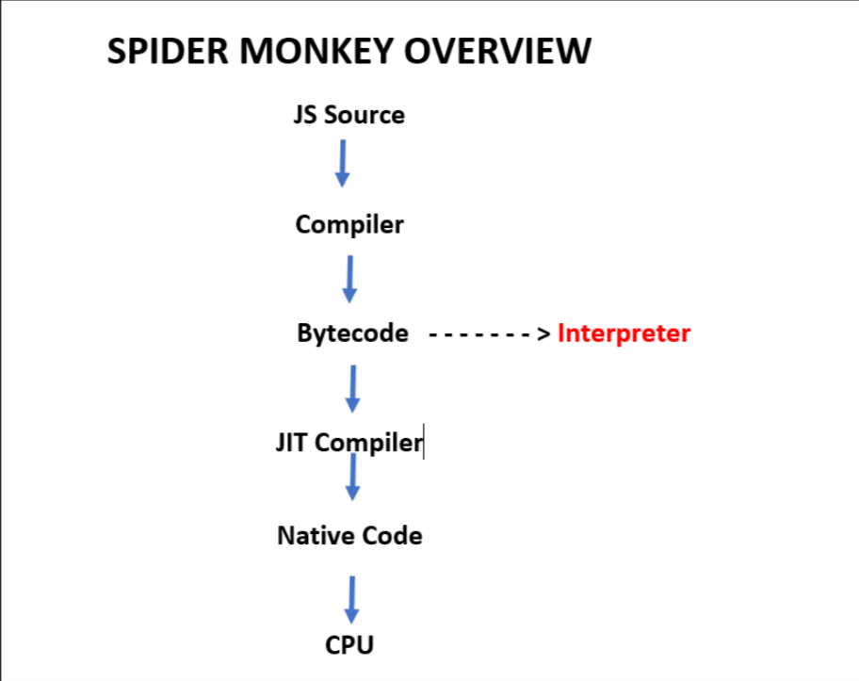

4. Webkit: WebKit is developed by Apple and used in its Safari web browser, as well as all iOS web browsers. It is used by the BlackBerry Browser, PlayStation consoles beginning from the PS3, the Tizen mobile operating systems, and a browser included with the Amazon Kindle e-book reader. WebKit’s C++ Application Programming Interface (API) provides a set of classes to display Web content in windows and implements browser features such as following links when clicked by the user, managing a back-forward list, and managing a history of pages recently visited.
JavaScript is one of the 3 languages all web developers must learn:
1. HTML to define the content of web pages
2. CSS to specify the layout of web pages

CHROME V8 ENGINE

-V8 is Google's open source JavaScript engine.
-V8 implements ECMAScript as specified in ECMA-262.
-V8 is written in C++ and is used in Google Chrome, the open source browser from Google.
-V8 can run standalone, or can be embedded into any C++ application.
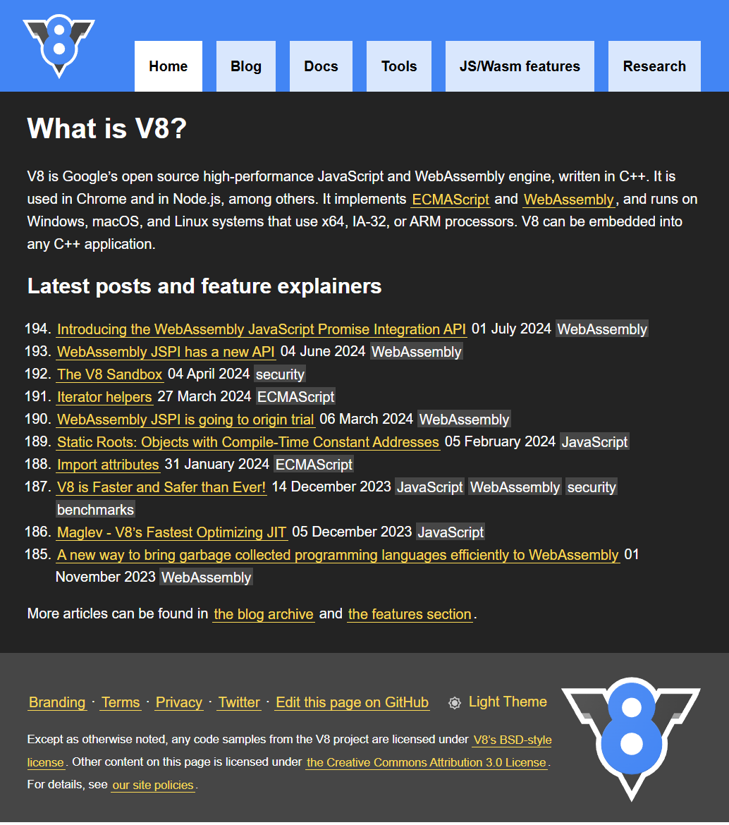
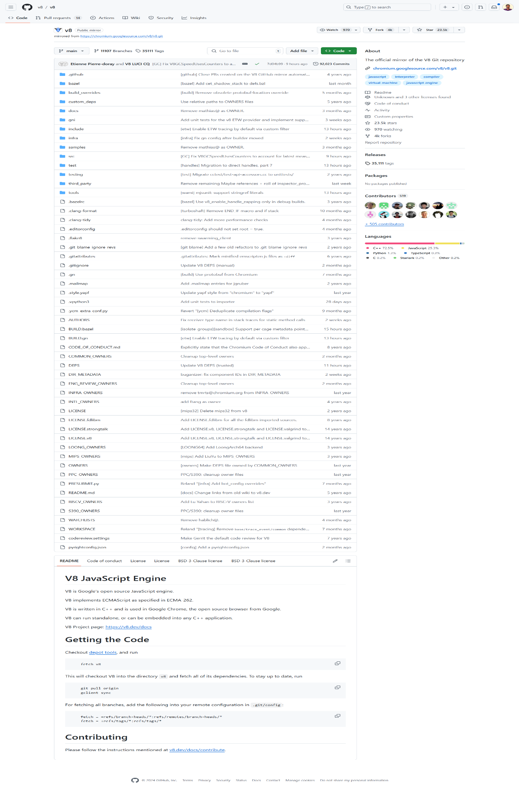
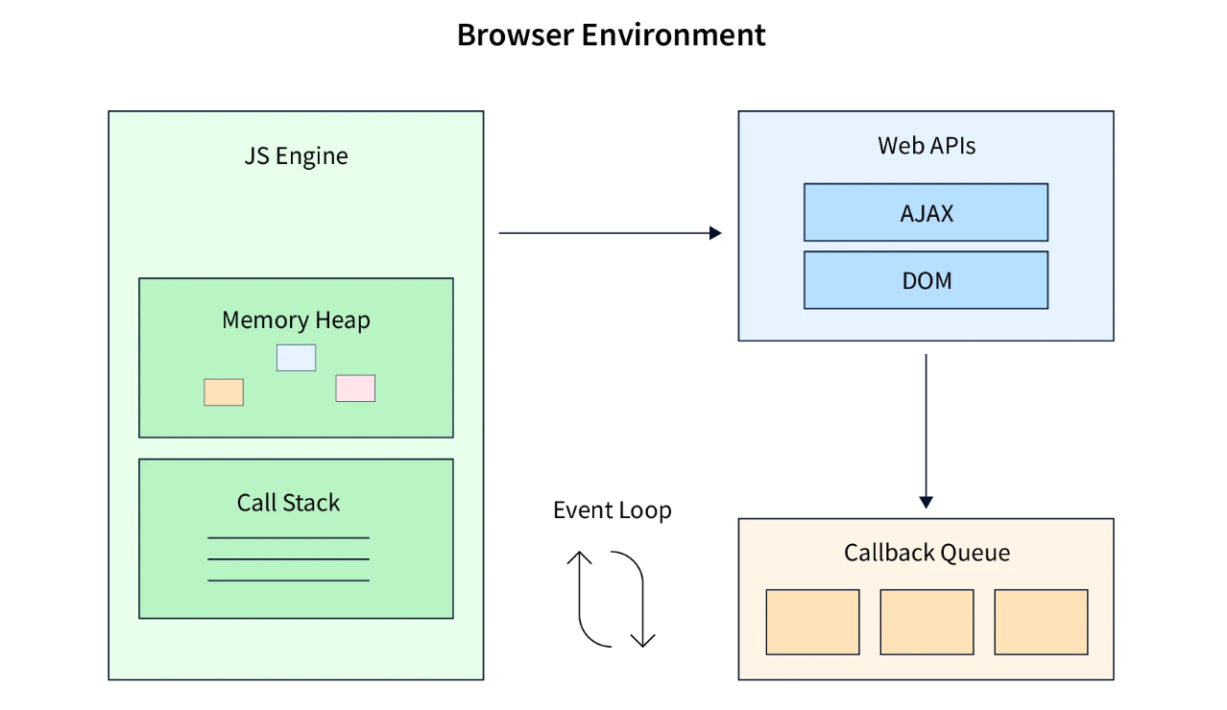
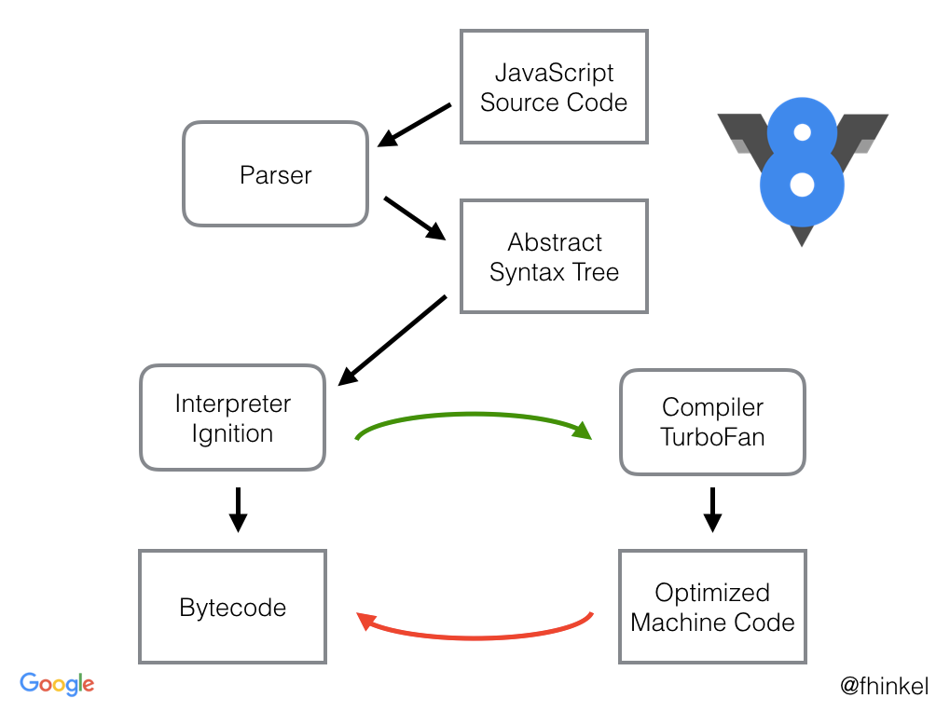
-Javascript code we write cannot be understood by the computer.
-A Javascript engine is a program that converts Javascript code the developers write into machine code that allows a computer to perform a specific tasks.
-A Javascript engine is a program that executes Javascript code.
-In 2008 Google created its own Javascript engine called V8.
-By embedding V8 into your own C++ application you can write C++ code that getes executed when a user writes Javascript code.
-You can add new features to Javascript Itself.
-Since C++ is great for lower level operations like file handling, database connectivity and Network operations, by embedding V8 into your won C++ program you have the power to add all of the functionality in Javscript.
-The C++ program we are talking about the NodeJs.
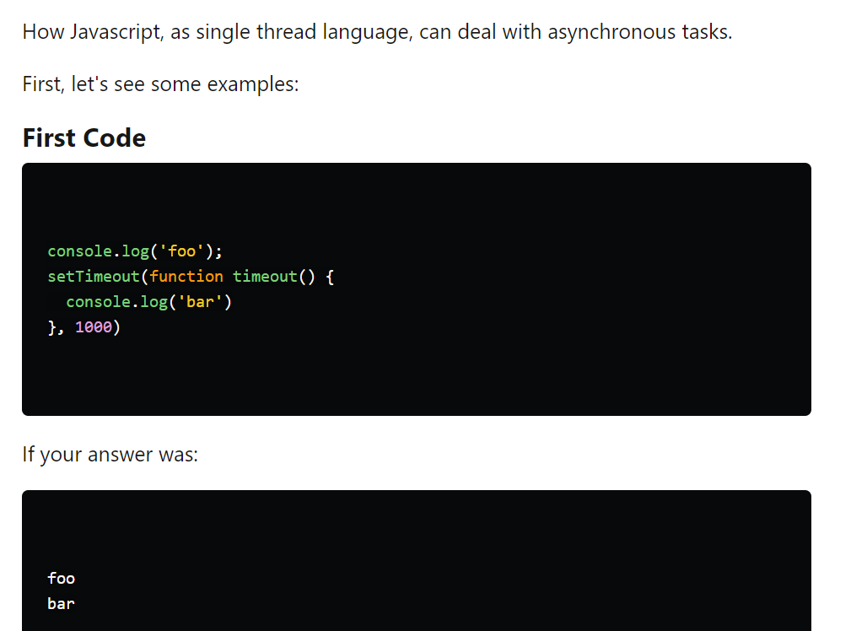


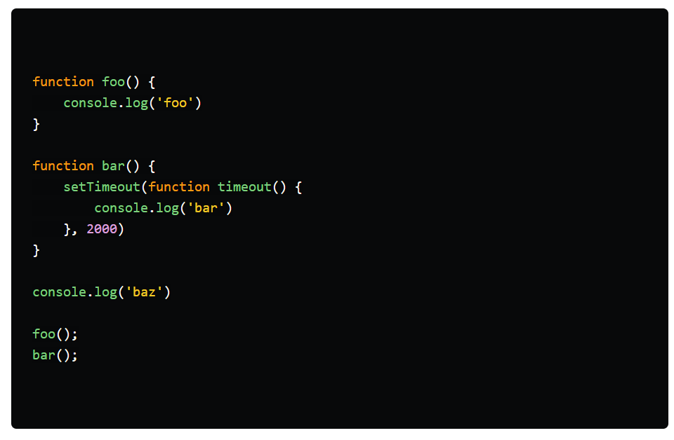
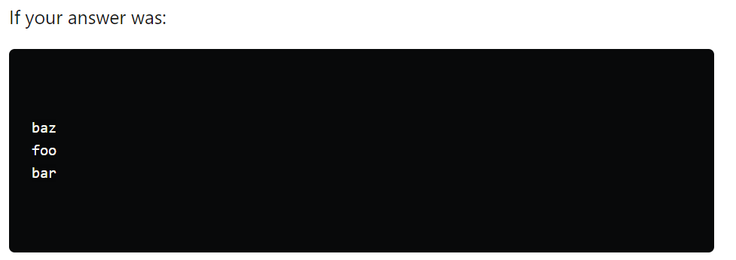


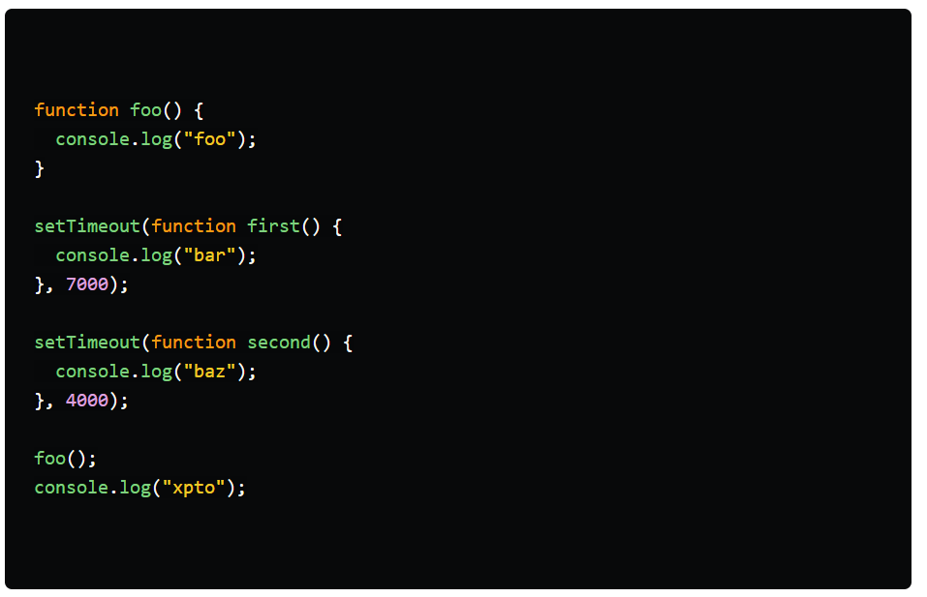
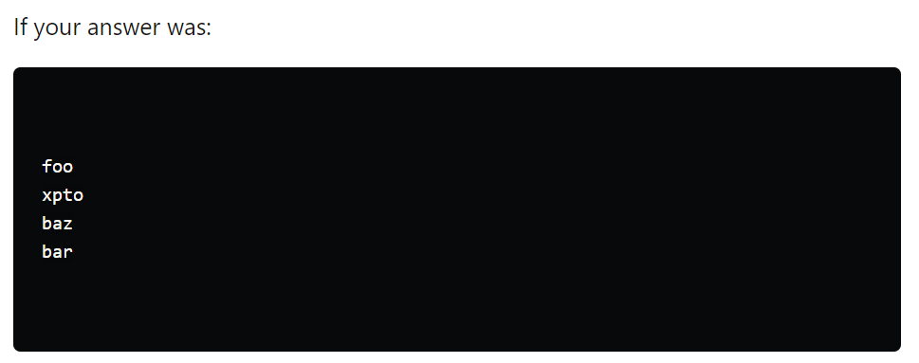

There are four "entites", that we need to know on Javascript Engines, the main focus will be on V8 Engine:
- CallStack
- WebApis or LIBUV (C++ library) - and this is a big spoiler
- Callback Queue or Event Queue
- Event Loop
Let's talk one by one:
1.CALL STACK

-Every command that is read on JS is inserted on a stack, fist in, last out (FILO) (that we called CallStack). So all commands like console.log, function call are pushed on this stack.
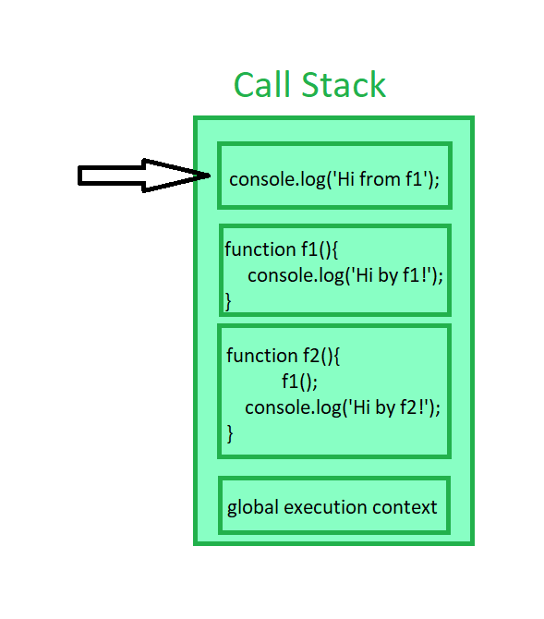
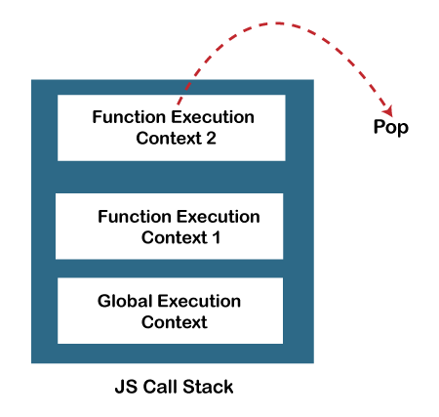

-In JavaScript, the call stack is a data structure that keeps track of the execution context of functions. It operates on a Last-In-First-Out (LIFO) principle, meaning the last function called is the first one to finish executing.

<script>
function foo() {
console.log("Inside foo");
bar();
}

function bar() {
console.log("Inside bar");
}

foo();
</script>

Call Stack Progression:
- foo() is called, and its execution context is pushed onto the call stack.
- console.log("Inside foo") executes.
- bar() is called, and its execution context is pushed onto the stack.
- console.log("Inside bar") executes.
- bar() completes, its context is popped off the stack.
- foo() completes, its context is popped off the stack.
-Why it's important:
-Function Execution Order: The call stack ensures that functions are executed in the correct order.
-Error Tracking: When an error occurs, the call stack provides a trace of the function calls leading to the error, making debugging easier.
-Recursion: The call stack enables recursive function calls, where a function calls itself.
Stack Overflow:
-If the call stack grows too large, it can lead to a "stack overflow" error. This often happens when a recursive function calls itself indefinitely without a proper base case to stop the recursion.

Role of JavaScript Call Stack
There are the following points where the call stack is being used by the JS engine:
-When any script is executed by the user, the JS engine creates a Global execution context and then adds it on the call stack and at the top of the stack so that it may get executed.
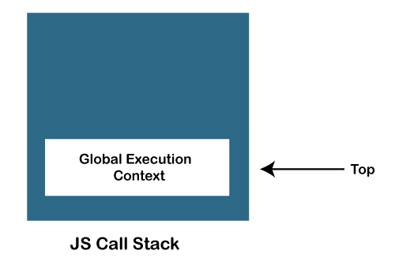
-When any function is invoked, the JS engine creates a Function execution context and adds it on the stack and at the top of the stack so that the invoked function may get executed.
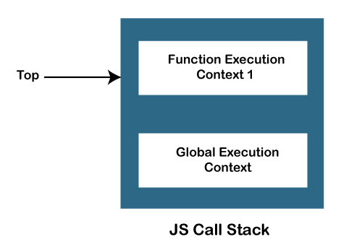
-In case a function invokes another function, the JS engine creates a Function execution context for the invoked function, adds it to the top of the stack, and begins the execution.
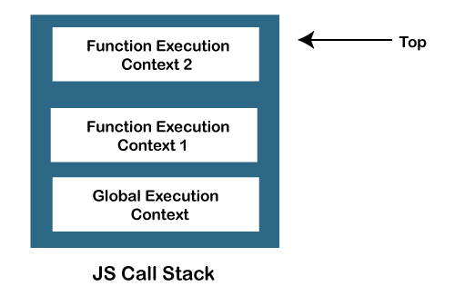
When any function execution gets completed, the JS engine pops it out of the stack and continues the execution of the other functions stored in the stack.

If no space is left in the stack and we try to push more functions, it throws a "stack overflow" error, and if no further execution context is present in the call stack, it throws a "Stack Underflow" error.

JavaScript call stack example
Let’s start with the following example:
function add(a, b) {
return a + b;
}

function average(a, b) {
return add(a, b) / 2;
}

let x = average(10, 20);
Code language: JavaScript (javascript)
-When the JavaScript engine executes this script, it places the global execution context (denoted by main() or global() function on the call stack.
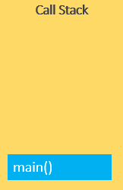
-The global execution context enters the creation phase and moves to the execution phase.
-The JavaScript engine executes the call to the average(10, 20) function and creates a function execution context for the average() function and pushes it on top of the call stack:
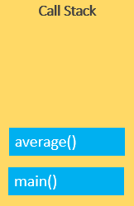
-The JavaScript engine starts executing the average() since because the average() function is on the top of the call stack.
-The average() function calls add() function. At this point, the JavaScript engine creates another function execution context for the add() function and places it on the top of the call stack:
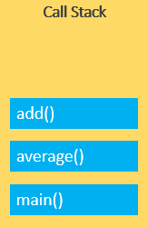
-JavaScript engine executes the add() function and pops it off the call stack:
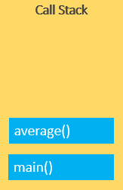
-At this point, the average() function is on the top of the call stack, the JavaScript engine executes and pops it off the call stack.
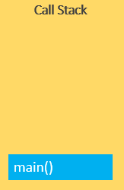
-Now, the call stack is empty so the script stops executing:


-The following picture illustrates the overall status of the Call Stack in all steps:
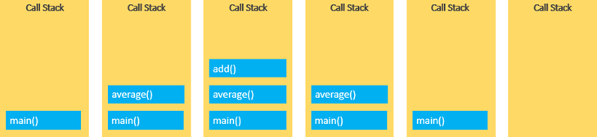

2. WebApis or Libuv

-In Node.js, Web APIs and libuv play crucial roles in enabling its non-blocking, asynchronous I/O model. Here's an explanation of each:
1.Web APIs
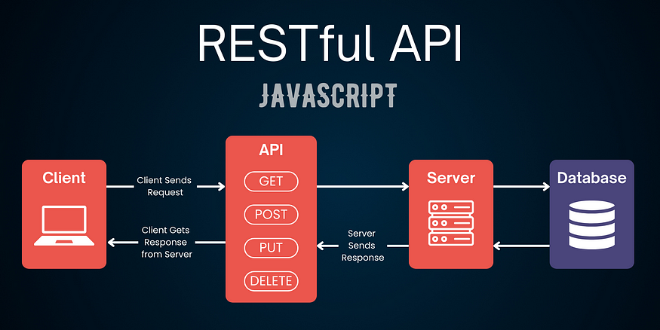
- These are a set of JavaScript APIs provided by the browser environment, allowing you to interact with various functionalities such as the DOM, network requests, timers, and more.
- They are not part of the Node.js runtime itself.
- When you use these APIs in a browser, the browser handles the asynchronous operations behind the scenes, allowing your JavaScript code to continue executing without blocking.
What is Web API?
-API stands for Application Programming Interface.
-A Web API is an application programming interface for the Web.
-A Browser API can extend the functionality of a web browser.
-A Server API can extend the functionality of a web server.

2.Libuv
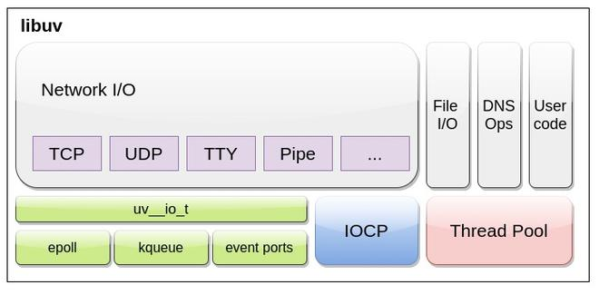
- libuv is a C library originally written for Node.js to abstract non-blocking I/O operations.
- Event-driven asynchronous I/O model is integrated.
- It allows the CPU and other resources to be used simultaneously while still performing I/O operations, thereby resulting in efficient use of resources and network.
- It facilitates an event-driven approach wherein I/O and other activities are performed using callback-based notifications.
Role of Libuv:
- Event Loop:
  - The event loop in Node.js, powered by Libuv, manages asynchronous operations like reading files, handling network requests, and executing timers.
- Thread Pool:
  - For blocking tasks like file I/O and DNS lookups, Libuv delegates operations to a thread pool, allowing the main thread to remain non-blocking.
- Cross-Platform Abstraction:
  - Libuv provides a unified API for interacting with operating system features, regardless of the underlying platform (Windows, Linux, macOS).
Examples of Tasks Handled by Libuv:
- File system operations (e.g., reading or writing files using the fs module).
- Networking tasks (e.g., handling TCP/UDP connections).
- Timers (e.g., setTimeout and setInterval).
- Child processes (e.g., spawning processes with the child_process module).

Example: If a program is querying the database, the CPU sits idle until the query is processed and the program stays at a halt, thereby causing wastage of system resources. To prevent this, libuv is used in Node.js which facilitates a non-blocking I/O.
It also has mechanisms to handle services like File System, DNS, network, child processes, pipes, signal handling, polling, and streaming.
To perform blocking operations that can’t be done asynchronously at OS level, libuv also includes a thread pool to distribute CPU loads.
Features of libuv:
- Full-featured event loop backed by epoll (Linux), kqueue (OSX), IOCP (Windows), event ports (SunOS).
- Asynchronous TCP (net module) and UDP (dgram module)
- Asynchronous DNS resolution (used partly for the dns module)
- Asynchronous file, file system operations & events (fs module)
- ANSI escape code controlled TTY
- Thread pool and Signal handling
- Child processes
- High-resolution clock
- Threading and synchronization primitives.
- Inter-Process Communication using sockets and Unix domain sockets (Windows)

How They Work Together:
- When you use a Web API-like setTimeout in Node.js, the JavaScript code is executed by V8.
- V8 then hands over the asynchronous operation (the timer in this case) to libuv.
- libuv manages the asynchronous operation using its event loop and underlying system calls.
- Once the operation is complete, libuv signals the event loop to execute the corresponding callback function.
- The event loop then executes the callback function within the JavaScript runtime (V8).
In summary:
- Web APIs: are the JavaScript interfaces for interacting with asynchronous operations in the browser.
- libuv: is the C library that provides the underlying implementation of the event loop and asynchronous I/O in Node.js.
- Together, they enable Node.js to achieve its high-performance, non-blocking I/O model.

3. Callback Queue or Event Queue

-Both names represents the structure where the callbacks of WebApis are stored after finish the execution.
-The Callback Queue (also called the Event Queue) is a data structure where callbacks or event handlers are placed when an asynchronous operation completes (e.g., a setTimeout, network request, or I/O operation).
-These callbacks are waiting to be executed by the Event Loop, which manages the flow of operations.
How It Works:
- Asynchronous Operation Starts:
  - When you invoke an asynchronous function (e.g., setTimeout, fetch, or fs.readFile in Node.js), the function registers a callback and delegates the operation to the underlying runtime (like Libuv in Node.js or Web APIs in the browser).
- Callback Queued:
  - Once the asynchronous task completes, its associated callback is placed into the Callback Queue.
- Event Loop Executes:
  - The Event Loop checks the Call Stack and processes the Callback Queue if the stack is empty, dequeuing the callback and executing it.
Key Characteristics of the Callback/Event Queue:
FIFO (First In, First Out):
-Callbacks are processed in the order they are queued.
Single-Threaded Execution:
-The Event Loop processes one callback at a time to maintain JavaScript's single-threaded nature.
Not Immediate:

Even if an operation finishes instantly, its callback won't execute until the Call Stack is clear.
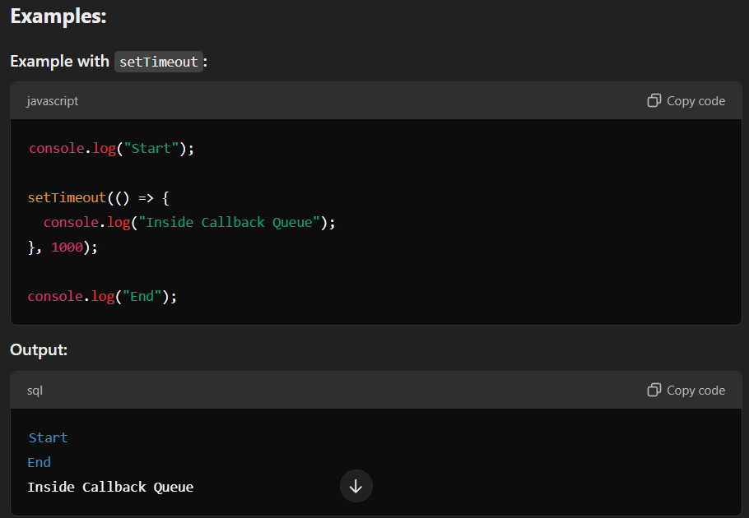
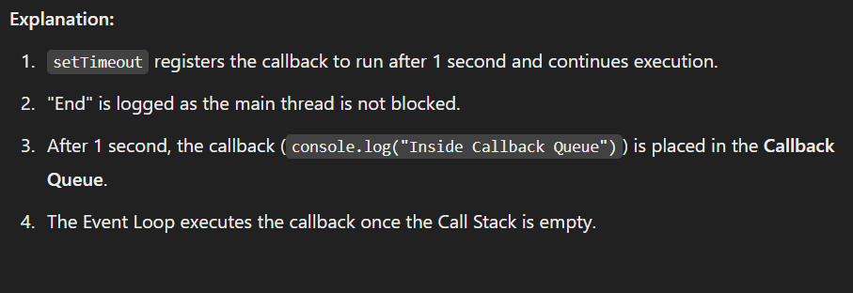
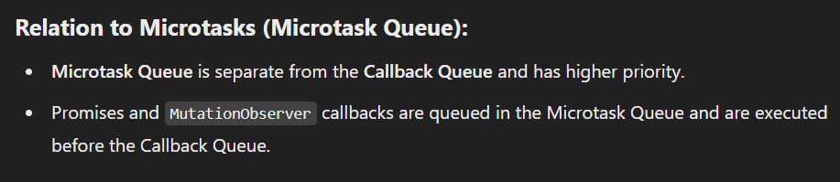
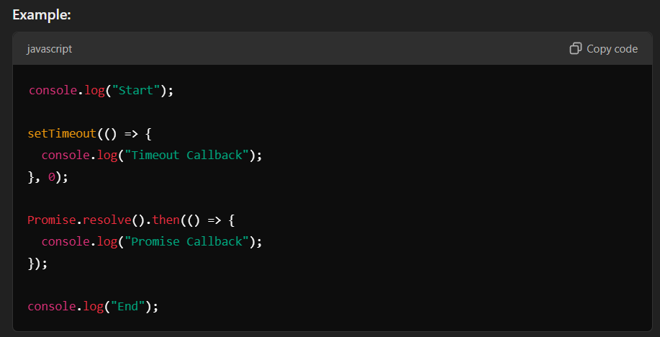
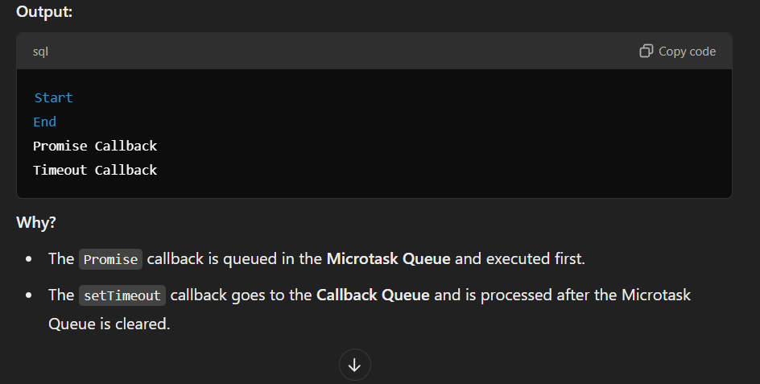
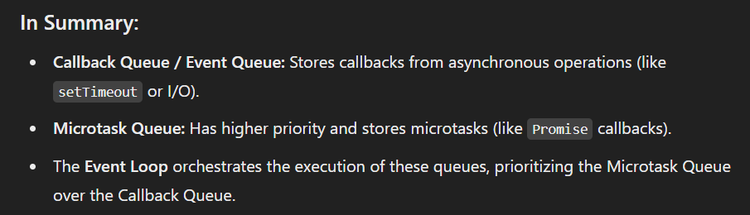

4.EVENT LOOP
-In Node, the Event Loop is a mechanism that handles asynchronous operations. It allows Node to perform non-blocking I/O operations despite the fact that JavaScript is single-threaded. It continuously checks the call stack and message queue, executes tasks from stack processing asynchronous operations.
-He is responsible to monitor the CallStack and Event Queue to execute the asynchronous process. Think the Event Loop as a "for(;;) or while(true)", that will always be monitoring the execution process and allow to we work with asynchronous tasks on Javascript.
The event loop takes precedence over some structures. The event loop will only run the event queue tasks when the callback stask is empty
We can see the model of this architecture on this example:
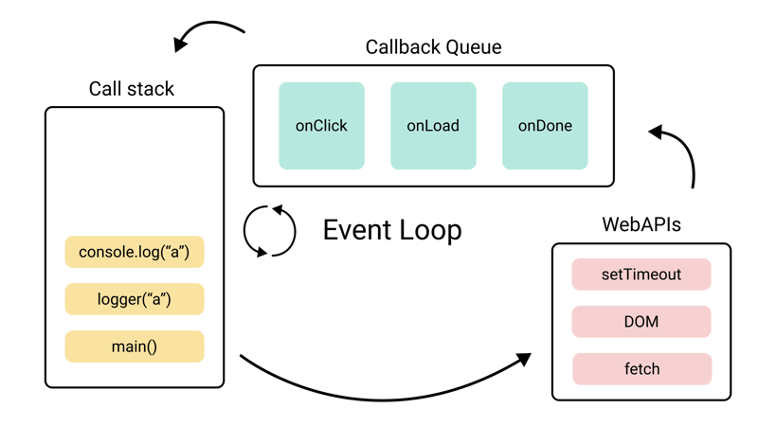
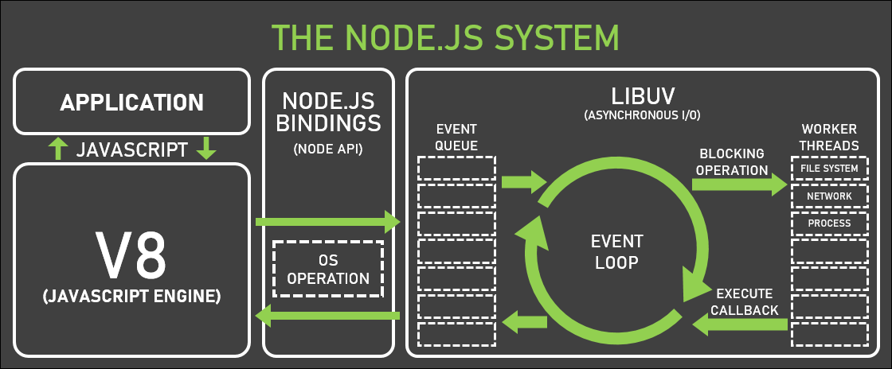
Why Event Loop is important?
-Most operating systems are multi-threaded and hence can handle multiple operations executing in the background. When one of these operations is completed, the kernel tells Node.js, and the respective callback assigned to that operation is added to the event queue which will eventually be executed.
Features
- An event loop is an endless loop, which waits for tasks, executes them, and then sleeps until it receives more tasks.
- The event loop executes tasks from the event queue only when the call stack is empty i.e. there is no ongoing task.
- The event loop allows us to use callbacks and promises.
- The event loop executes the tasks starting from the oldest first.
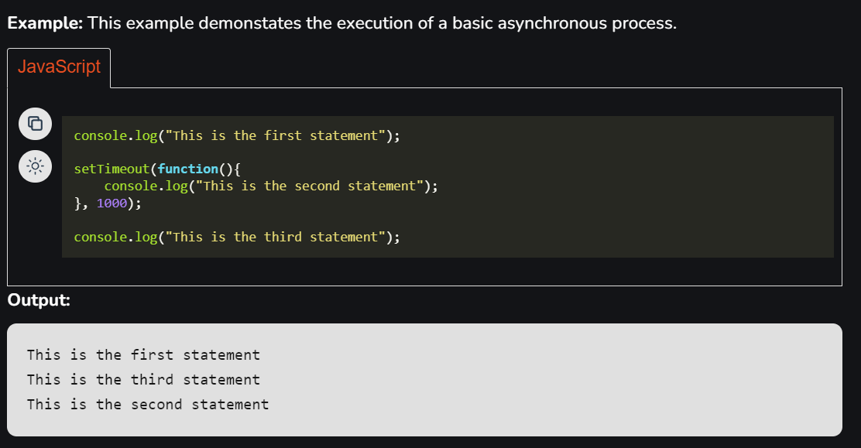
Explanation:
-In the above example, the first console log statement is pushed to the call stack, and “This is the first statement” is logged on the console, and the task is popped from the stack.
-Next, the setTimeout is pushed to the queue and the task is sent to the Operating system and the timer is set for the task. This task is then popped from the stack.
-Next, the third console log statement is pushed to the call stack, and “This is the third statement” is logged on the console and the task is popped from the stack.
-When the timer set by the setTimeout function (in this case 1000 ms) runs out, the callback is sent to the event queue.
-The event loop on finding the call stack empty takes the task at the top of the event queue and sends it to the call stack. The callback function for the setTimeout function runs the instruction and “This is the second statement” is logged on the console and the task is popped from the stack.
Note: In the above case, if the timeout was set to 0ms then also the statements will be displayed in the same order. This is because although the callback will be immediately sent to the event queue, the event loop won’t send it to the call stack unless the call stack is empty i.e. until the provided input script comes to an end.

How the Event Loop Works?
-When Node.js starts, it initializes the event loop, processes the provided input script which may make async API calls, schedules timers, then begins processing the event loop. In the previous example, the initial input script consisted of console.log() statements and a setTimeout() function which schedules a timer.
-When using Node.js, a special library module called libuv is used to perform async operations. This library is also used, together with the back logic of Node, to manage a special thread pool called the libuv thread pool. This thread pool is composed of four threads used to delegate operations that are too heavy for the event loop. I/O operations, Opening and closing connections, setTimeouts are examples of such operations.
-When the thread pool completes a task, a callback function is called which handles the error(if any) or does some other operation. This callback function is sent to the event queue. When the call stack is empty, the event goes through the event queue and sends the callback to the call stack.
-The following diagram is a proper representation of the event loop in a Node.js server:
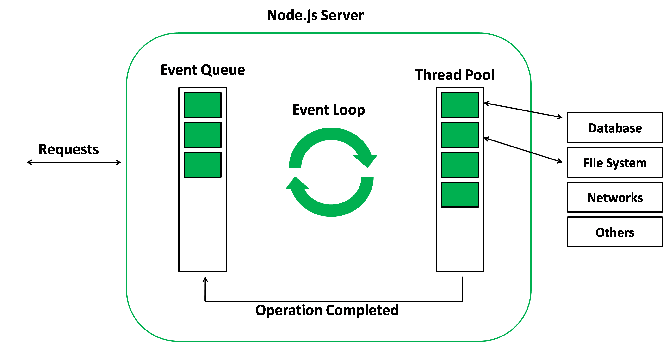

Phases of the Event loop
-The event loop in Node.js consists of several phases, each of which performs a specific task. These phases include:
-The following diagram shows a simplified overview of the event loop order of operations:
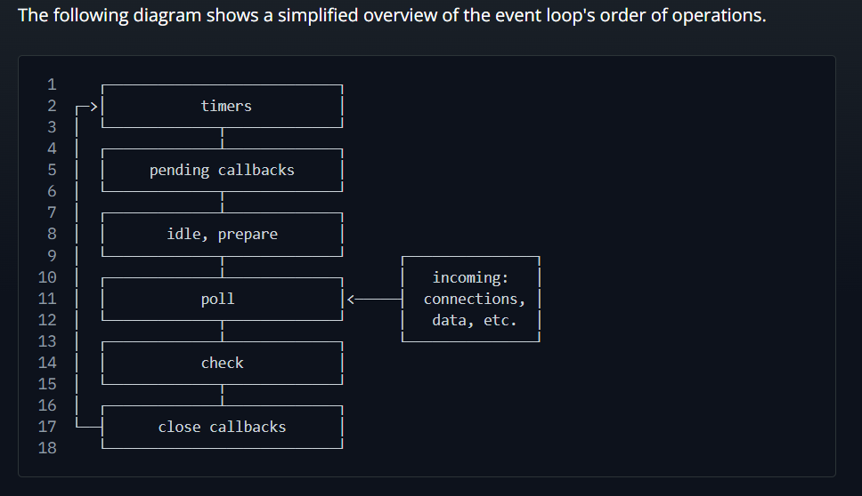

1. Timers:
This phase processes timers that have been set using setTimeout() and setInterval().
Here is an example of how the timers phase works:
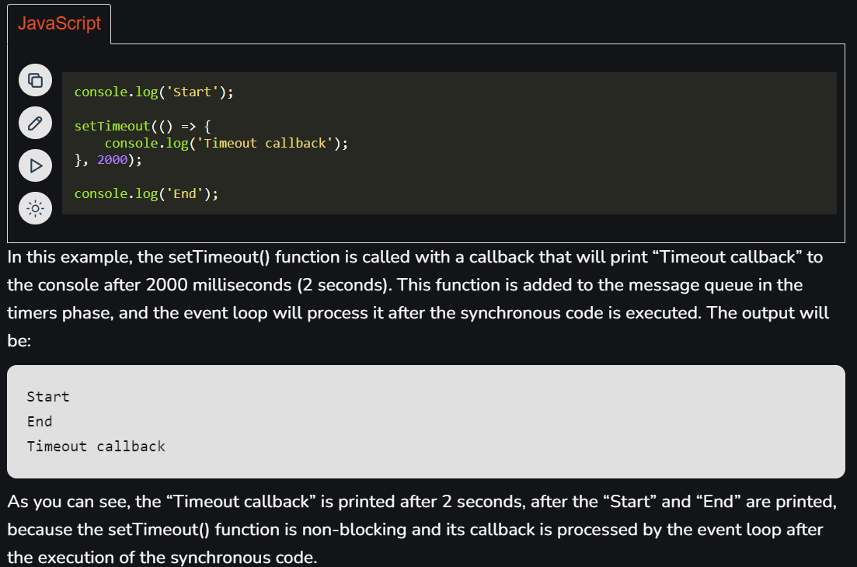
2. Pending Callbacks:
This phase processes any callbacks that have been added to the message queue by asynchronous functions.
Here is an example of how the pending callbacks phase works:
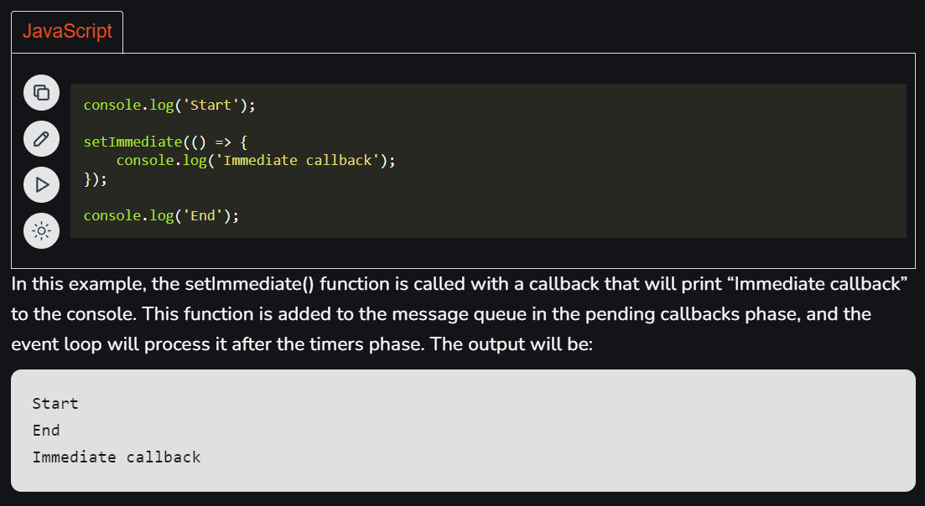

3. Idle, Prepare:
The “idle.ignore” phase is not a standard phase of the event loop in Node.js. It means it’s Used internally only. The “idle” phase is a period of time during which the event loop has nothing to do and can be used to perform background tasks, such as running garbage collection or checking for low-priority events.
“idle.ignore” is not an official phase of the event loop, it is a way to ignore the idle phase, meaning that it will not use the time of the idle phase to perform background tasks.
An example of using idle.ignore can be:
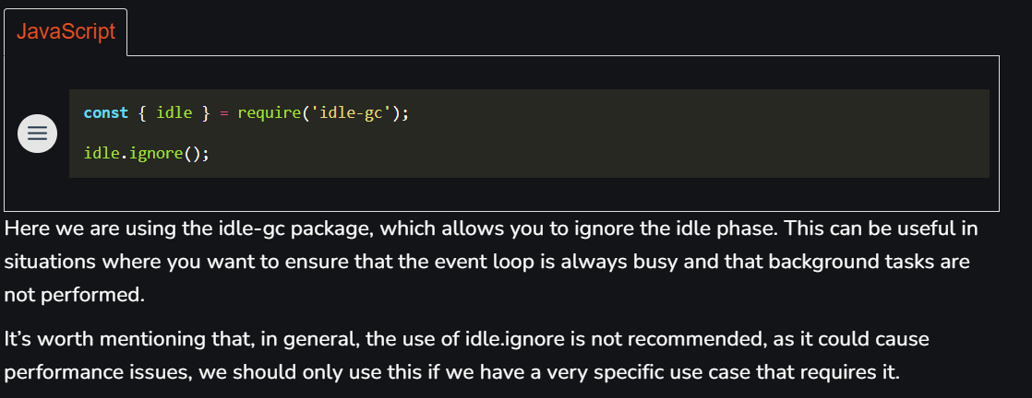

4. Poll:
This phase is used to check for new I/O events and process any that have been detected.
Here is an example of how the poll phase works using a readStream:
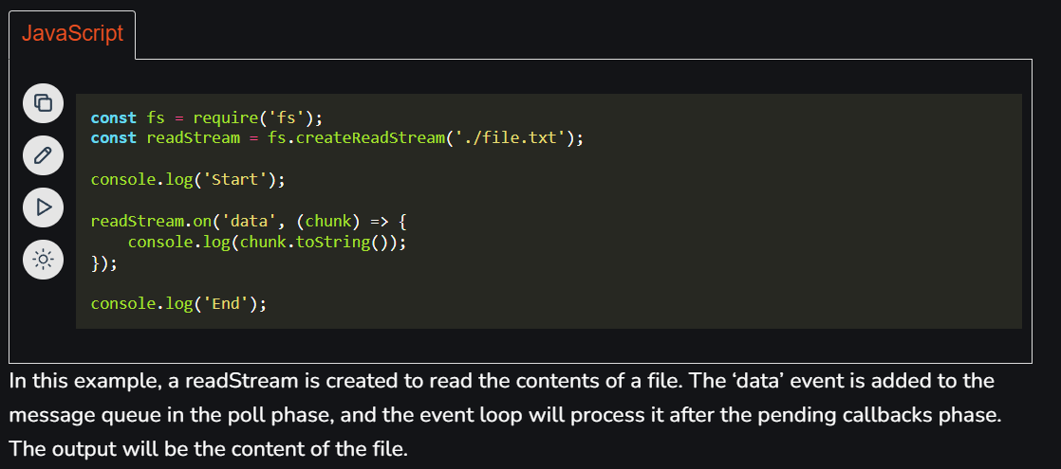
5. Check
This phase processes any setImmediate() callbacks that have been added to the message queue.
Here is an example of how the check phase works:
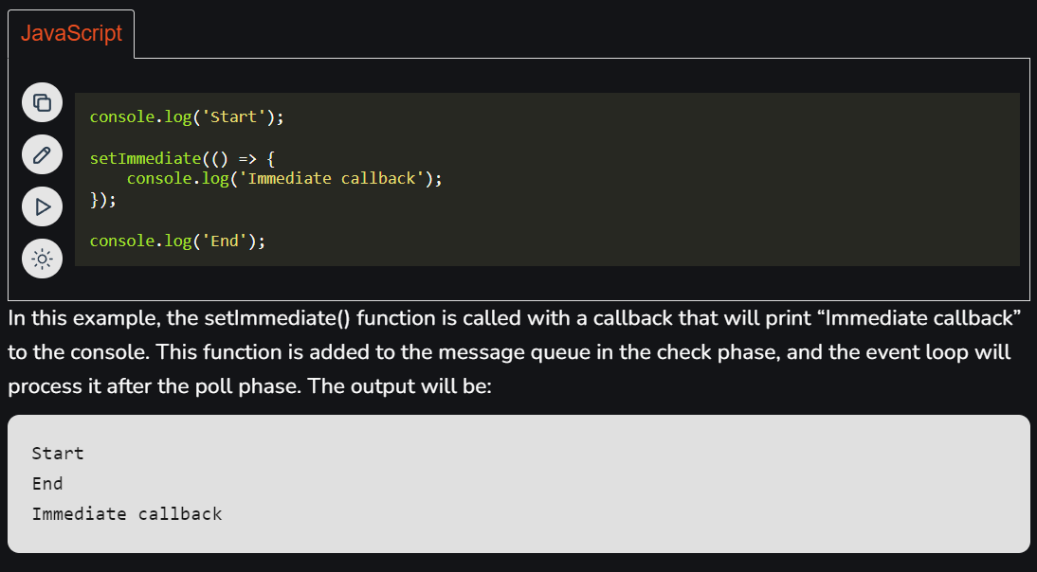

6. Close Callbacks:
This phase processes any callbacks that have been added to the message queue by the close event of a socket. This means that any code that needs to be executed when a socket is closed is placed in the message queue and processed during this phase.
Here is an example of how the close callbacks phase works:
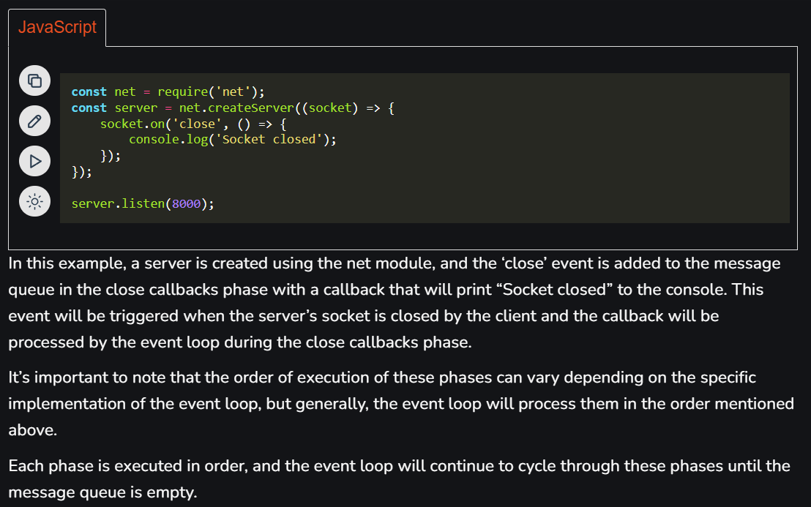
So for the first example:

- The console.log is pushed and executed on callStack
- The setTimeout is pushed on WebApis and process the asynchronous process
- After the process finished, the callback is pushed on Callback Queue
- The Event Loop will realize that there is an event on Call Back Queue and push to Call Stack.

So for the second example:

- The console.log('baz') is pushed and executed on callStack
- The function foo() is pushed and executed on callStack
- The setTimeout inside of bar() function is pushed on WebApis and process the asynchronous process
- After the process finished, the callback is pushed on Callback Queue
- The Event Loop will realize that there is an event on Call Back Queue and push to Call Stack.

So for the third example:

- The console.log('foo') is pushed and executed on Call Stack
- The first setTimeout with 7 seconds is pushed on Web Apis
- The second setTimeout with 4 seconds is pushed on Web Apis
- The console.log('Baz') is pushed and executed on Call Stack
- The second setTimeout finished first and the callback is pushed on Event Queue to be processed.
- Event Loop notice the event on Event Queue and push on Call Stack
- Meanwhile the first setTimeout finished also and the callback is pushed on Event Queue.
- Notice that the Event Loop will not push the callback of the first function, because the Call Stack is not empty.
- After the total execution, the Event Loop push the first callback to the Call Stack to complete.

JAVASCRIPT EXECUTION

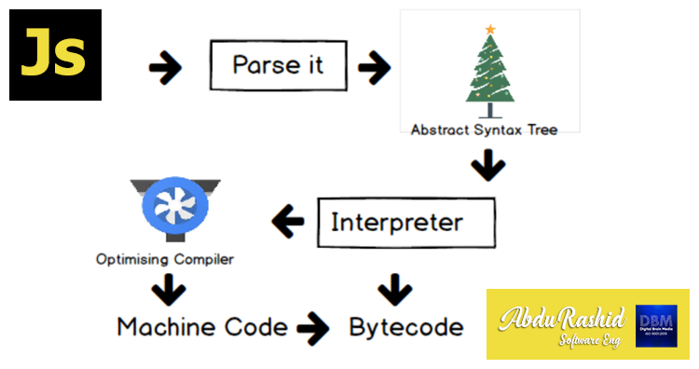
-Then the Render engine, will process the received resourses. After that the Browser Engine will performs data presentation.
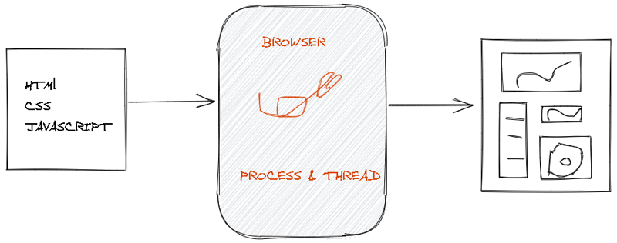
so how all this happen...?
-To know better about these processes, we should know how a browser process JavaScript . And that is done by JavaScript engines.
-A JavaScript engine is a program or an interpreter which executes JavaScript code. JS is a higher level dynamic language and it has no way to directly interact with our machines lower level logic. So JavaScript engine can be implemented as a standard interpreter, or just-in-time compiler that compiles JavaScript to bytecode in some form . see the high level overview of the js engine in below image
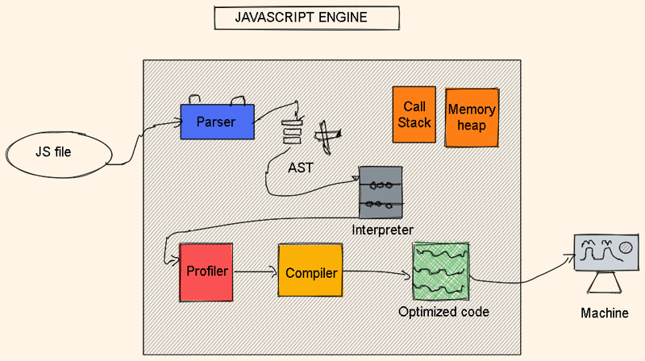
- Parser The Html Parser will fetch all scripts loaded via <script> tag. The source code inside this script gets loaded as a UTF-16 byte stream to a byte stream decoder. This byte stream decoder then decodes the bytes into token and then its sent to parser.
- AST(Abstract Syntax Tree)
The parser creates nodes based on the tokens it gets. With these nodes, it creates an Abstract Syntax Tree (AST).
- Interpreter
The interpreter walks through the AST and generates byte code. It reads the code line by line. When the byte code has been generated, the AST is deleted for clearing up memory space.
- Profiler
The Profiler monitors and watches code to optimize it.
- Compiler
The compiler works ahead of time and creates a translation of the code that has been written and compiles down to a lower level language that machines can read.
1.Parser

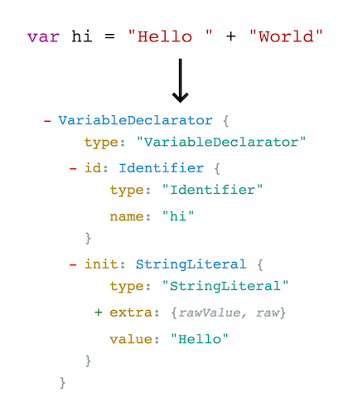
-A JavaScript parser is a crucial component of the JavaScript engine, responsible for analyzing and transforming your code into a format that the computer can understand and execute. Here's a breakdown of how it works:
1. Lexical Analysis (Tokenization):
- The parser reads your JavaScript code character by character, breaking it down into smaller units called tokens.
- Tokens represent the building blocks of your code, such as keywords (if, for, function), identifiers (variable names), operators (+, -, =), literals ("hello", 123), and punctuation.
2. Syntactic Analysis (Parsing):
- The parser takes the stream of tokens generated in the previous step and builds a parse tree or Abstract Syntax Tree (AST).
- The AST represents the hierarchical structure of your code, showing how different tokens relate to each other.
- It ensures that your code adheres to the rules of the JavaScript grammar, checking for syntax errors like missing semicolons, mismatched parentheses, or incorrect keyword usage.
3. Code Generation:
- The AST generated by the parser is then used to generate machine code or bytecode, which is a low-level representation of your JavaScript program that can be executed by the computer.
Key Points to Remember:
- Error Handling:
If the parser encounters syntax errors during the parsing process, it will throw an error, preventing your code from executing.
- Fault Tolerance:
JavaScript is known for being a fault-tolerant language, meaning the parser can sometimes guess and interpret your code even if it contains minor syntax errors.
- Hoisting:
The parser handles hoisting, which is the process of moving variable and function declarations to the top of their scope during compilation.

Example:
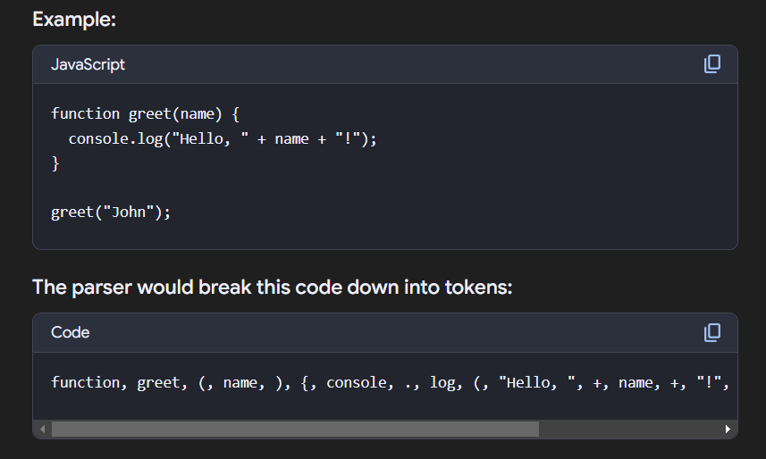
Parser Outputs
What comes out of a JS parser can be a few things:
- Abstract syntax trees (ASTs): This is the main output, the tree diagram we talked about that shows how all the parts of the code are connected.
- Parse trees: This is like the AST but includes more details, some of which aren't necessary for understanding the code's structure.
- Tokenized stream: This is a line-up of all the small pieces the code was broken into at the start.

2.AST

-Abstract syntax trees are data structures widely used in compilers, due to their property of representing the structure of program code. An AST is usually the result of the syntax analysis phase of a compiler.
-In JavaScript, an Abstract Syntax Tree (AST) is a tree representation of the structure of your code. It's a way to dissect and analyze your code in a structured format, making it easier to manipulate and understand.
- Use Cases:
ASTs are heavily used in:
  - Compilers: To transform code into machine-readable instructions.
  - Linters: To analyze code for potential errors and stylistic issues.
  - Code Transformers: To modify code automatically, such as in codemods or minifiers.

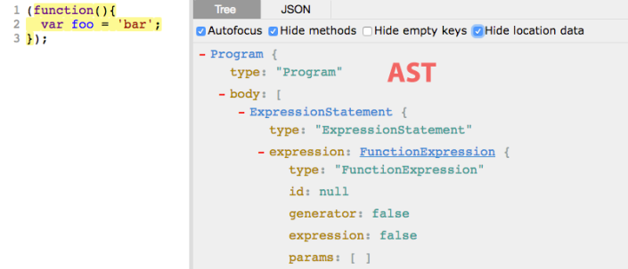

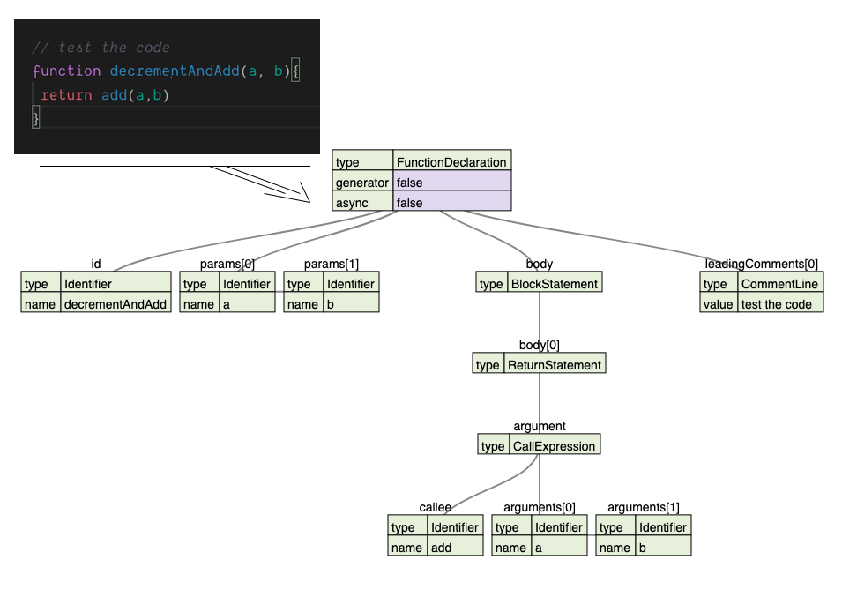

WHAT IS RUNTIME ENVIRONMENT
-Javascript runtime is an environment which provides all the necessary components in order to use and run a Javascript program.
-Every browser has a Javascript Engine.
-A Javascript Engine is one component in the Javascript Runtime.
-Javascript Runtime Environment: - Provide all the necessary Components in order to use and run Javascript program outside the browser.
-A runtime environment is a platform or environment that provides the necessary resources and services for executing a program written in a specific language. It bridges the gap between the code you write and the underlying hardware or operating system, ensuring the code runs as expected.
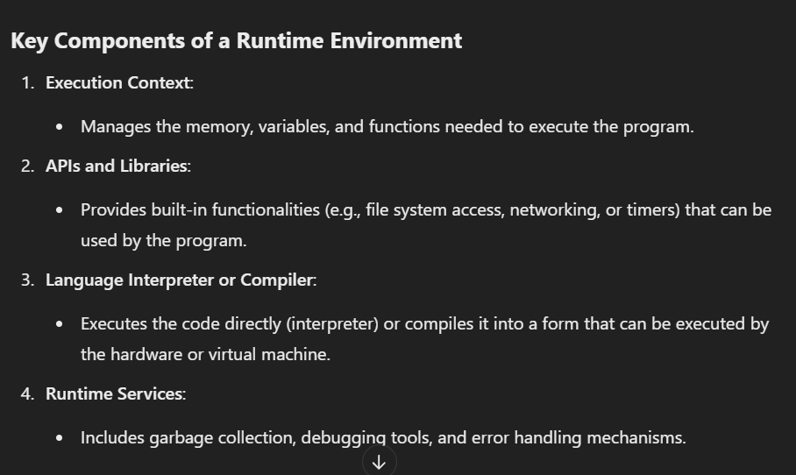

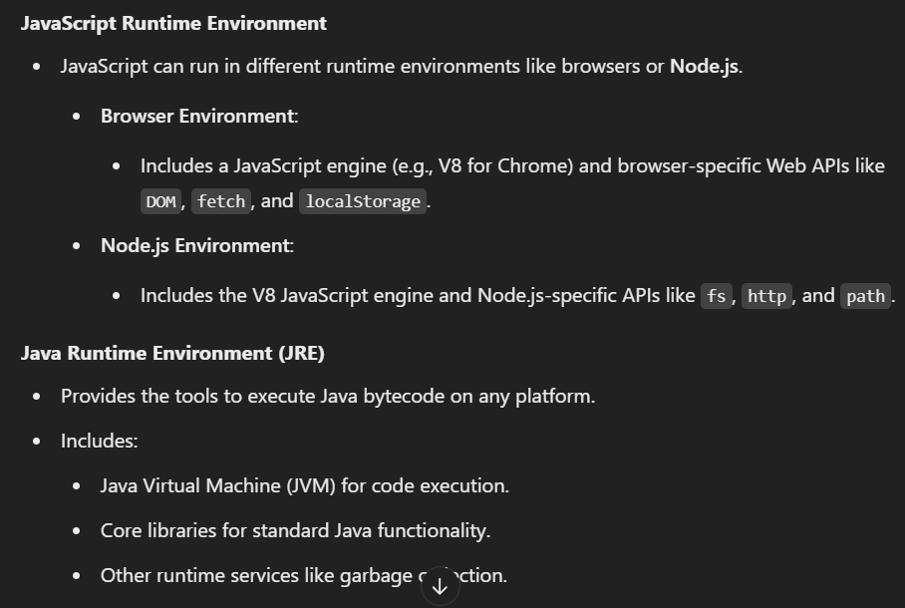
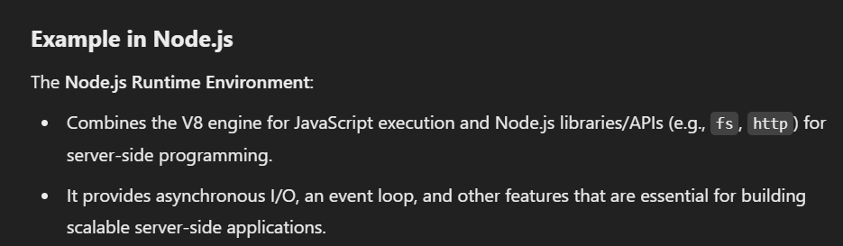

BROWSER RUNTIME VS NODEJS RUNTIME
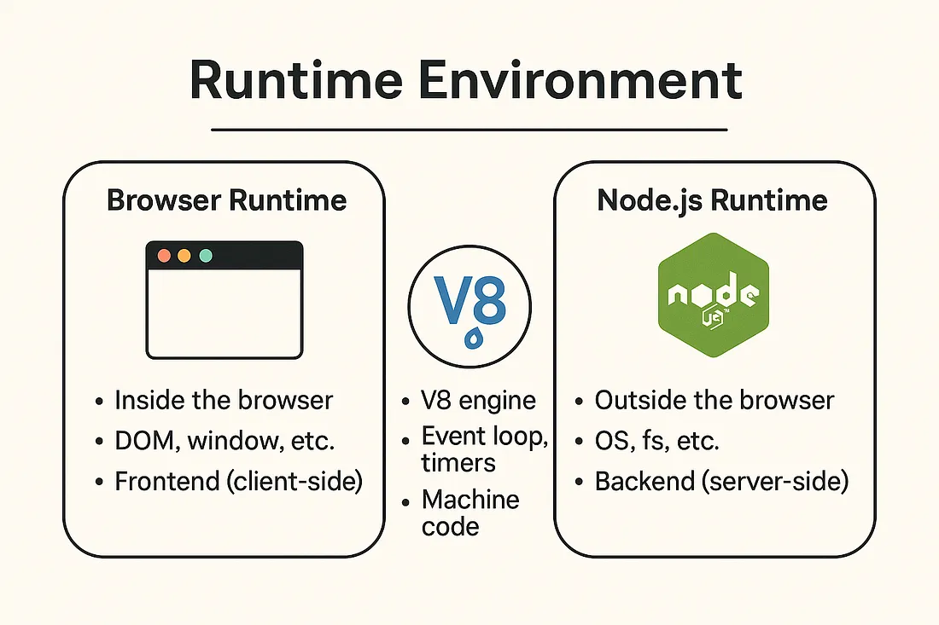
-A runtime environment is a background system that allows your code to run. It provides built-in functions, methods, and APIs that help your code interact with the system and perform actions. In JavaScript, there are mainly two types of runtime environments: Browser Runtime and Node.js Runtime.

1.BROWSER RUNTIME
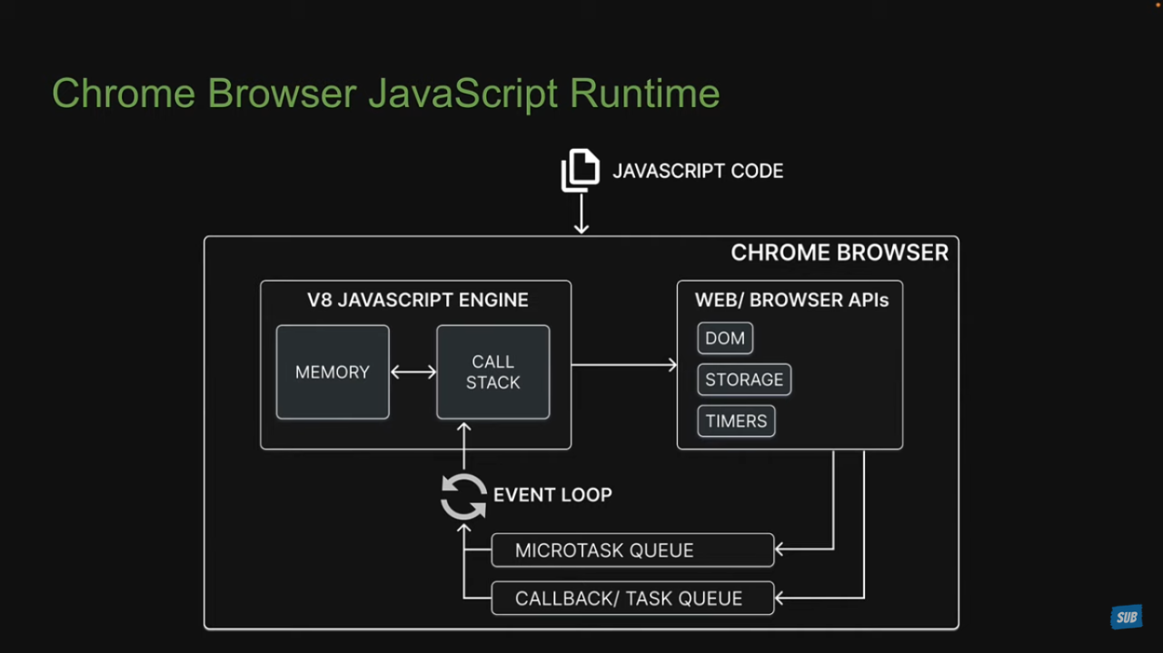
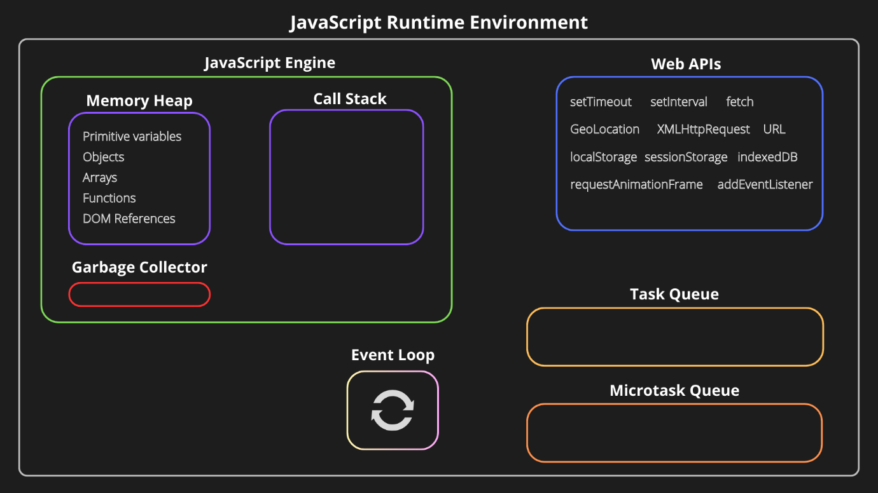
-The Browser Runtime runs JavaScript code inside the browser and is mainly used for frontend development. It provides access to things like the DOM (Document Object Model), window object, and handles user interactions such as clicks, typing, or page changes. It doesn’t work with files, databases, or the server — it only interacts with the web interface (client-side).

Core Components of the Browser Runtime
-The runtime is a container consisting of several key parts working in harmony:
- JavaScript Engine: The core that parses and executes code. It contains:
  - Memory Heap: Unstructured memory used for storing objects and variables.
  - Call Stack: A single-threaded structure that tracks the current execution of functions in a "Last In, First Out" order.
- Web APIs: These are not part of the JS language itself but are provided by the browser (accessible via the window object). Common examples include:
  - DOM (Document Object Model) API: Allows manipulation of HTML and CSS.
  - Fetch API: Used for making network requests.
  - Timers: Functions like setTimeout and setInterval.
- Callback Queue (Task Queue): A storage area for callback functions from asynchronous operations (like a completed network request or a timer) that are waiting to be executed.
- Microtask Queue: A high-priority queue specifically for Promises and mutation observers, which are processed before the standard callback queue.
- Event Loop: The orchestrator that constantly monitors the call stack and the queues. If the call stack is empty, it pushes the next task from the queue onto the stack for execution

-A JavaScript Runtime consists of the following components-
- [🚀] The JS Engine.
- [🌏] Web/Global APIs.
- [⌛] Callback Queue.
- [🔬] Microtask Queue.
- [🔄] Event Loop.
-Here, we can glimpsed the JavaScript Runtime Environment as a whole in one picture.
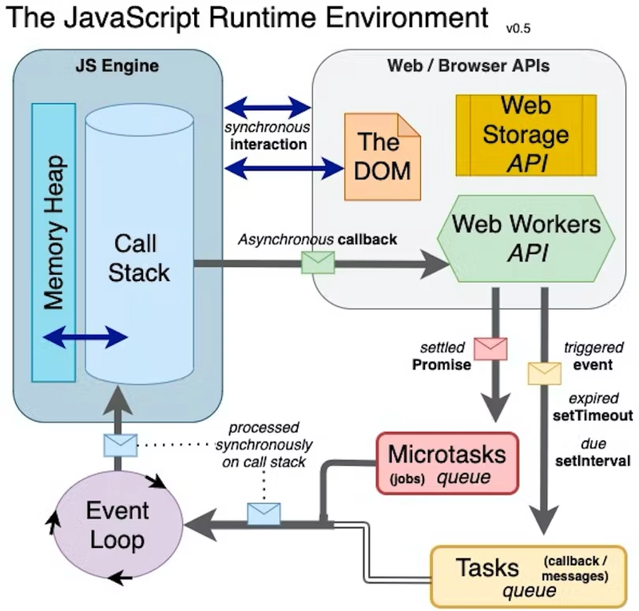
1. The JS Engine 🚀
-The JavaScript engine, is a vital component of the JavaScript Runtime Environment. Consider it heart of the JavaScript runtime environment. Operating in a single-threaded manner,it executes tasks one at a time, following a specific order. There are a lot of steps involved in doing that, but essentially executing JavaScript code is what an engine does.
-Every browser has its own JavaScript engine but the most well known engine is Google's V8. The V8 engine powers Google Chrome but also Node.js which is that JavaScript Runtime.
2. Web/Global APIs 🌏
-Web/Global APIs play a crucial role in the JavaScript Runtime Environment by enabiling the execution of tasks in the background, creating the illusion of a multi-threaded environment. It's not part of the JS Engine rather it's crucial part of Runtime environment. These APIs, provided by the browser or the operating system, allow JavaScript to interact with external resources and perform operations asynchronously.
Queue
-The queue is an essential part of the JavaScript task scheduling algorithm, which dertermines the order in which tasks are executed by the JavaScript Engine.Both queues hold tasks that are executed asynchronously, but there are some differences in how they work.
3. Callback Queue (Macrotask Queue) ⌛
-The Callback Queue also known as the task queue, holds tasks that are pushed to the queue by Web/Global APIs, such as setTimeout,setInterval,XMLHttpRequest, or Events like mouse clicks and keyboard inputs. When the call stack is empty & microtask queue has no priority task, the event loop moves the first task from callback queue to the call stack for execution.
For example:
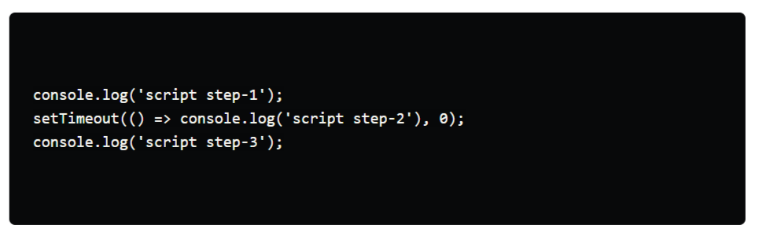

4. Microtask Queue 🔬
-The Microtask Queue, also known as the Job Queue or Promise Queue. It's handle the mutation observer callbacks and promise callbacks. These tasks are scheduled to run after the currently executing script is complete and before the event loop continues with the next task in the task queue.The microtask queue is processed before the callback queue, so the tasks in the microtask queue are given priority over tasks in the callback queue.
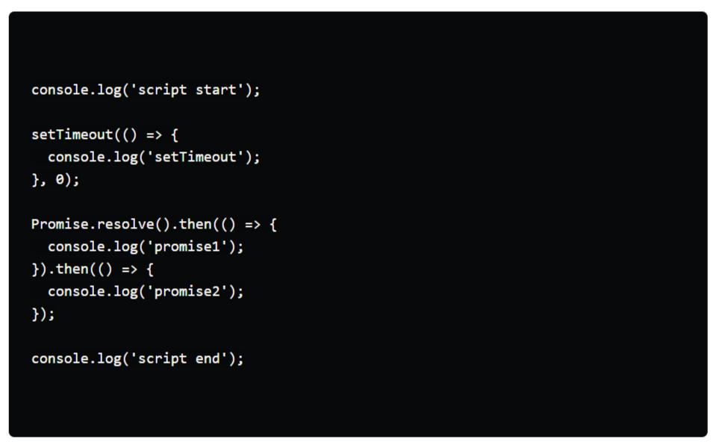

5. Event Loop 🔄
-The event loop is a continuous process that constantly checks the call stack and the callback queue,microtask queue. Event loop takes callback functions from the callback queue,microtask queue and puts them in the call stack. So that they can be executed. Also Event Loop is essential for non-blocking concurrency model.
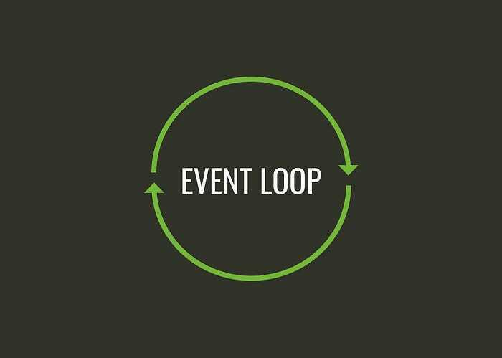

2.NODEJS RUNTIME
-So, while Browser Runtime is for frontend (client-side) interactions and Node Runtime is for backend (server-side) logic, they both work on the same core JavaScript engine and follow similar processing models.
-The Node.js Runtime runs JavaScript code outside the browser, usually on a server. It’s used for backend development and gives access to OS-level features like the file system, network, creating servers, working with databases, and more.
-Even though both runtimes are different, they share some similarities. Both use the V8 engine (from Google Chrome) to convert JavaScript into machine code. They both use event loops to handle asynchronous tasks and support functions like setTimeout, setInterval, and callback queues to manage non-blocking operations.
Core Architecture Components
-The runtime functions through three primary internal components that work together to manage code execution:
- V8 Engine: Originally developed for Chrome, this engine compiles JavaScript directly into machine code at runtime (Just-In-Time compilation) rather than interpreting it line-by-line, ensuring high performance.
- Libuv Library: A C++ library that handles the "heavy lifting" of the operating system. It manages asynchronous I/O (Input/Output) operations like file system access, networking, and DNS lookups.
- Event Loop: Often called the "heart" of Node.js, it manages the execution of callbacks. It continuously checks for pending tasks in the event queue and executes them when the main execution stack is empty.
Key Characteristics
- Asynchronous & Non-Blocking: Instead of waiting for a task (like reading a file) to finish before moving to the next line, Node.js offloads that task to the system and continues executing other code. A callback is triggered once the task is complete.
- Single-Threaded: Node.js operates on a single main thread for executing JavaScript code. It can handle thousands of concurrent connections because it doesn't block that thread while waiting for I/O.
- Rich Ecosystem (NPM): Node.js comes bundled with the Node Package Manager (npm), the world's largest software registry, giving developers access to millions of reusable code packages.
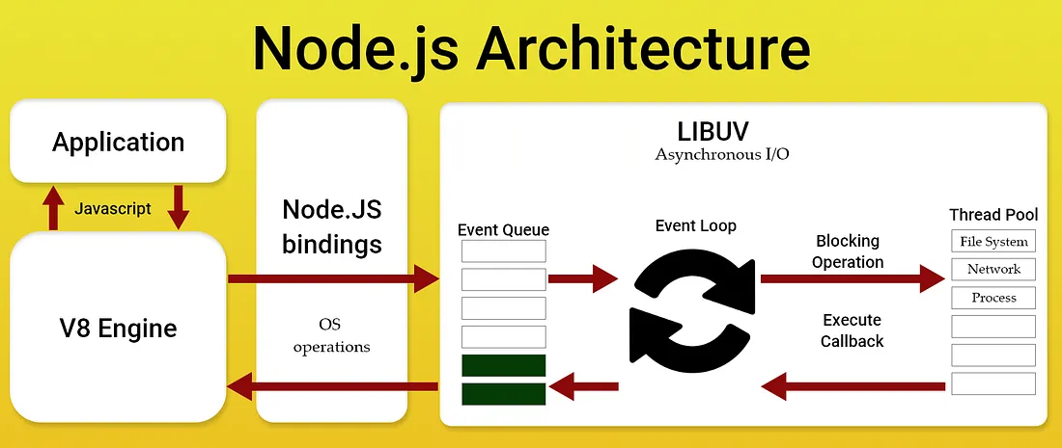
-We can categorize Node.js architecture into two main components as V8 engine and LIBUV. Let’s see each component's functionalities separately.
V8 Engine
-The V8 engine is the fundamental part of Node.js architecture. Without V8 engine there is no way to identify JavaScript. V8 engine helps to convert JavaScript code to machine code which is C++ that can be understood by machines.
LIBUV
-LIBUV is an open-source library that is strongly focused on asynchronous I/O. This library provides access to Node.js as a computer operating system, file system, and Networking. Below are some features of LIBUV
- Asynchronous TCP (net module) and UDP (dgram module)
- Asynchronous DNS resolution (used partly for the DNS module)
- Asynchronous file, file system operations & events (fs module)
- ANSI escape code-controlled TTY
- Thread pool and Signal handling
- Child processes
- High-resolution clock
- Threading and synchronization primitives.
- Inter-Process Communication using sockets and Unix domain sockets (Windows)
Event Queue, Event Loop, and Thread Pool are the most ----important components in the LIBUV.
Event Queue
-Event queue to the incoming client request and pass them to the event loop in sequentially
Event Loop
-The event loop is responsible for handling small tasks such as executing callback functions or network I/O. Those are non-blocking tasks that do not block the main thread. It takes care of all the incoming events and performs the balancing part by offloading heavier tasks into the thread pool and doing the simpler tasks by itself. Below are some features of the event loop
- Event loop is an endless loop, which waits for tasks, executes them, and then sleeps until it receives more tasks.
- The event loop executes tasks from the event queue only when the call stack is empty i.e. there is no ongoing task.
- The event loop allows us to use callbacks and promises.
- The event loop executes the tasks starting from the oldest first.
Thread Pool
-The thread pool gives us 4 separate threads. The event loop will offload the heavy task to the thread pool, which happens automatically. The thread pool is responsible for handling heavy tasks such as
- File access
- Cryptography related things
- Caching password
- File Compression
- DNS lookups
Other Libraries
-Apart from the above main components following libraries are also used in the Node.js architecture for some other purposes
- HTTP Parser — parsing HTTP
- C-ARES — DNS queries
- OpenSSL — cryptography
- Zlib — file compression
The flow of Node.js Architecture
- The client sends requests to the server. Request can be blocking or non-blocking.
- Node.js retrieves the incoming request and adds it to the event queue.
- From the event queue, it passes each request to the event loop one by one.
- Event loop checks if the request is small enough to execute in itself, otherwise passes the request to the thread loop
- When a request is received to the thread pool it executes the request and passes the response again to the event loop.

NODE JS CODE EXCUTION
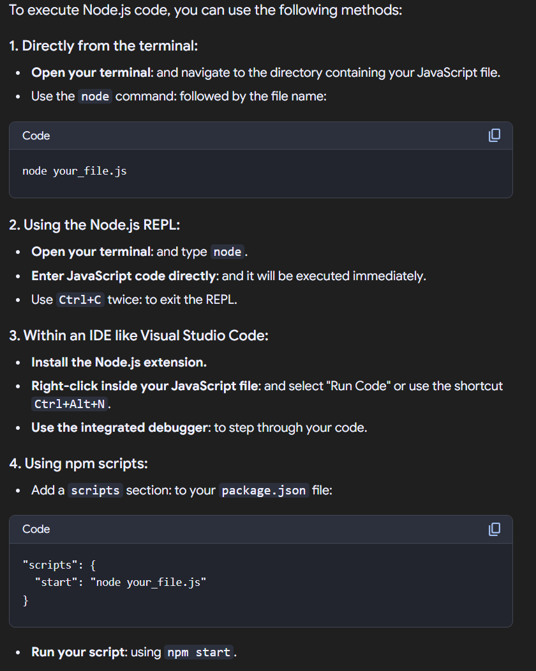

1.NODE REPL

R = Read
E = Evaluate
P = Print
L = Loop
REPL stands for:
- Read: The REPL reads user input (JavaScript code).
- Eval: The input is evaluated (executed) by the JavaScript engine.
- Print: The result of the evaluation is printed to the screen.
- Loop: The process repeats (loops), waiting for the next input.

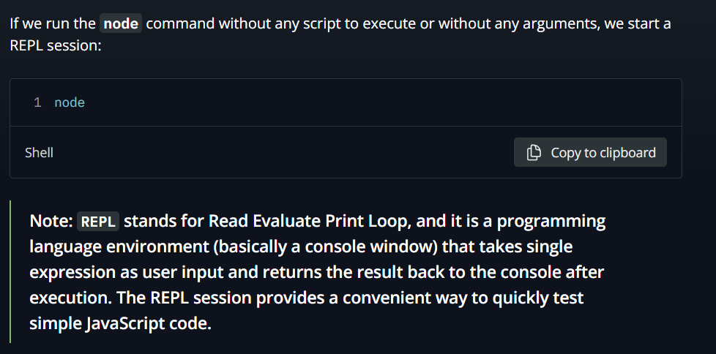
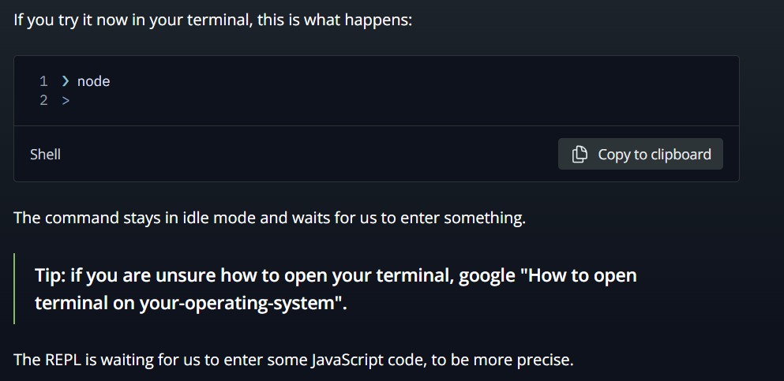
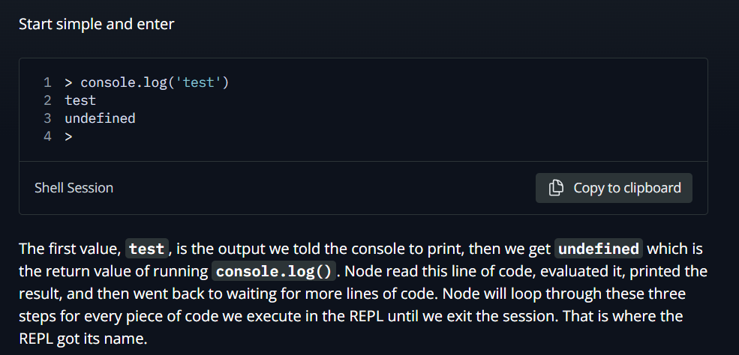
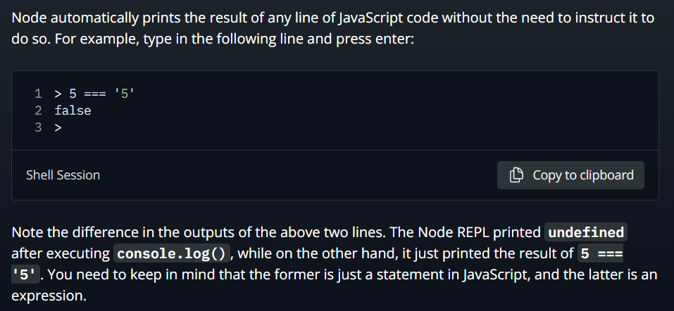
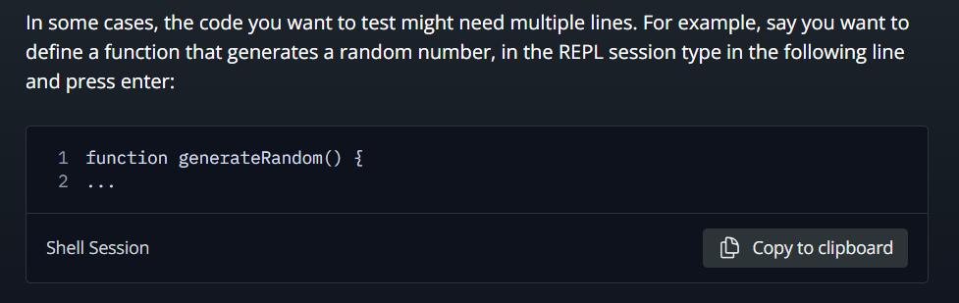
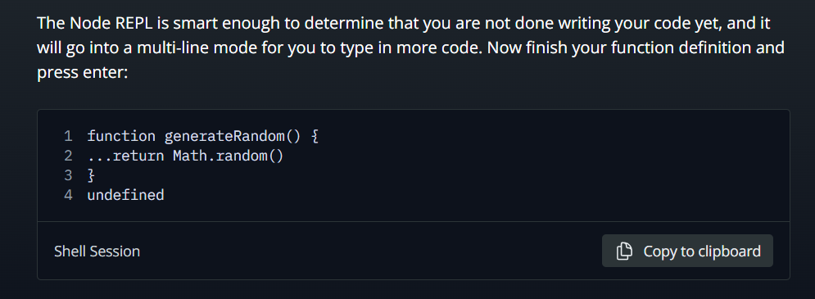
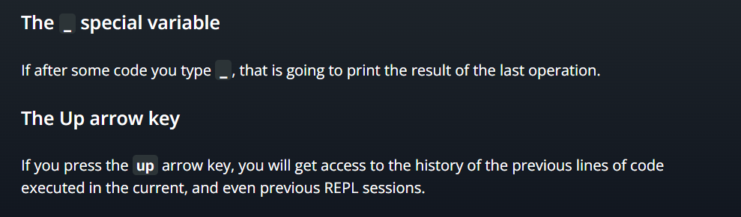
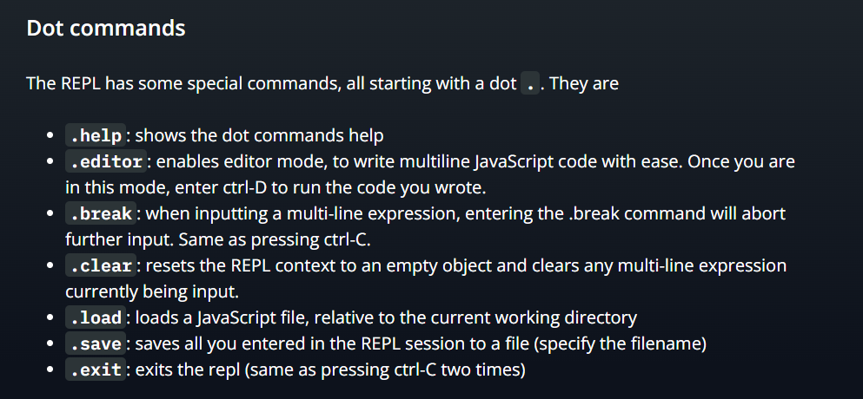

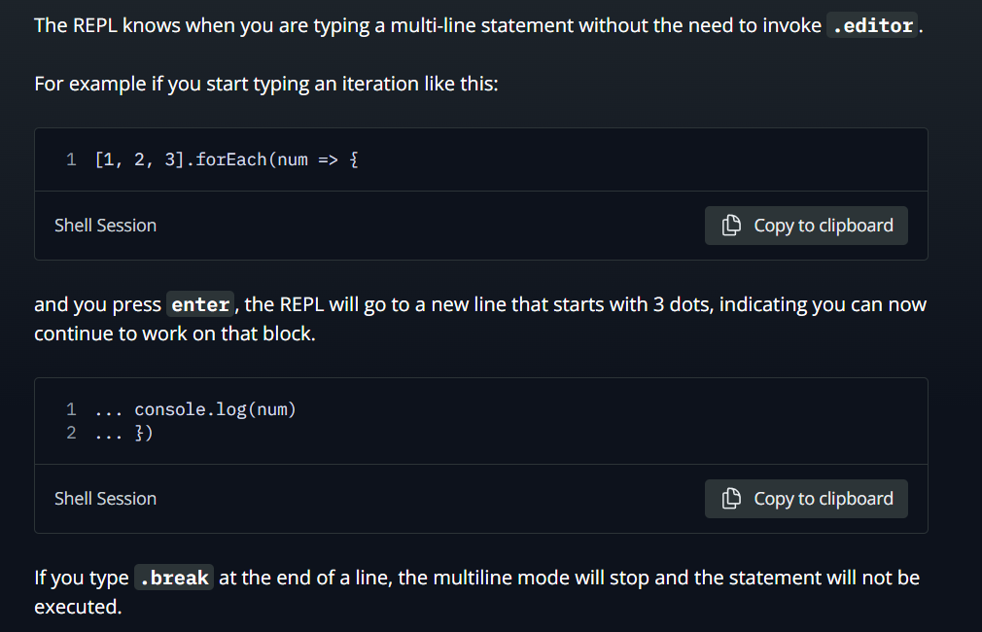

2.Terminal Line
-Executing code in Javascript file, in the command line.
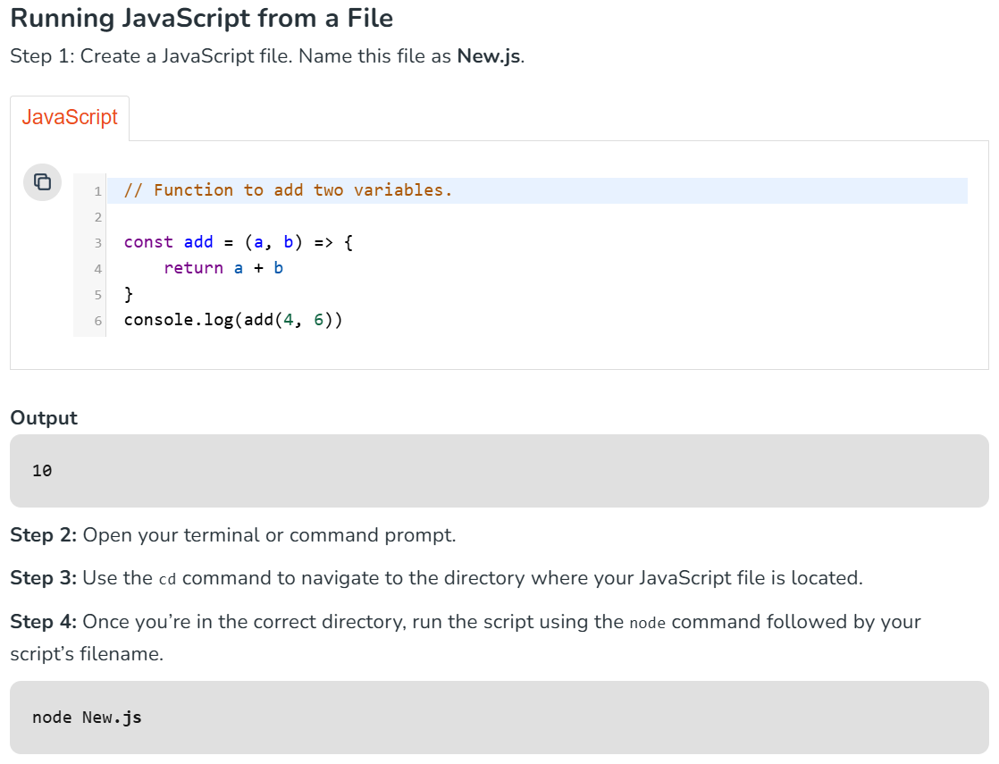

3.USING IDE

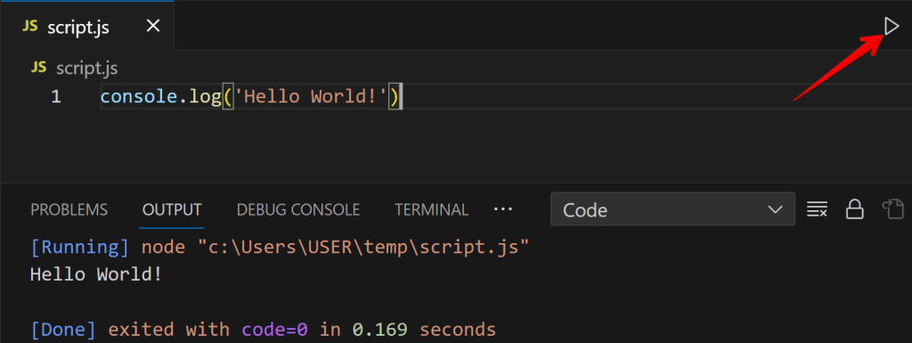

4.Using Script
-Node.js allows you to create standalone executables from your JavaScript programs, making them easy to distribute and run on various platforms without requiring Node.js to be installed. This article will guide you through the process of converting a Node.js program into an executable file using popular tools like pkg, nexe, and pkg-conf
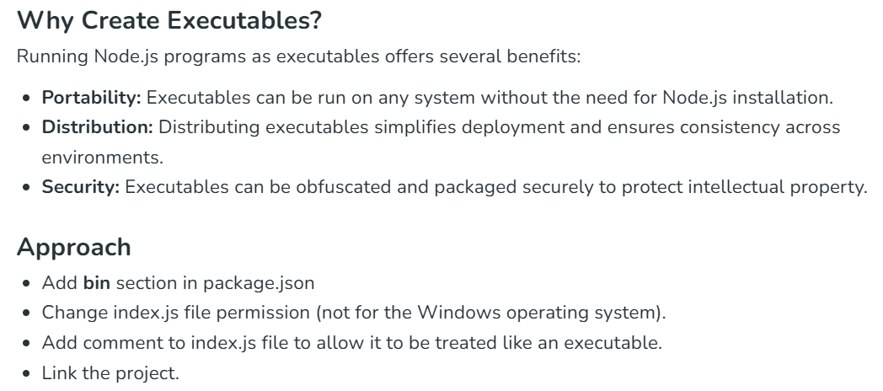
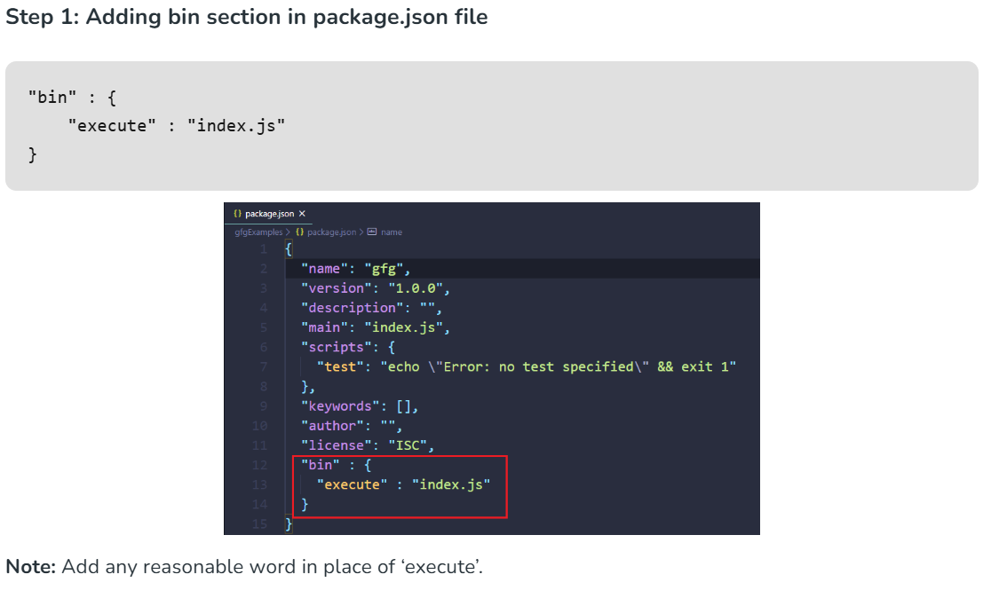

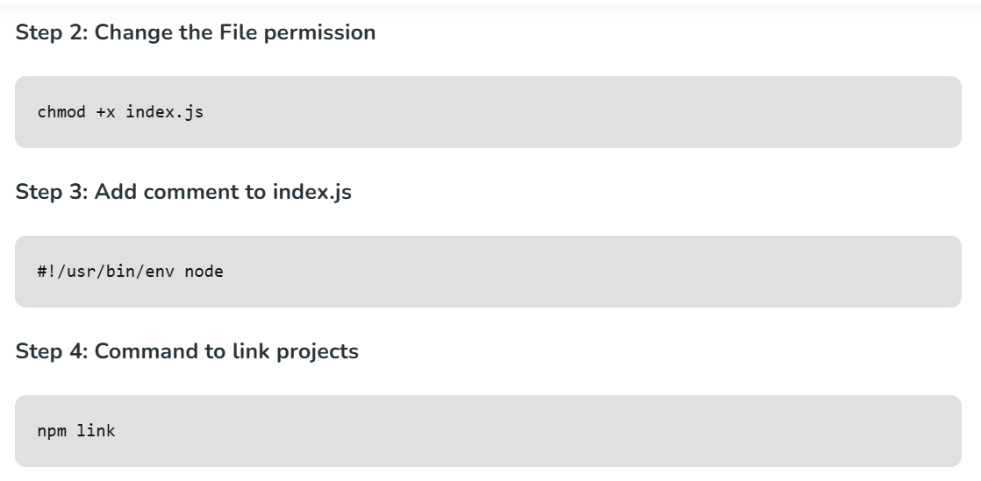
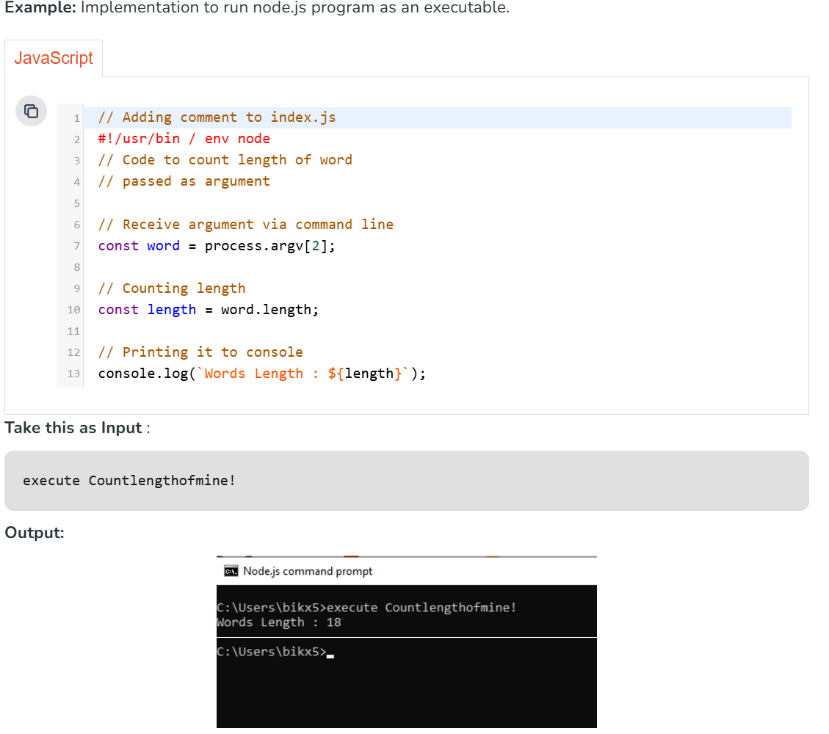

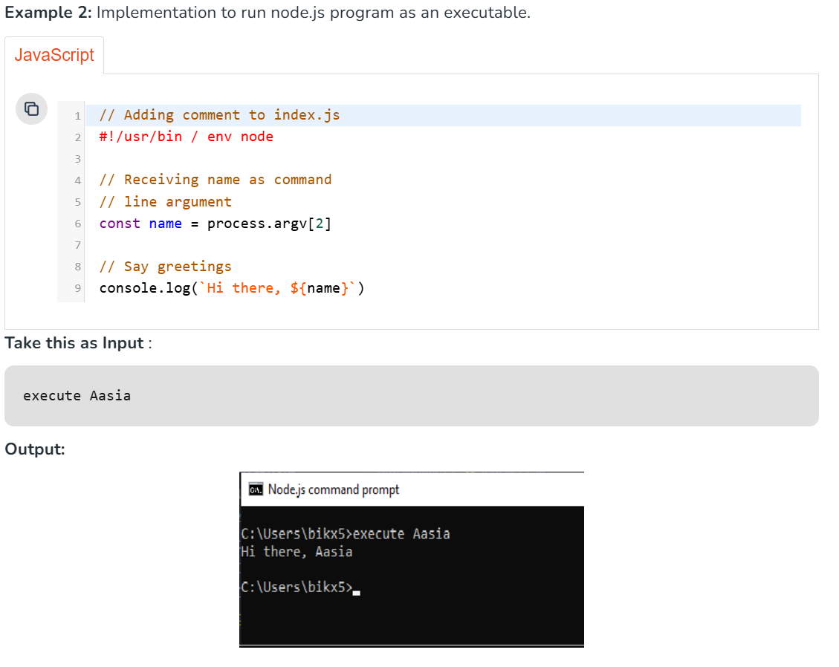

BROWSER VS NODEJS
-Both the browser and Node.js use JavaScript as their programming language. Building apps that run in the browser is completely different from building a Node.js application.
What changes is the ecosystem.
-In the browser, most of the time what you are doing is interacting with the DOM, or other Web Platform APIs like Cookies.
-Those do not exist in Node.js, of course. You don't have the document, window and all the other objects that are provided by the browser.
-And in the browser, we don't have all the nice APIs that Node.js provides through its modules, like the filesystem access functionality.
-Another big difference is that in Node.js you control the environment. Unless you are building an open source application that anyone can deploy anywhere, you know which version of Node.js you will run the application on
-Compared to the browser environment, where you don't get the luxury to choose what browser your visitors will use, this is very convenient.
-Another difference is that Node.js supports both the CommonJS and ES module systems (since Node.js v12),
-while in the browser, we are starting to see the ES Modules standard being implemented.
-In practice, this means that you can use both require() and import in Node.js, while you are limited to import in the browser.

-Browser vs. Node.js refers to the different environments in which JavaScript can run. Here's a comparison between the two:
1. Execution Environment:
- Browser: JavaScript in the browser runs on the client side. It is primarily used to manipulate web pages, interact with users, and manage UI events.
- Node.js: Node.js is a JavaScript runtime built on Chrome’s V8 engine, allowing JavaScript to run on the server side. It is used for building server-side applications, handling backend logic, and interacting with databases or file systems.
2. APIs Available:
- Browser: The browser provides Web APIs such as DOM, window, document, localStorage, fetch, etc., for tasks like DOM manipulation, network requests, and local storage.
- Node.js: Node.js provides APIs that allow server-side tasks, such as file system access (fs), handling HTTP requests (http, express), interacting with databases, or dealing with operating system processes.
3. Modules:
- Browser: Browsers don’t have a built-in module system (historically). You can now use ECMAScript modules (import/export) natively in modern browsers, but no file system or server-specific modules are included.
- Node.js: Node.js uses the CommonJS module system (require and module.exports) but also supports ECMAScript modules. It includes many built-in modules to handle file systems, networking, and streams.
4. File System and OS Access:
- Browser: No direct access to the file system or operating system. It’s restricted to ensure security in a user-facing environment.
- Node.js: Full access to the file system and the underlying operating system (permissions allowing). You can read, write, and modify files, interact with hardware, and spawn child processes.
5. Event Loop:
- Both environments use the event loop to handle asynchronous tasks. However, Node.js uses the event loop for managing server-side tasks, like network requests and file I/O, while the browser uses it primarily for managing user interaction and rendering the UI.
6. Security:
- Browser: Runs in a more secure sandboxed environment. It follows strict cross-origin policies (CORS) to protect user data and prevent malicious scripts from interacting with sensitive information.
- Node.js: Runs on the server, so security concerns include protecting data from external threats and ensuring safe handling of sensitive data. You have more control over security protocols.
7. Use Cases:
- Browser: Ideal for front-end applications, UI/UX handling, and direct user interaction (e.g., building interactive websites, handling forms, and updating the UI dynamically).
- Node.js: Ideal for server-side applications (e.g., REST APIs, server-side rendering, interacting with databases, handling large-scale data processing).
8. Concurrency:
- Browser: Typically single-threaded, though Web Workers can be used to handle background tasks.
- Node.js: Also single-threaded but designed to handle many connections concurrently via an asynchronous, non-blocking I/O model. It handles multiple tasks effectively using callbacks, promises, and async/await patterns.
Conclusion:
- Browser: Best suited for client-side, UI-based tasks.
- Node.js: Best suited for server-side tasks, backend development, and building scalable network applications.

MODULES
-In Node.js, modules are reusable blocks of code that encapsulate specific functionality and can be imported or exported to/from other files. Node.js has a built-in module system, allowing developers to break their code into smaller, manageable pieces.
Key Aspects of Node.js Modules:
1. Types of Modules:
- Core Modules/Built-In Modules: These are built-in modules provided by Node.js. Examples include:
  - fs (File System): To work with the file system.
  - http: To create HTTP servers and make requests.
  - path: To work with file paths.
  - os: To interact with the operating system.
  - url: To parse and manipulate URLs.
- Local Modules: These are custom modules that developers create in their applications. They typically contain code that can be reused across different files in the project.
- Third-Party Modules: These are modules developed by others and available via the npm (Node Package Manager) registry. Examples include express, lodash, mongoose, etc.
-Node.js has a set of built-in modules which you can use without any further installation.
Here is a list of the built-in modules of Node.js version 6.10.3:
Module | Description
assert | Provides a set of assertion tests
buffer | To handle binary data
child_process | To run a child process
cluster | To split a single Node process into multiple processes
crypto | To handle OpenSSL cryptographic functions
dgram | Provides implementation of UDP datagram sockets
dns | To do DNS lookups and name resolution functions
domain | Deprecated. To handle unhandled errors
events | To handle events
fs | To handle the file system
http | To make Node.js act as an HTTP server
https | To make Node.js act as an HTTPS server.
net | To create servers and clients
os | Provides information about the operation system
path | To handle file paths
punycode | Deprecated. A character encoding scheme
querystring | To handle URL query strings
readline | To handle readable streams one line at the time
stream | To handle streaming data
string_decoder | To decode buffer objects into strings
timers | To execute a function after a given number of milliseconds
tls | To implement TLS and SSL protocols
tty | Provides classes used by a text terminal
url | To parse URL strings
util | To access utility functions
v8 | To access information about V8 (the JavaScript engine)
vm | To compile JavaScript code in a virtual machine
zlib | To compress or decompress files

EXPORTING MODULES
-In Node.js, module.exports is used to define what a module exports so that other files can access and use it. This is part of the CommonJS module system, which Node.js uses to handle modules.
How module.exports Works:
-Every Node.js file is treated as a module. By default, Node.js wraps your code inside a function, which gives each file its own local scope. This means variables and functions defined in one file are not available in another unless explicitly exported.
-The module.exports object is what the require() function returns when importing a module. By adding properties or functions to module.exports, you make them accessible to other files.
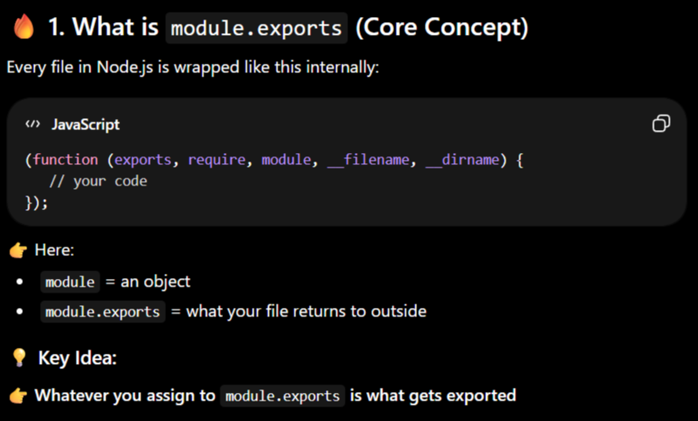

EXPORTING WAYS OF MODULES
1.COMMON EXPORT

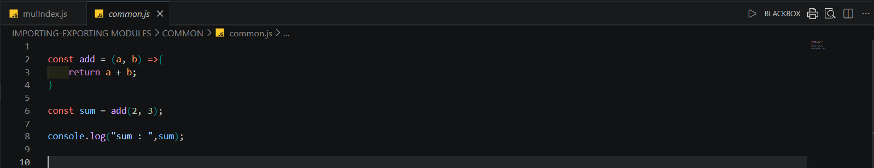
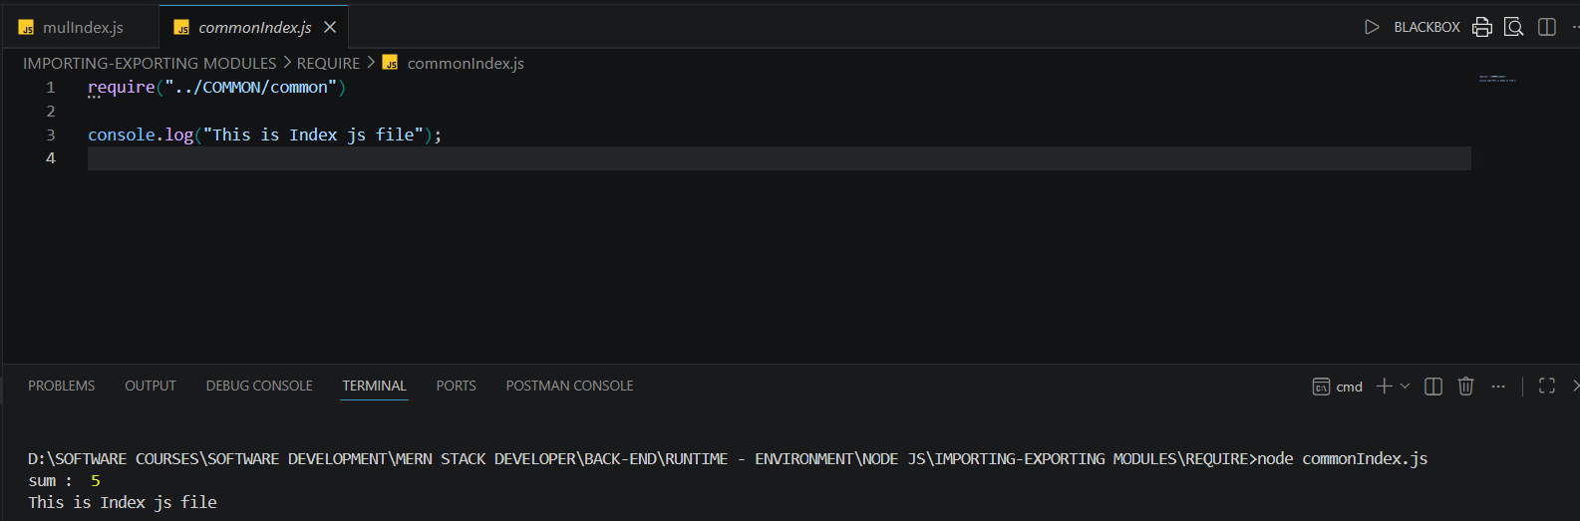
-This is runs the whole file.
-This is not recommended way

2.DIRECT EXPORT

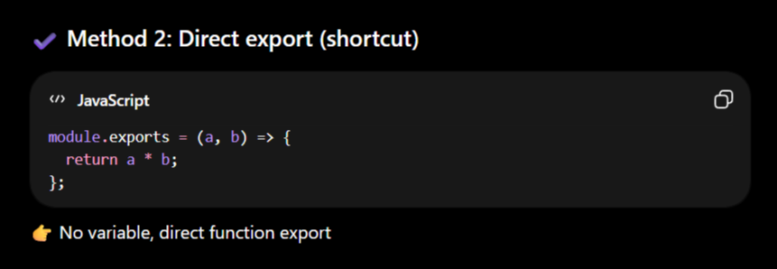
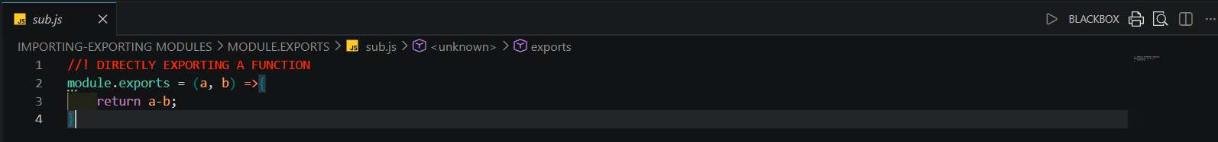
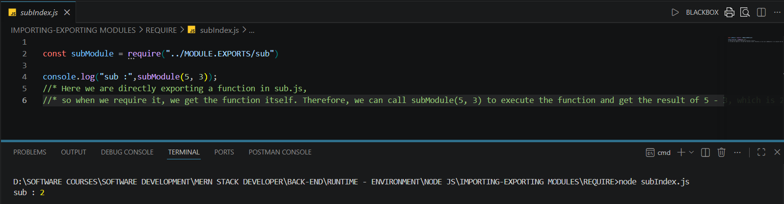

3.USING exports

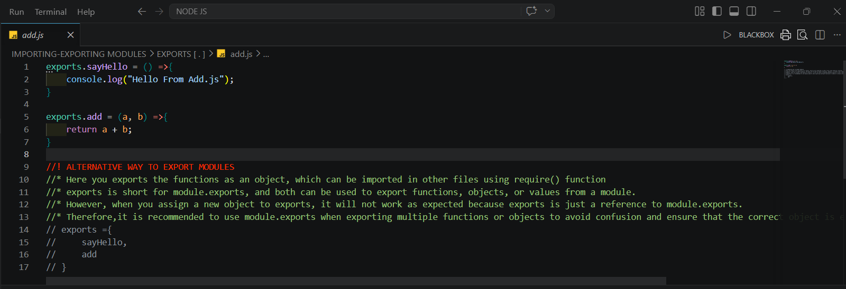
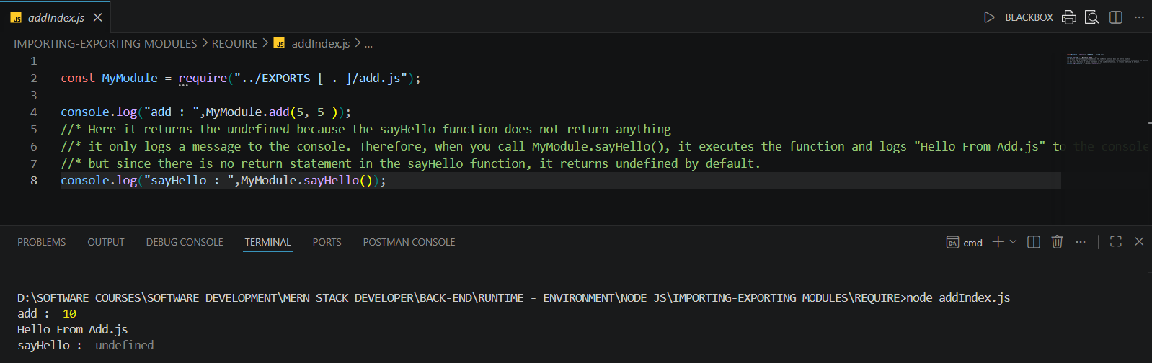
-The exports is a short-hand property of module.exports.
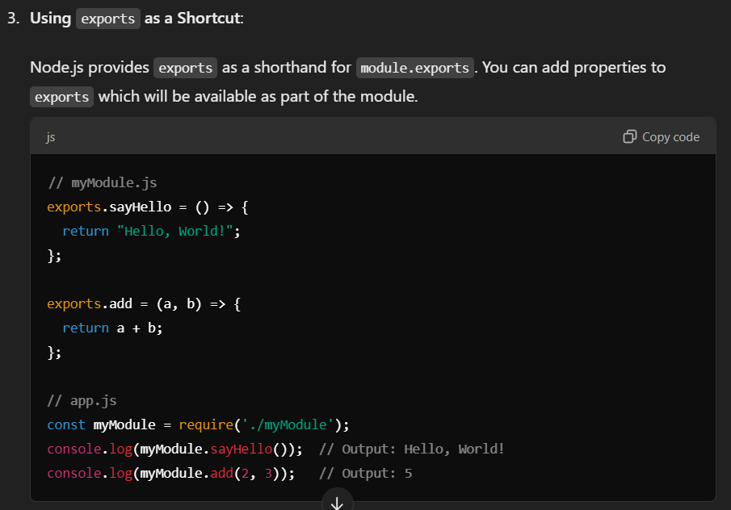

4.USING module.exports

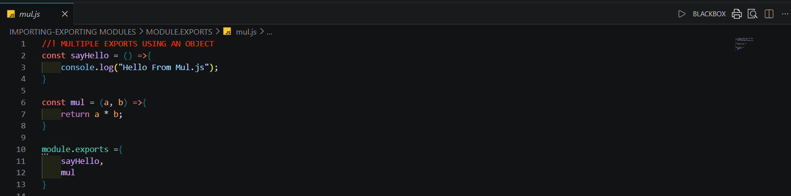
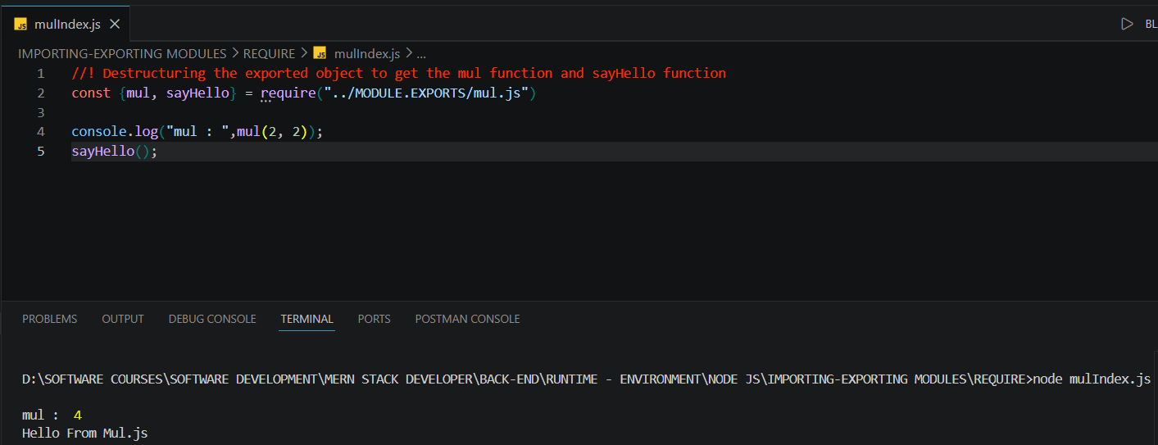

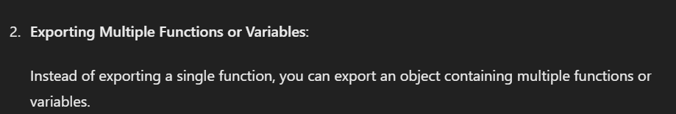
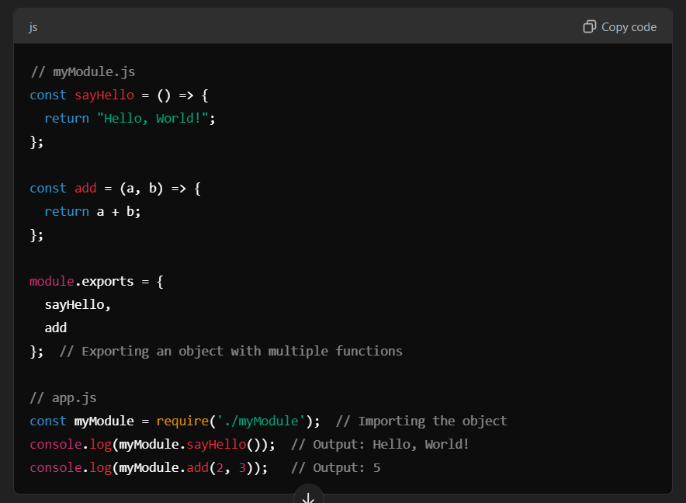
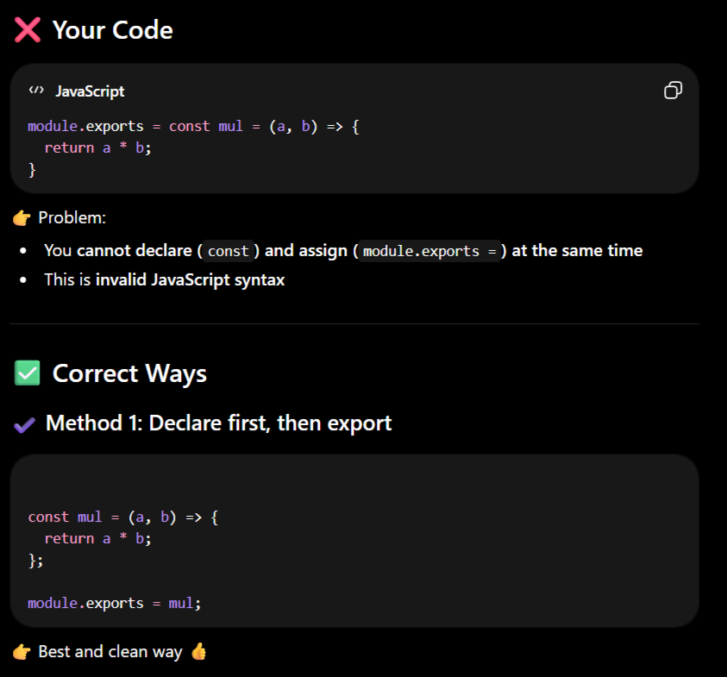

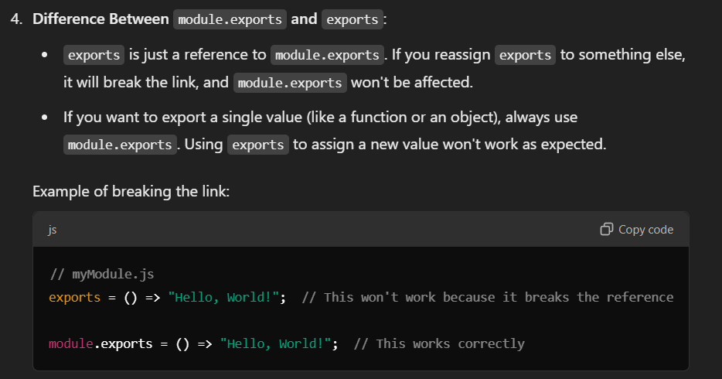

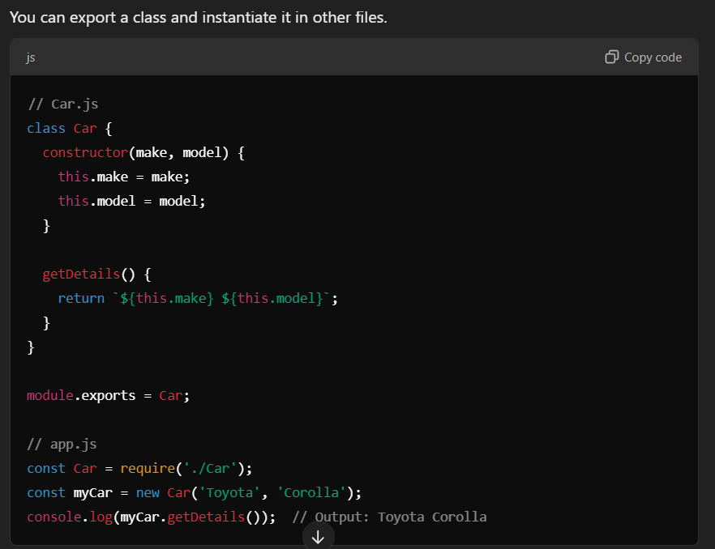
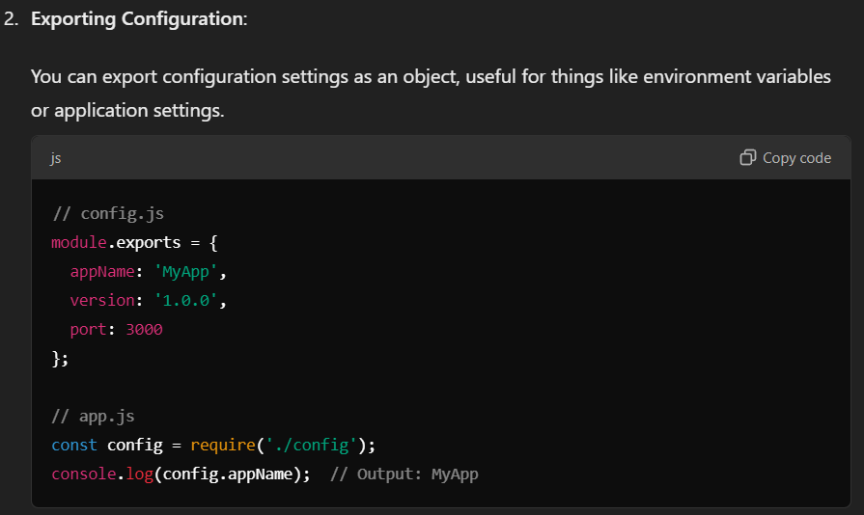
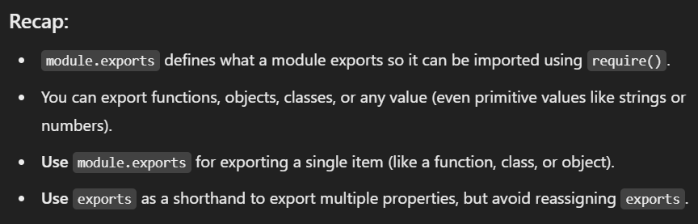

INCLUDE MODULES

require(“path/moduleName”)

-In Node.js, the require() function is used to import modules. It's a fundamental part of the CommonJS module system, which allows you to break down your code into manageable, reusable pieces.
-In Node.js, require() is a built-in function used to import modules, JSON files, or local files into your application. It enables you to include functionality from external sources or your own files, making it a core part of how modules are used in Node.js.
-It is used to load the modules to the current files.
var http = require('http');

How it works:
- Module Path:
-The require() function takes a string argument that represents the path to the module you want to import. This path can be:
  - Core Module: Built-in modules like fs, http, or path.
  - Local Module: A file in your project, using relative or absolute paths (e.g., ./myModule or /path/to/myModule).
  - Installed Module: A module installed from npm, located in the node_modules directory.
How require() Resolves Modules:
Core Modules: If the name matches a Node.js core module (like fs or http), Node.js loads it.
Relative/Absolute Paths: If a path (starting with ./, ../, or /) is provided, Node.js treats it as a local file or module.
Modules from node_modules: If neither a core module nor a relative path is used, Node.js looks for the module in the node_modules folder.
-In summary, require() is essential in Node.js to load and use code from other files, modules, or packages. It helps in modularizing applications and reusing code efficiently.
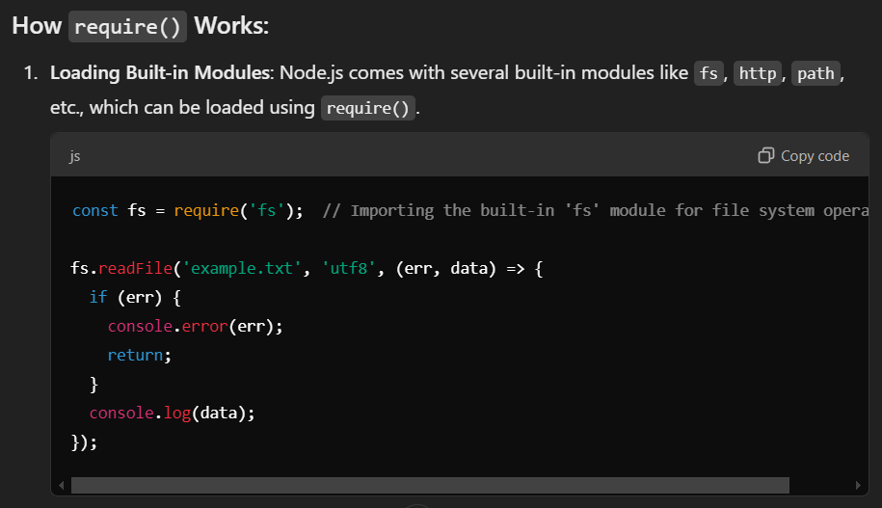
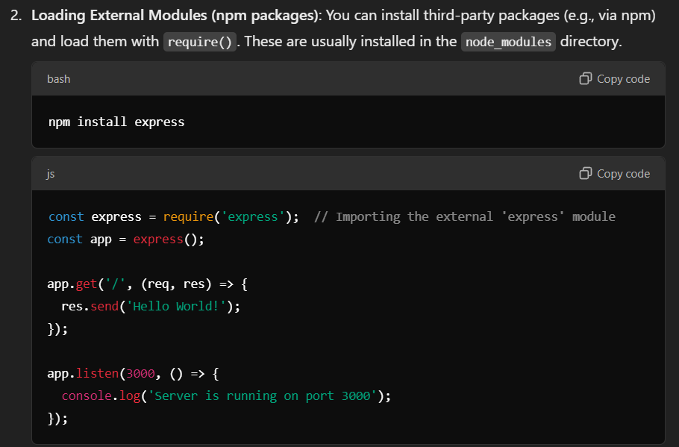
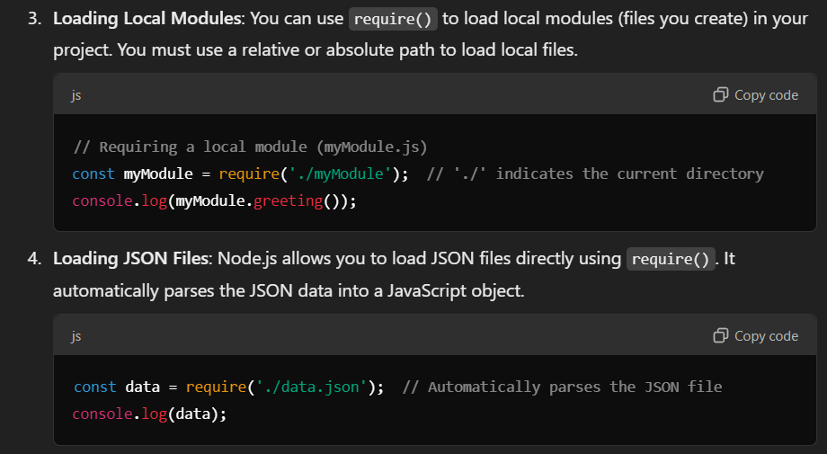

MODULE SCOPE
-In Node.js, module scope refers to the fact that each file is treated as its own isolated environment. Unlike in a web browser, where variables declared at the top level are often added to the global window object, variables and functions in a Node.js file are private to that specific file (module).
-👉 Each file (module) has its own private scope
Variables, functions, and data defined in one file are NOT accessible in another file by default.
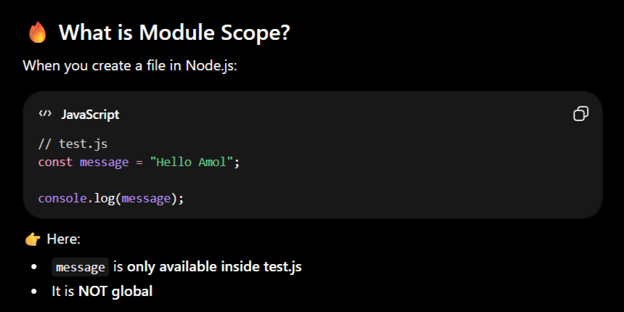
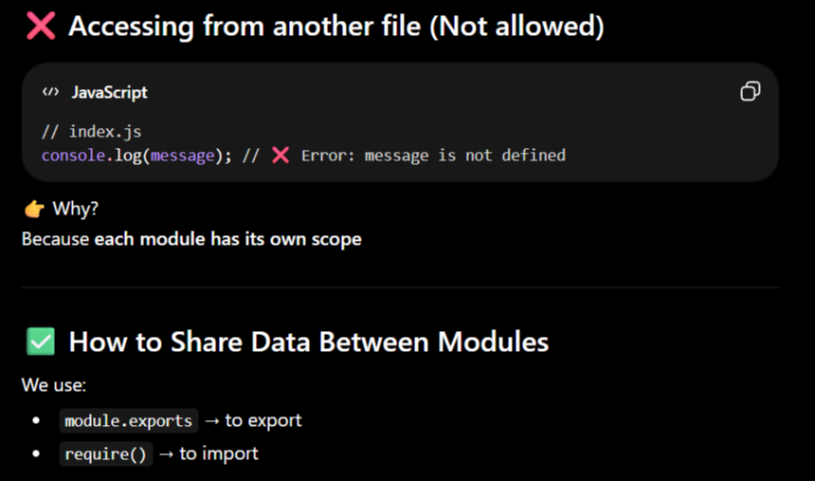
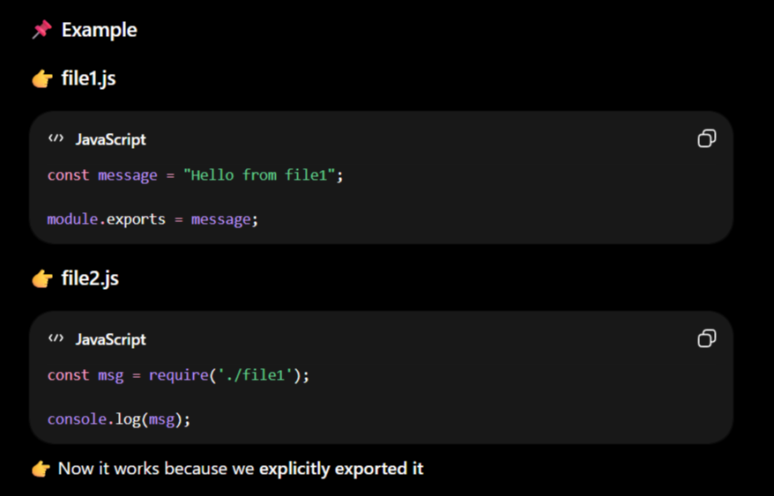
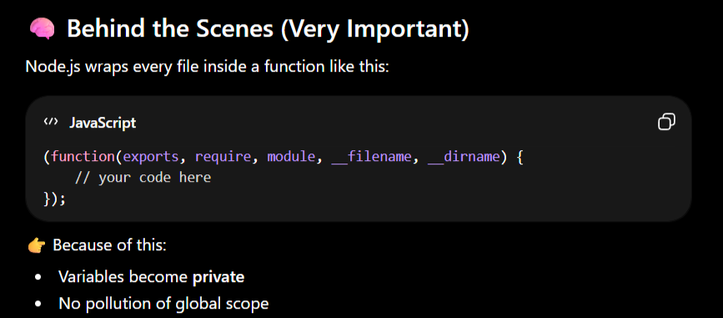
-Before a Module code is executed, Nodejs will wrap it with function wrapper that provides module scope.
-This saves us from having to worry about conflicting variable or functions.
-There is proper encapsulation and reusability is unaffected.
-Each loaded module in Nodej sis wrapped with an IIFE that provides scoping of code.
-IIFE allows you to repeat variable or function names without any conflicts.
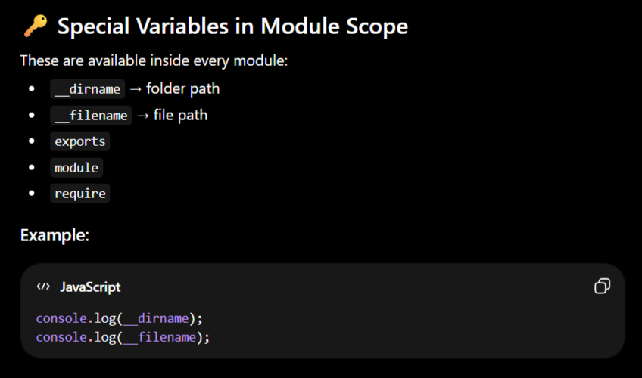
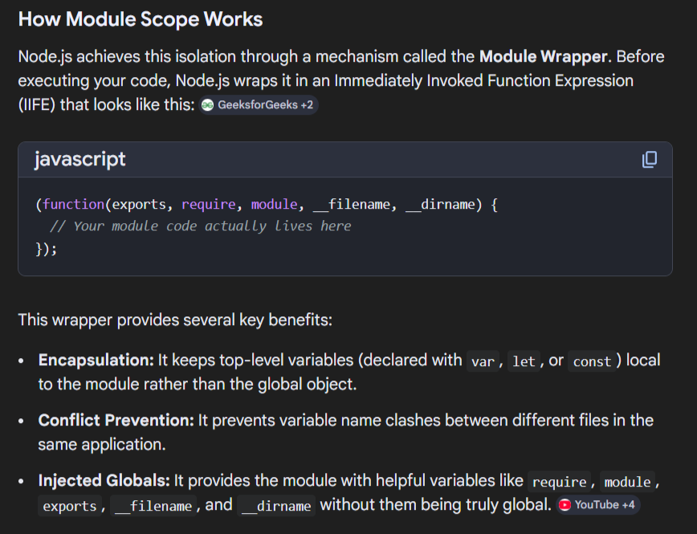

Module Caching:
-When a module is required for the first time, Node.js loads it, executes the code, and caches the result.
-On subsequent require() calls for the same module, Node.js will return the cached version, so the code is not re-executed.
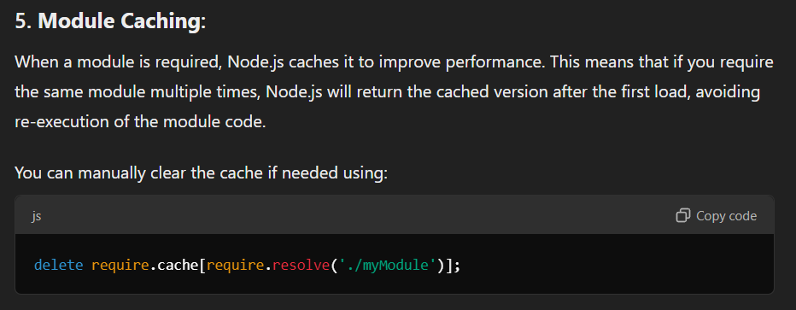


MODULARE WRAPPER
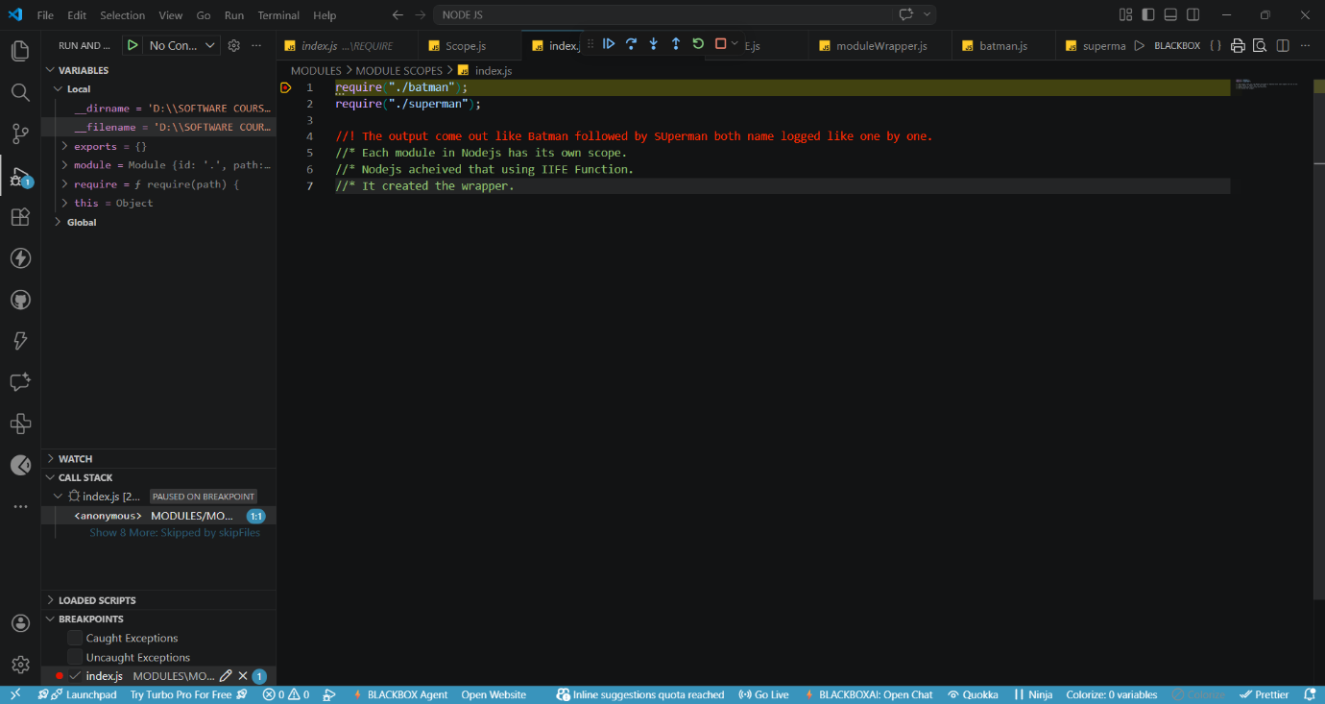

-If you debug the code then you see the this Five variable are present.
- __dirname → folder path
- __filename → file path
- exports
- module
- require

-Every module in node.js gets wrapped in an IIFE before being loaded.
-IIFE help keep top-level variables scoped to the module rather than the global object.
-The IIFE that wraps every module contains 5 Parameters which are pretty important for the functioning of a module.
🔥 The 5 Special Variables in Node.js
1. exports
👉 Shortcut to export values from a module
Example:
exports.name = "Amol";
👉 Used to send data outside the file

2. require
👉 Used to import another module
Example:
const fs = require('fs');
👉 It loads:
- Built-in modules
- Local modules
- Third-party modules

3. module
👉 Represents the current module
Example:
module.exports = "Hello World";
👉 Important:
- module.exports is the actual object being exported
- exports is just a reference to it

4. __filename
👉 Gives full path of current file
Example:
console.log(__filename);
👉 Output:
C:\project\index.js

5. __dirname
👉 Gives folder path of current file
Example:
console.log(__dirname);
👉 Output:
C:\project
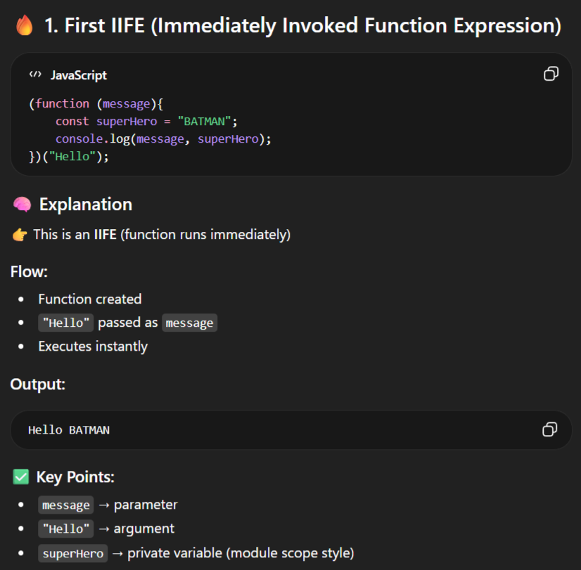
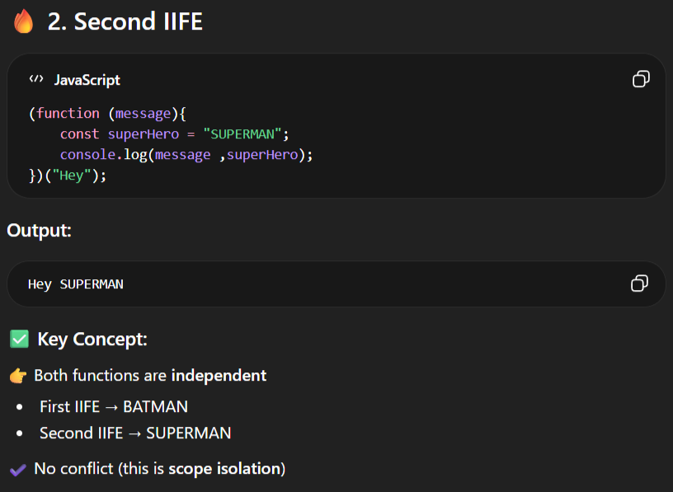
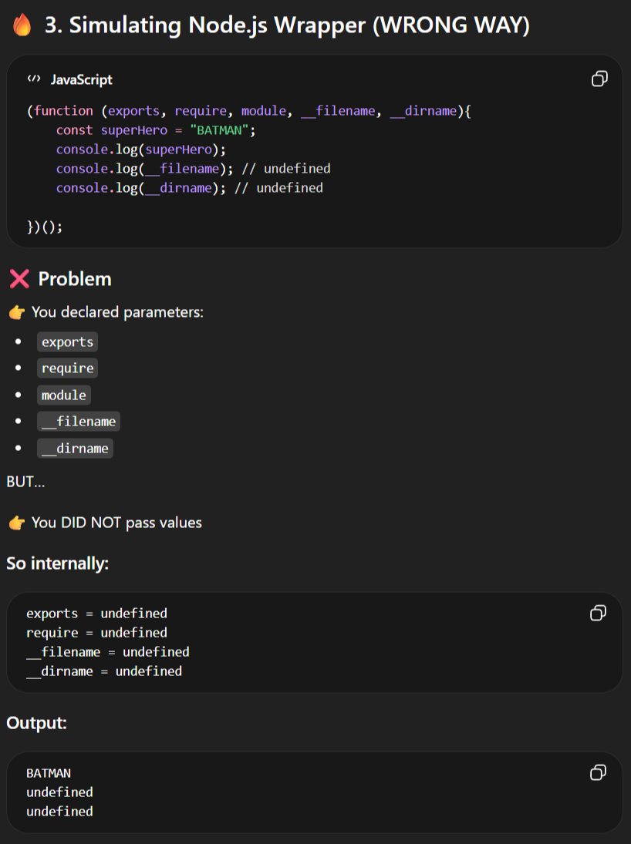
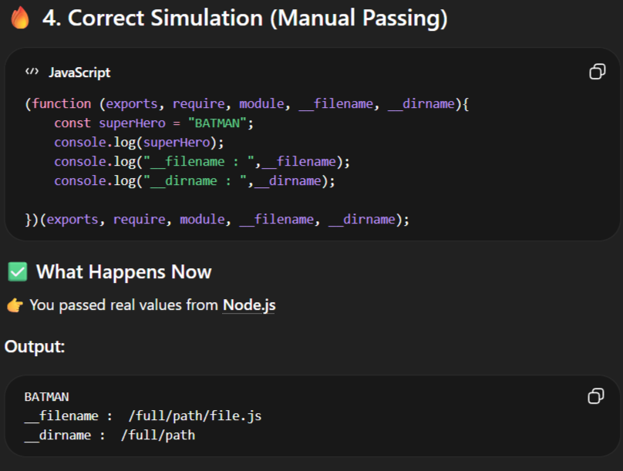
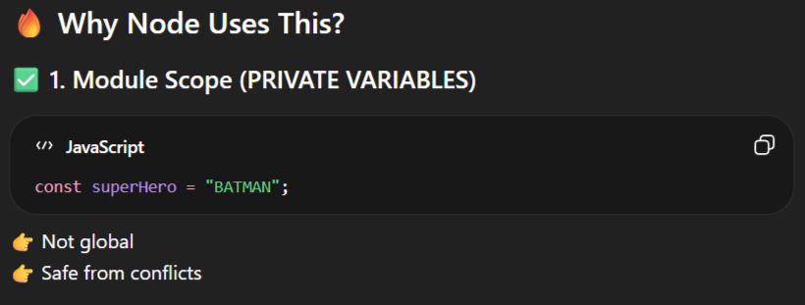
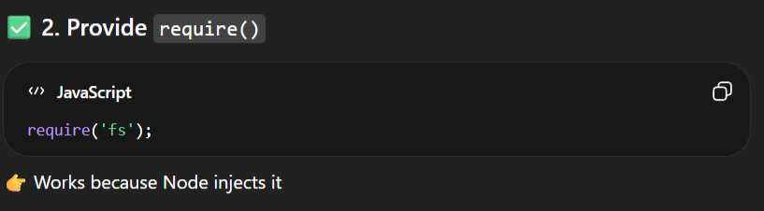
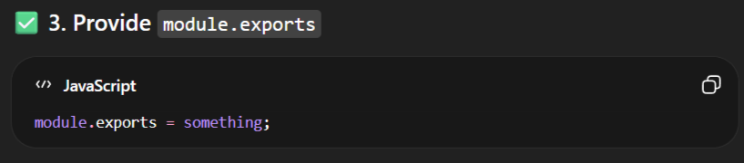
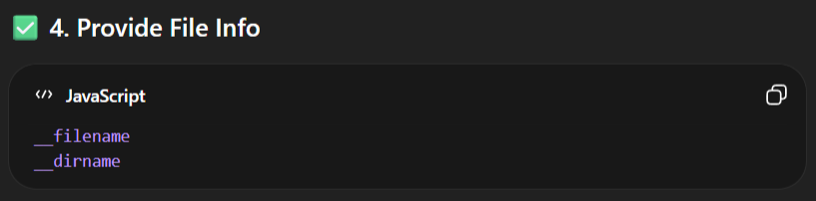
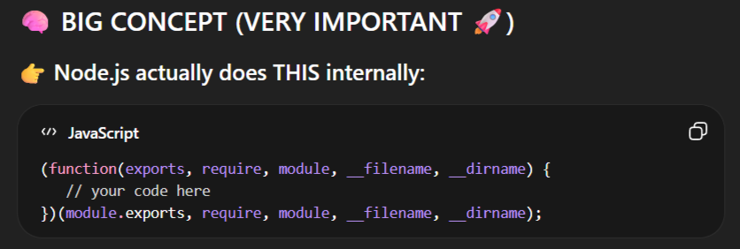

MODULE CACHING
-In Node.js, when you use require() to import a module, it does NOT load the module again and again. Instead, it loads it once and then caches it.
-What is Module Caching?
👉 Module caching means:
- First time you require() a file → Node.js loads and executes it
- Next time you require() the same file → Node.js returns the cached version
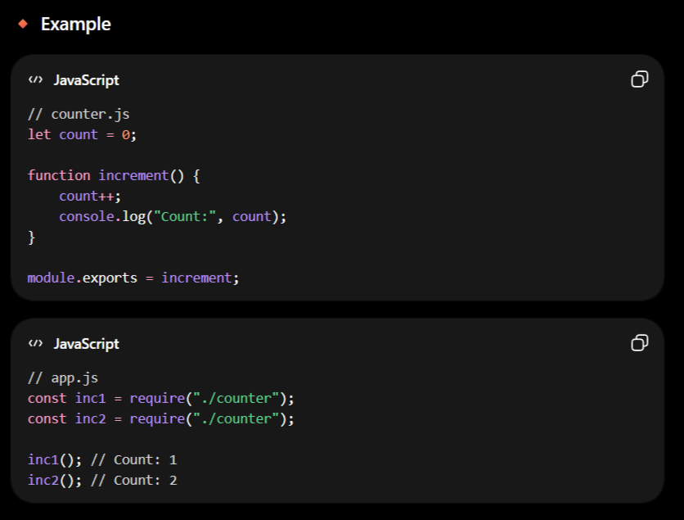
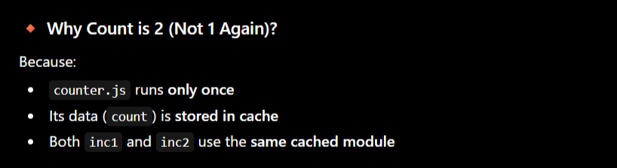
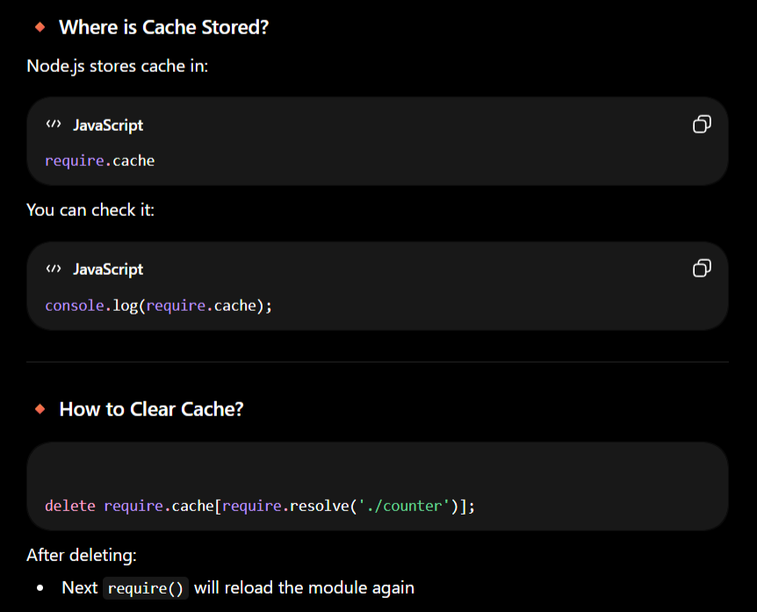
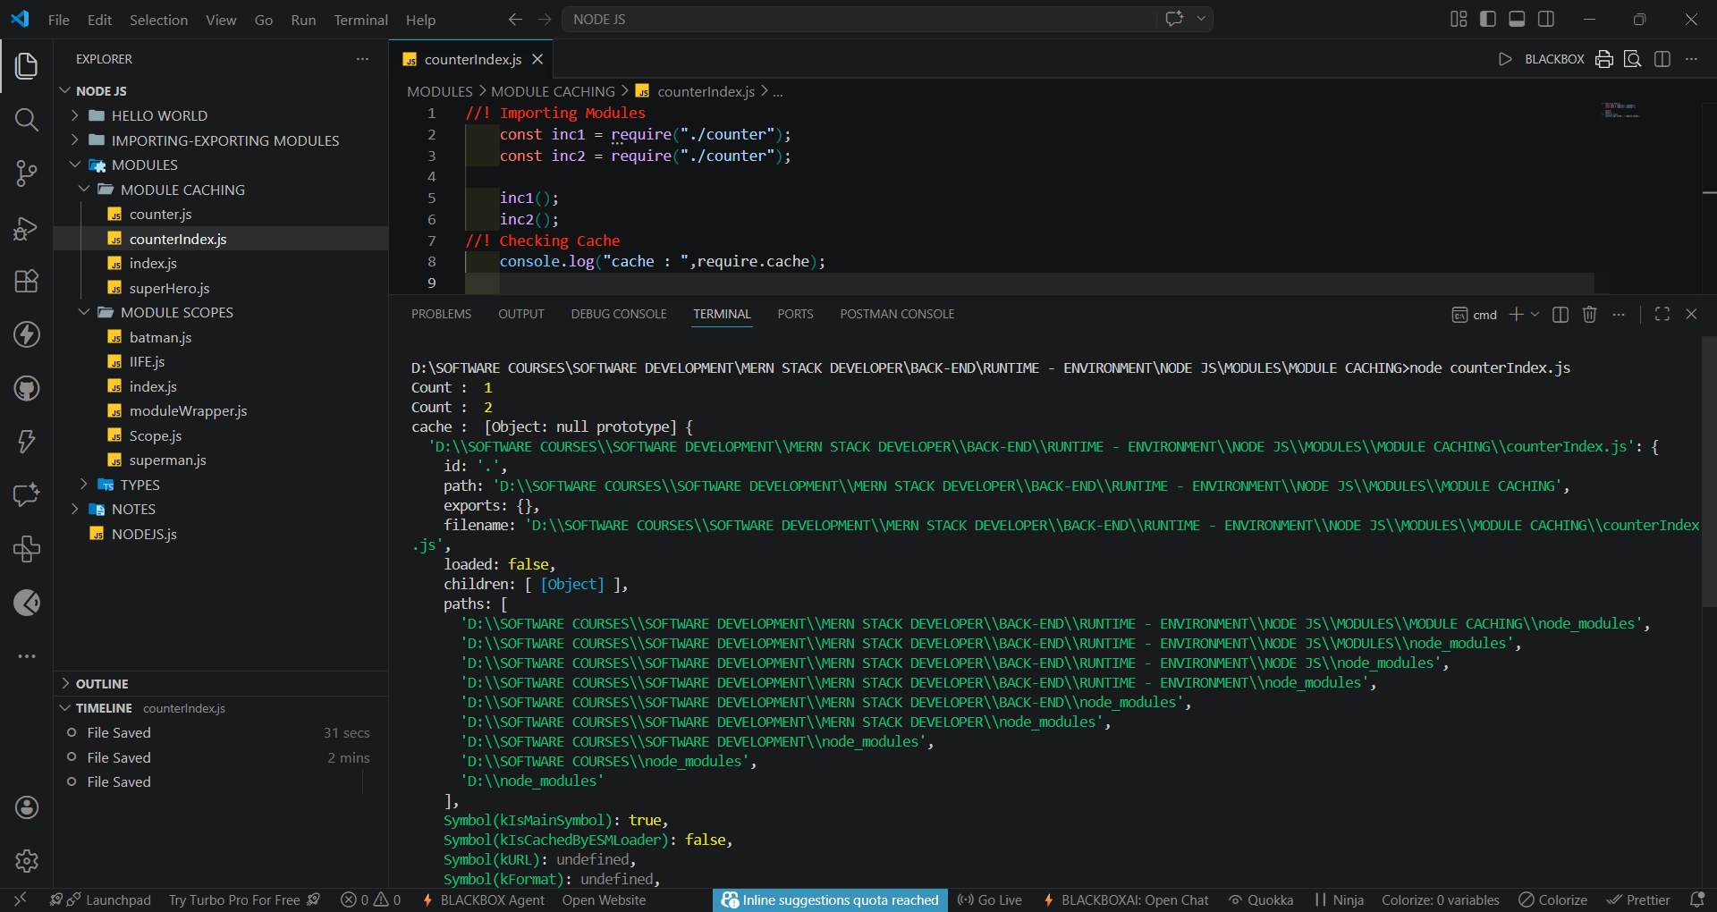
-The Second time when we call the inc2() function the result comes 2 because of caching. The Module is already loaded so the result is stored in the caching.
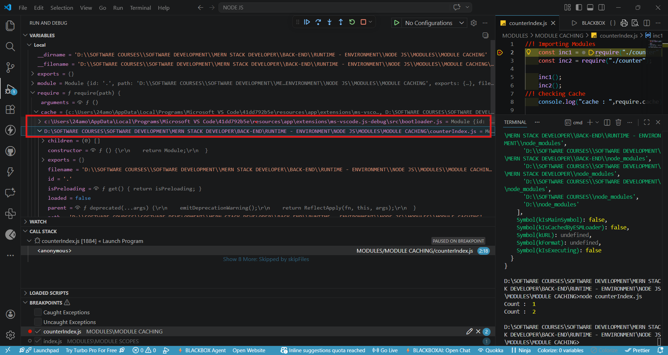
-After debugging the program checking in require() function we have seen there only two modules are there.
1.By default vs code setup.
2.counterIndex.js
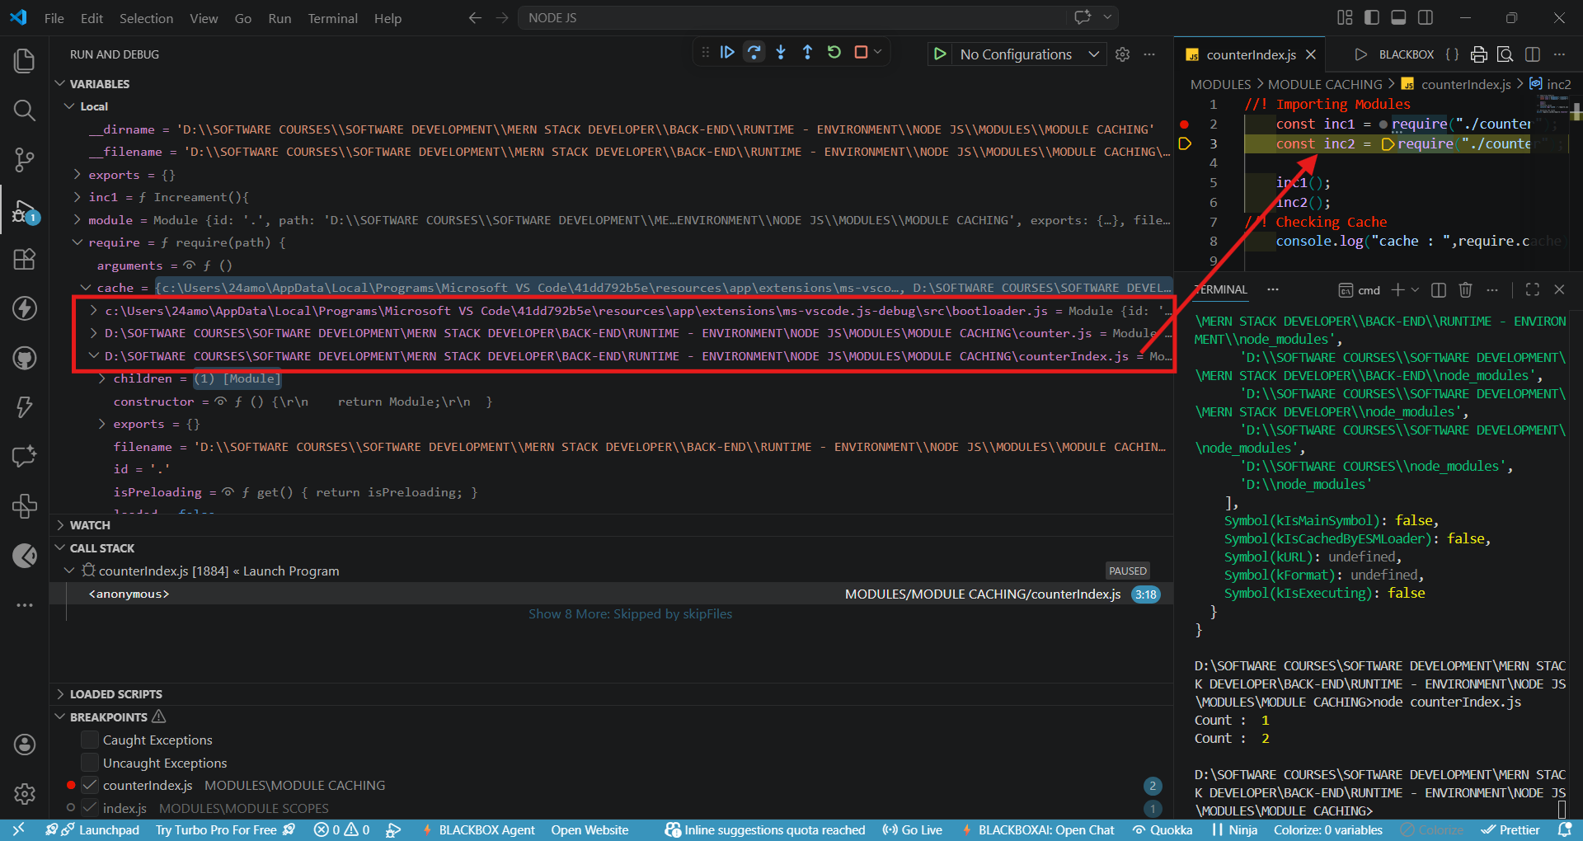
-Now After Clicking to the next line we have an entry of counter.js which is third module which third module where logic is written.
-So When we call inc1() and inc2() then the counter.js is does loaded again and again cause it is already loaded.

1.LOCAL MODULES
-Local modules are the user created modules.
-In Node.js, a local module refers to a module that you create yourself within your Node.js project, as opposed to built-in or external (third-party) modules.
-Local modules allow you to structure your code into smaller, reusable pieces, making it easier to manage and maintain large applications.
EXAMPLE
-Here we have created file MathematicOperation.js as an Local-Modules.
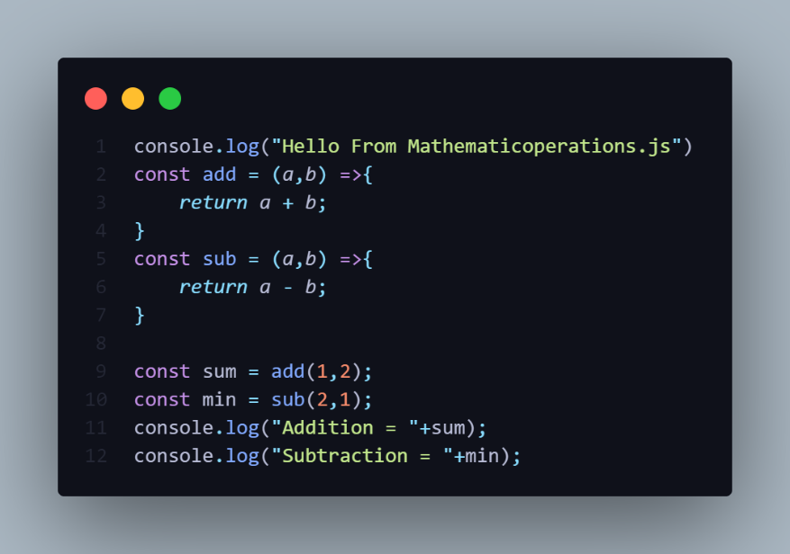
-Here the Local-Modules we have created named Mathematic-Operation to load that we have to use require() function.
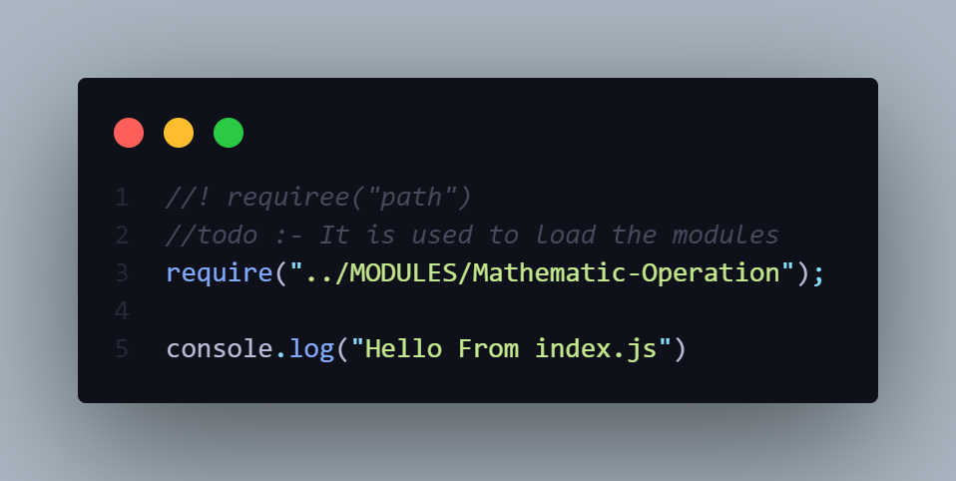
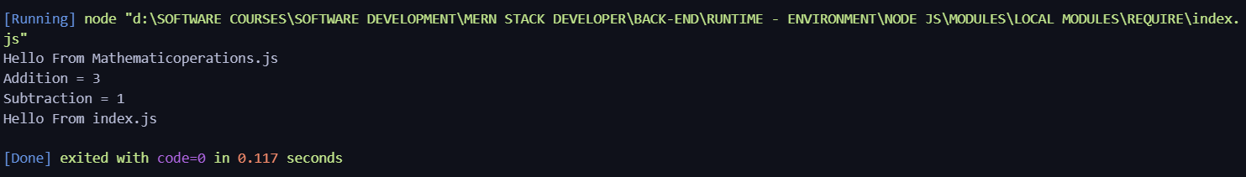
Key Points:
- Exporting: You need to explicitly export the functions or variables you want to be available in other files using module.exports.
- Requiring: To use the local module in another file, use require('./myModule').
- Relative Path: When requiring local modules, use relative paths (./ for the current directory).
================ IMPORTANT ================
1]If you does not exporting the modules and you want to run this file code then you have to just use require() function in other file.It runs the whole file code.
2]If you want use only particular function in the file then you have export function using exports.module.
3]If you are created file in the require(Mathematic-operation) you does not mention the .js file extension the node automatically detect .js extension

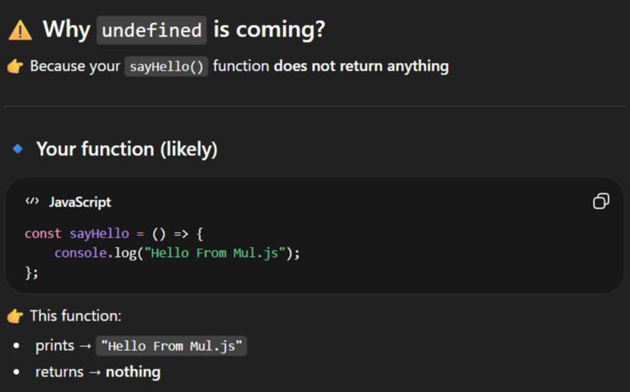
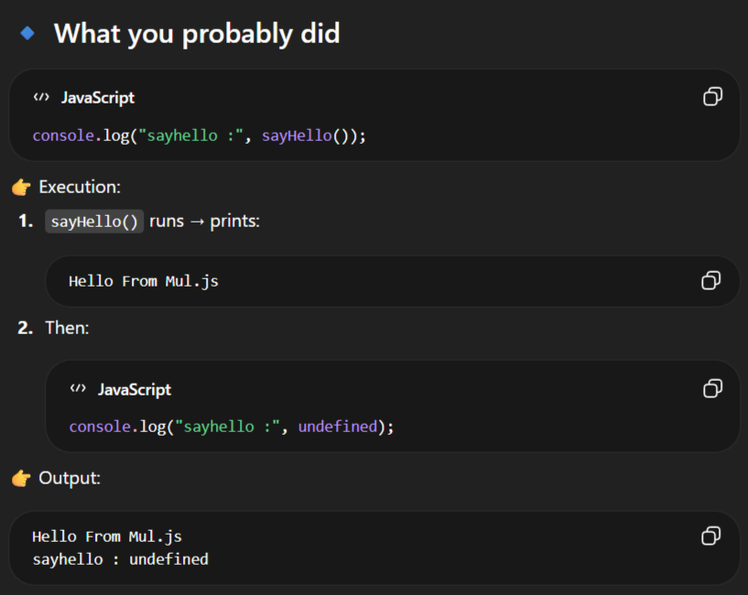
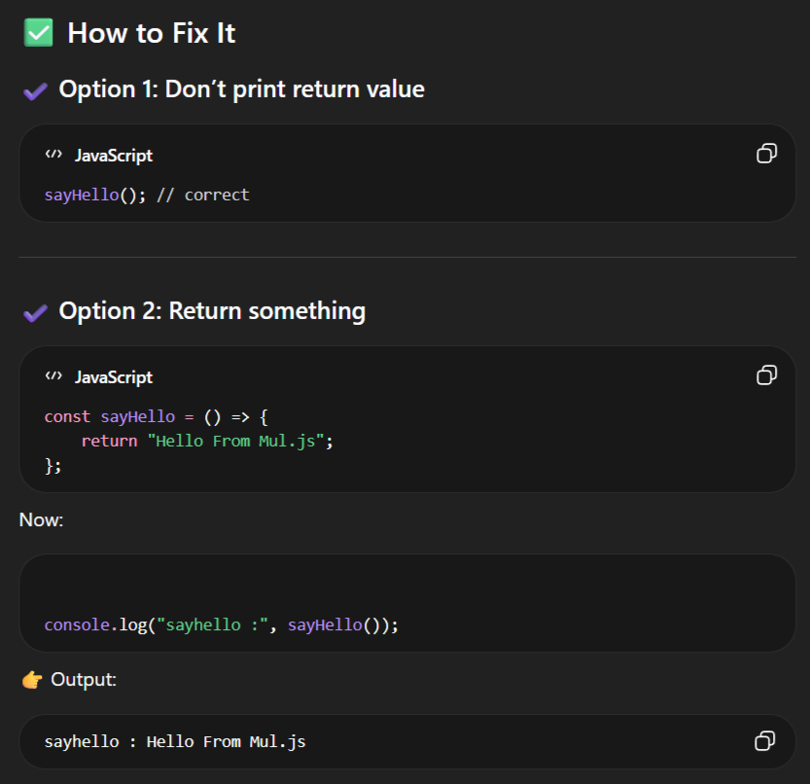
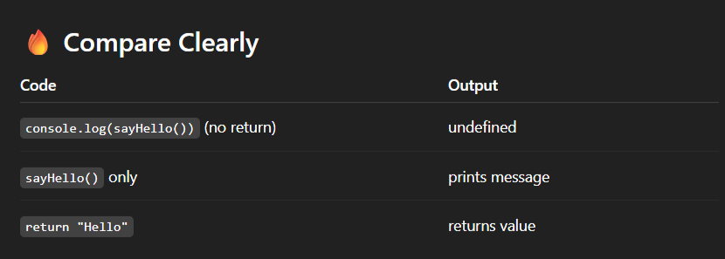

2.CORE MODULES [BUILT IN]
-Node.js comes with a rich set of built-in modules, also known as core modules, that provide essential functionalities.
-Core modules in Node.js are built-in modules that come pre-installed with Node.js. These modules provide essential functionalities that can be used without installing any external dependencies. They are written in C++ or JavaScript and are optimized for performance.
Here is a list of the built-in modules of Node.js version 6.10.3:
Module | Description
assert | Provides a set of assertion tests
buffer | To handle binary data
child_process | To run a child process
cluster | To split a single Node process into multiple processes
crypto | To handle OpenSSL cryptographic functions
dgram | Provides implementation of UDP datagram sockets
dns | To do DNS lookups and name resolution functions
domain | Deprecated. To handle unhandled errors
events | To handle events
fs | To handle the file system
http | To make Node.js act as an HTTP server
https | To make Node.js act as an HTTPS server.
net | To create servers and clients
os | Provides information about the operation system
path | To handle file paths
punycode | Deprecated. A character encoding scheme
querystring | To handle URL query strings
readline | To handle readable streams one line at the time
stream | To handle streaming data
string_decoder | To decode buffer objects into strings
timers | To execute a function after a given number of milliseconds
tls | To implement TLS and SSL protocols
tty | Provides classes used by a text terminal
url | To parse URL strings
util | To access utility functions
v8 | To access information about V8 (the JavaScript engine)
vm | To compile JavaScript code in a virtual machine
zlib | To compress or decompress files

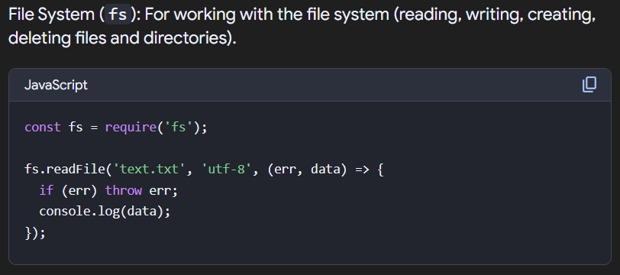
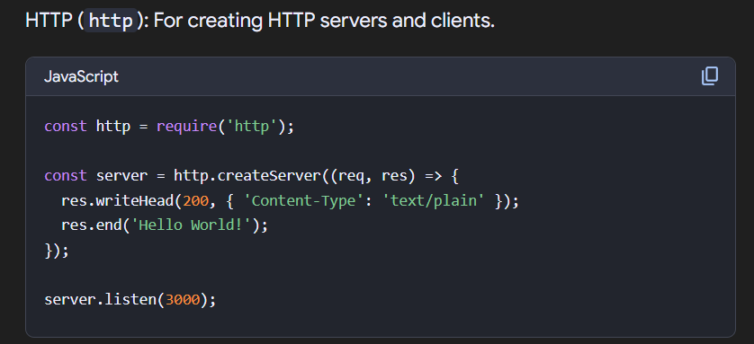
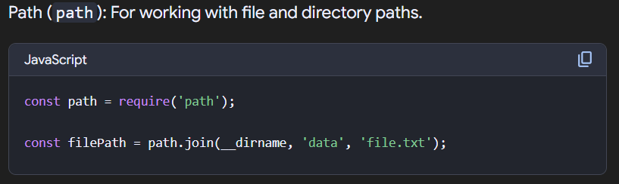
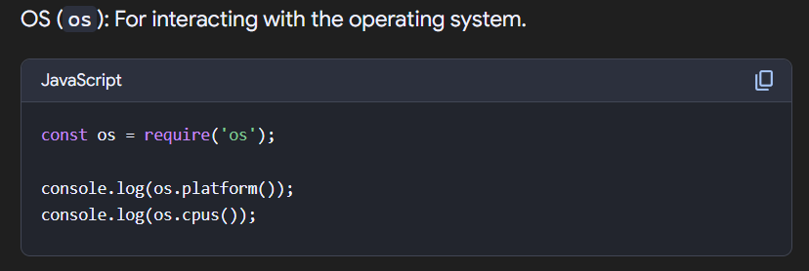
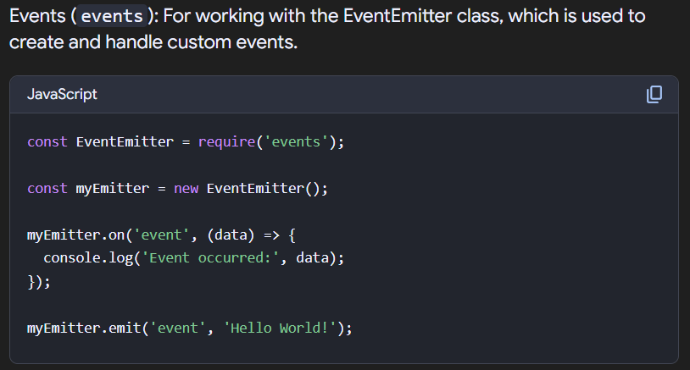
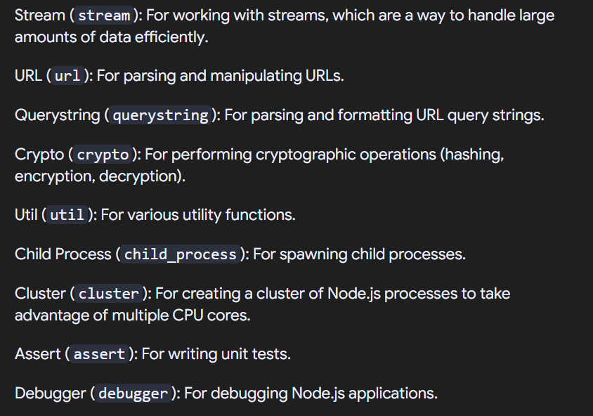

Benefits of Core Modules
- No need for installation.
- Optimized for performance.
- Well-documented and reliable.
- Wide compatibility across Node.js versions.
To use a core module, you simply need to require it in your code, as shown in the examples above.

LOADASH
-Lodash is a popular javascript based library which provides 200+ -functions to facilitate web development. It provides helper functions like map, filter, invoke as well as function binding, javascript templating, deep equality checks, creating indexes and so on. Lodash can be used directly inside a browser and also with Node.js.
-Lodash is a JavaScript library that works on the top of underscore.js. It helps in working with arrays, strings, objects, numbers, etc.
Why Lodash?
It provides various inbuilt functions for collections, arrays, manipulated objects, and other utility methods that we can use directly instead of writing them from scratch. It makes it easier to iterate over the arrays, strings as well as objects. Its modular methods make the creation of composite functions easier.
What is Lodash npm ?
The Lodash npm is used to install and import Lodash library using npm module. The command for installation of Lodash using npm module is - npm i lodash
How to Install Lodash ?
Lodash library can be used directly using the CDN link or can be installed using npm or yarn.
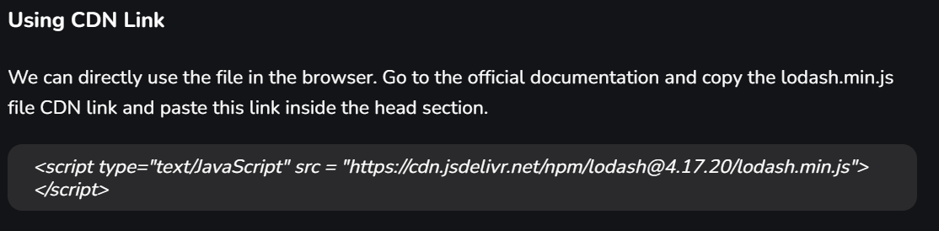
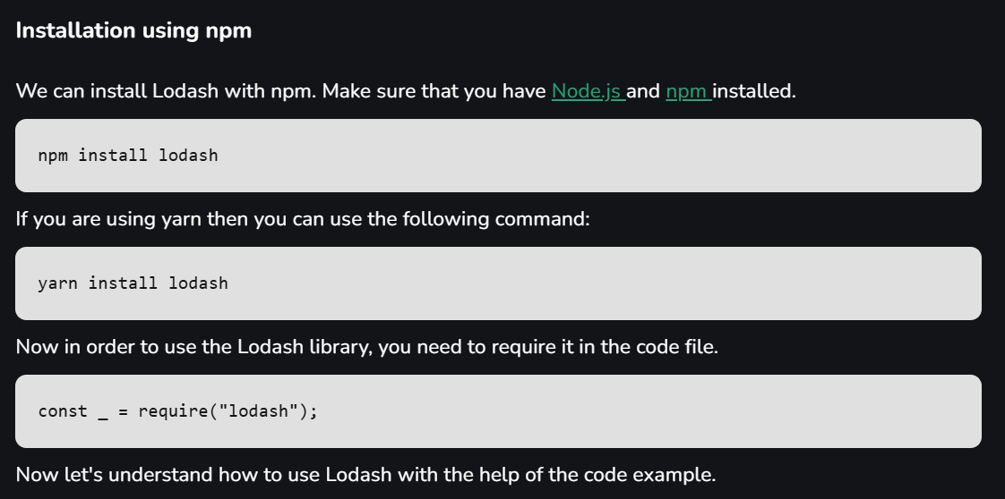

Lodash - Array

-Lodash has many easy to use methods which helps in processing Arrays. This chapter discusses them in detail.
Lodash provides various methods to process the Arrays as listed below −
Sr.No. | Method & Syntax
1 | chunk  _.chunk(array, [size=1])
2 | compact  _.compact(array)
3 | concat  _.concat(array, [values])
4 | difference  _.difference(array, [values])
5 | differenceBy  _.differenceBy(array, [values], [iteratee=_.identity])
6 | differenceWith  _.differenceWith(array, [values], [comparator])
7 | drop  _.drop(array, [n=1])
8 | dropRight  _.dropRight(array, [n=1])
9 | dropRightWhile  _.dropRightWhile(array, [predicate=_.identity])
10 | dropWhile  _.dropWhile(array, [predicate=_.identity])
11 | fill  _.fill(array, value, [start=0], [end=array.length])
12 | findIndex  _.findIndex(array, [predicate=_.identity], [fromIndex=0])
13 | findLastIndex  _.findLastIndex(array, [predicate=_.identity], [fromIndex=array.length-1])
14 | flatten  _.flatten(array)
15 | flattenDeep  _.flattenDeep(array)
16 | flattenDepth  _.flattenDepth(array, [depth=1])
17 | fromPairs  _.fromPairs(pairs)
18 | head  _.head(array)
19 | indexOf  _.indexOf(array, value, [fromIndex=0])
20 | initial  _.initial(array)
21 | intersection  _.intersection([arrays])
22 | intersectionBy  _.intersectionBy([arrays], [iteratee=_.identity])
23 | intersectionWith  _.intersectionWith([arrays], [comparator])
24 | join  _.join(array, [separator=','])
25 | last  _.last(array)
26 | lastIndexOf  _.lastIndexOf(array, value, [fromIndex=array.length-1])
27 | nth  _.nth(array, [n=0])
28 | pull  _.pull(array, [values])
29 | pullAll  _.pullAll(array, values)
30 | pullAllBy  _.pullAllBy(array, values, [iteratee=_.identity])
31 | pullAllWith  _.pullAllWith(array, values, [comparator])
32 | pullAt  _.pullAt(array, [indexes])
33 | remove  _.remove(array, [predicate=_.identity])
34 | reverse  _.reverse(array)
35 | slice  _.slice(array, [start=0], [end=array.length])
36 | sortedIndex  _.sortedIndex(array, value)
37 | sortedIndexBy  _.sortedIndexBy(array, value, [iteratee=_.identity])
38 | sortedIndexOf  _.sortedIndexOf(array, value)
39 | sortedLastIndex  _.sortedLastIndex(array, value)
40 | sortedLastIndexBy  _.sortedLastIndexBy(array, value, [iteratee=_.identity])
41 | sortedLastIndexOf  _.sortedLastIndexOf(array, value)
42 | sortedUniq  _.sortedUniq(array)
43 | sortedUniqBy  _.sortedUniqBy(array, [iteratee])
44 | tail  _.tail(array)
45 | take  _.take(array, [n=1])
46 | takeRight  _.takeRight(array, [n=1])
47 | takeRightWhile  _.takeRightWhile(array, [predicate=_.identity])
48 | takeWhile  _.takeWhile(array, [predicate=_.identity])
49 | union  _.union([arrays])
50 | unionBy  _.unionBy([arrays], [iteratee=_.identity])
51 | unionWith  _.unionWith([arrays], [comparator])
52 | uniq  _.uniq(array)
53 | uniqBy  _.uniqBy(array, [iteratee=_.identity])
54 | uniqWith  _.uniqWith(array, [comparator])
55 | unzip  _.unzip(array)
56 | unzipwith  _.unzipWith(array, [iteratee=_.identity])
57 | without  _.without(array, [values])
58 | xor  _.xor([arrays])
59 | xorBy  _.xorBy([arrays], [iteratee=_.identity])
60 | xorWith  _.xorWith([arrays], [comparator])
61 | zip  _.zip([arrays])
62 | zipObject  _.zipObject([props=[]], [values=[]])
63 | zipObjectDeep  _.zipObjectDeep([props=[]], [values=[]])
64 | zipWith  _.zipWith([arrays], [iteratee=_.identity])

Lodash - Collection
Lodash has many easy to use methods which helps in processing Collections. This chapter discusses them in detail.
Lodash provides various methods to process the Collections as listed below −
Sr.No. | Method & Syntax
1 | countBy  _.countBy(collection, [iteratee=_.identity])
2 | every  _.every(collection, [predicate=_.identity])
3 | filter  _.filter(collection, [predicate=_.identity])
4 | find  _.find(collection, [predicate=_.identity], [fromIndex=0])
5 | findLast  _.findLast(collection, [predicate=_.identity], [fromIndex=collection.length-1])
6 | flatMap  _.flatMap(collection, [iteratee=_.identity])
7 | flatMapDeep  _.flatMapDeep(collection, [iteratee=_.identity])
8 | flatMapDepth  _.flatMapDepth(collection, [iteratee=_.identity], [depth=1])
9 | forEach  _.forEach(collection, [iteratee=_.identity])
10 | forEachRight  _.forEachRight(collection, [iteratee=_.identity])
11 | groupBy  _.groupBy(collection, [iteratee=_.identity])
12 | includes  _.includes(collection, value, [fromIndex=0])
13 | invokeMap  _.invokeMap(collection, path, [args])
14 | keyBy  _.keyBy(collection, [iteratee=_.identity])
15 | map  _.map(collection, [iteratee=_.identity])
16 | orderBy  _.orderBy(collection, [iteratees=[_.identity]], [orders])
17 | partition  _.partition(collection, [predicate=_.identity])
18 | reduce  _.reduce(collection, [iteratee=_.identity], [accumulator])
19 | reduceRight  _.reduceRight(collection, [iteratee=_.identity], [accumulator])
20 | reject  _.reject(collection, [predicate=_.identity])
21 | sample  _.sample(collection)
22 | sampleSize  _.sampleSize(collection, [n=1])
23 | shuffle  _.shuffle(collection)
24 | size  _.size(collection)
25 | some  _.some(collection, [predicate=_.identity])
26 | sortBy  _.sortBy(collection, [iteratees=[_.identity]])

Lodash - Date

Lodash provides a now function to get the current time in milliseconds.

Syntax
_.now()
Gets the timestamp of the number of milliseconds that have elapsed since the Unix epoch (1 January 1970 00:00:00 UTC).

Output
- (number) − Returns the timestamp.

Explore our latest online courses and learn new skills at your own pace. Enroll and become a certified expert to boost your career.

Example
var _ = require('lodash');
var result = _.now();
console.log(result);
Save the above program in tester.js. Run the following command to execute this program.

Command
\>node tester.js

Output
1601614929848

Lodash - Function

Lodash has many easy to use methods which helps in creating and processing Functions. This chapter discusses them in detail.
Lodash provides various methods to process the Functions as listed below −
Sr.No. | Method & Syntax
1 | ary  _.ary(func, [n=func.length])
2 | before  _.before(n, func)
3 | bind  _.bind(func, thisArg, [partials])
4 | bindKey  _.bindKey(object, key, [partials])
5 | curry  _.curry(func, [arity=func.length])
6 | curryRight  _.curryRight(func, [arity=func.length])
7 | delay  _.delay(func, wait, [args])
8 | flip  _.flip(func)
9 | memoize  _.memoize(func, [resolver])
10 | negate  _.negate(predicate)
11 | once  _.once(func)
12 | overArgs  _.overArgs(func, [transforms=[_.identity]])
13 | partial  _.partial(func, [partials])
14 | partialRight  _.partialRight(func, [partials])
15 | rearg  _.rearg(func, indexes)
16 | rest  _.rest(func, [start=func.length-1])
17 | spread  _.spread(func, [start=0])
18 | unary  _.unary(func)
19 | wrap  _.wrap(value, [wrapper=identity])

Lodash - Lang

-Lodash has many easy to use general purpose methods. This chapter discusses them in detail.
Lodash provides various general purpose methods as listed below −
Sr.No. | Method & Syntax
1 | castArray  _.castArray(value)
2 | clone  _.clone(value)
3 | cloneDeep  _.cloneDeep(value)
4 | conformsTo  _.conformsTo(object, source)
5 | eq  _.eq(value, other)
6 | gt  _.gt(value, other)
7 | gte  _.gte(value, other)
8 | isArguments  _.isArguments(value)
9 | isArray  _.isArray(value)
10 | isArrayBuffer  _.isArrayBuffer(value)
11 | isArrayLike  _.isArrayLike(value)
12 | isArrayLikeObject  _.isArrayLikeObject(value)
13 | isBoolean  _.isBoolean(value)
14 | isBuffer  _.isBuffer(value)
15 | isDate  _.isDate(value)
16 | isEmpty  _.isEmpty(value)
17 | isEqual  _.isEqual(value, other)
18 | isEqualWith  _.isEqualWith(value, other, [customizer])
19 | isError  _.isError(value)
20 | isFinite  _.isFinite(value)
21 | isFunction  _.isFunction(value)
22 | isInteger  _.isInteger(value)
23 | isLength  _.isLength(value)
24 | isMap  _.isMap(value)
25 | isMatch  _.isMatch(object, source)
26 | isMatchWith  _.isMatchWith(object, source, [customizer])
27 | isNaN  _.isNaN(value)
28 | isNative  _.isNative(value)
29 | isNil  _.isNil(value)
30 | isNull  _.isNull(value)
31 | isNumber  _.isNumber(value)
32 | isObject  _.isObject(value)
33 | isObjectLike  _.isObjectLike(value)
34 | isPlainObject  _.isPlainObject(value)
35 | isRegExp  _.isRegExp(value)
36 | isSafeInteger  _.isSafeInteger(value)
37 | isSet  _.isSet(value)
38 | isString  _.isString(value)
39 | isSymbol  _.isSymbol(value)
40 | isTypedArray  _.isTypedArray(value)
41 | isUndefined  _.isUndefined(value)
42 | isWeakMap  _.isWeakMap(value)
43 | isWeakSet  _.isWeakSet(value)
44 | lt  _.lt(value, other)
45 | lte  _.lte(value, other)
46 | toArray  _.toArray(value)
47 | toFinite  _.toFinite(value)
48 | toInteger  _.toInteger(value)
49 | toLength  _.toLength(value)
50 | toNumber  _.toNumber(value)
51 | toPlainObject  _.toPlainObject(value)
52 | toSafeInteger  _.toSafeInteger(value)
53 | toString  _.toString(value)

API

-API stands for Application Programming Interface, and it's a set of rules that allows software applications to communicate with each other. APIs act as a messenger between applications, delivering requests to the provider and returning the response.
-The Collection of Endpoints is called as API’s.
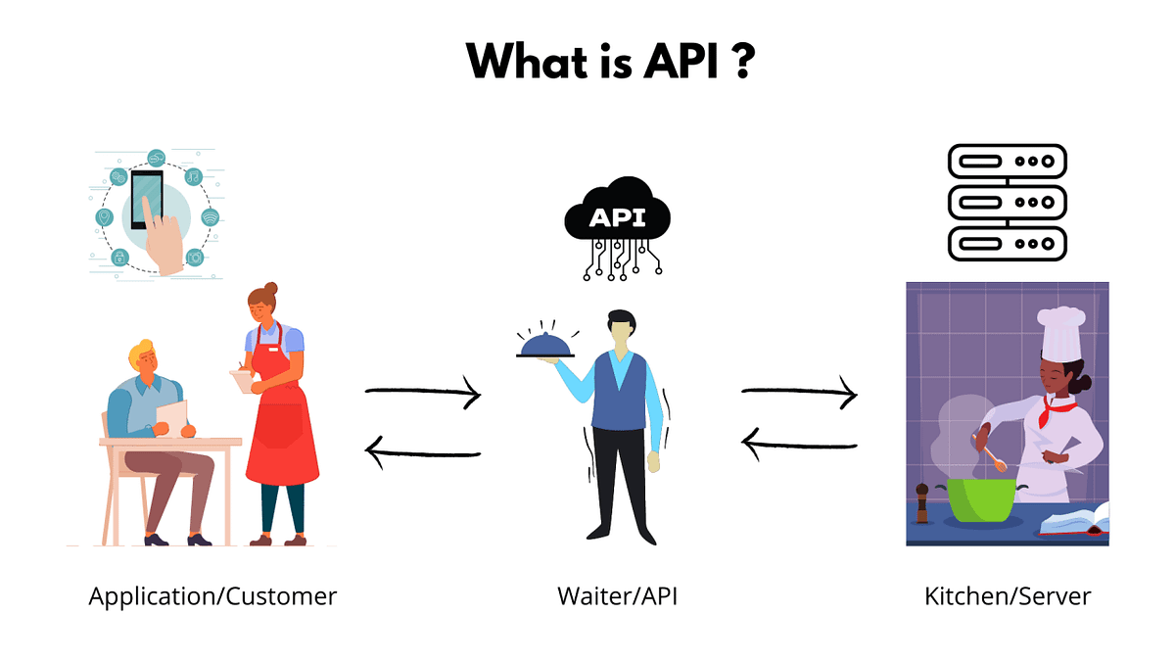
-Defines the methods and data structures that developers can use to interact with the functionality of a service, application, or system without needing to understand its internal workings.
Key Concepts of an API:
- Communication: APIs allow different systems or software components to interact, enabling them to send and receive data or invoke specific actions. For example, when you use a mobile app to check the weather, the app makes API calls to a weather service to retrieve data.
- Abstraction: APIs provide an abstraction layer that hides the complexities of a system, enabling developers to interact with it in a simpler way. The user doesn’t need to know how the service is implemented—only how to use its API.
- Requests and Responses: The basic idea of an API involves sending requests to a service and receiving responses. The request specifies what the client wants (e.g., retrieving data, performing an action), and the response provides the result.
- Endpoints: As part of a web API, an endpoint is a specific URL where the API can be accessed, typically associated with a particular function or resource. For example, an API for a movie database might have an endpoint like /movies to fetch a list of movies.
Types of APIs:
- Web APIs (REST, SOAP, GraphQL):
  - REST (Representational State Transfer): A popular architectural style for web services that uses standard HTTP methods (GET, POST, PUT, DELETE) to perform operations on resources.
  - SOAP (Simple Object Access Protocol): A more rigid protocol that defines a specific set of rules for exchanging messages over HTTP or other protocols.
  - GraphQL: A query language for APIs that allows clients to request only the data they need, rather than a fixed set of data.
- Library or Framework APIs: These APIs allow developers to interact with a specific software library or framework, such as a UI framework (e.g., React), database (e.g., MongoDB), or cloud service (e.g., AWS SDK).
- Operating System APIs: These APIs allow software to interact with the underlying operating system. For example, Windows API provides access to system functions like file management, window handling, and networking.
- Hardware APIs: These APIs allow software to interact with hardware components like cameras, printers, sensors, etc.
How APIs Work:
- Request: A client (e.g., a web app or mobile app) sends a request to the server, specifying what it wants to do (such as retrieving data or submitting data). The request typically includes the HTTP method (GET, POST, etc.), an endpoint (URL), and sometimes parameters or a request body.
- Processing: The server processes the request, performs any necessary operations, and prepares a response (e.g., fetching data from a database).
- Response: The server sends a response back to the client, usually in a standard format like JSON or XML. The response contains the result of the request, such as the requested data or a success/failure message.
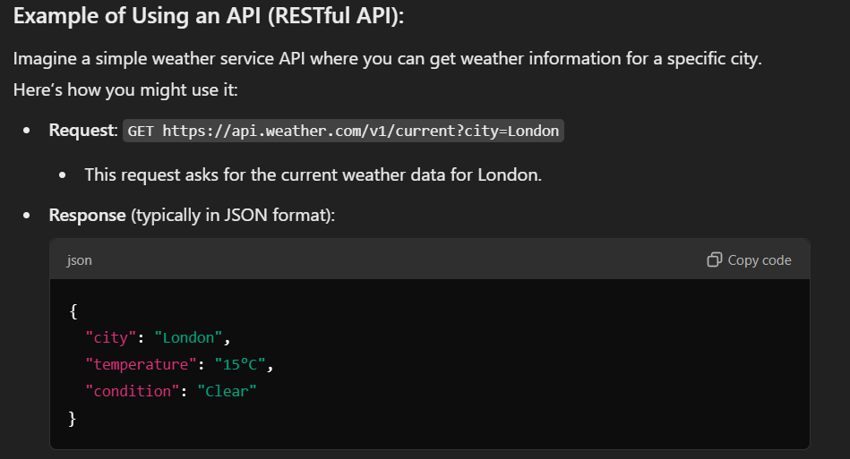

ENDPOINT

-An API endpoint is a specific URL that indicates the location where an API can access resources to perform a function. Endpoints are important because they:
- Specify where APIs can access resources
- Ensure that the software that interacts with the API functions correctly
- An API's performance depends on its ability to communicate with API endpoints
Here are some examples of API endpoints:
- GET /api/v1/users/{userId}: This endpoint represents a specific user resource identified by {userId}. It uses the GET HTTP method to retrieve the user's information.
- https://api.spotify.com/v1/albums/{id}: This endpoint allows you to access any album in the Spotify catalog.
- https://api.spotify.com/v1/playlists/{playlist_id}/followers: This endpoint allows you to send a request that makes a user follow a playlist.

CREATE SERVER EXPRESS

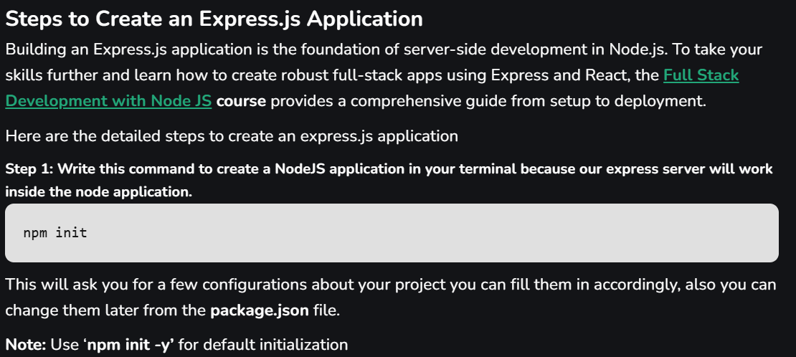
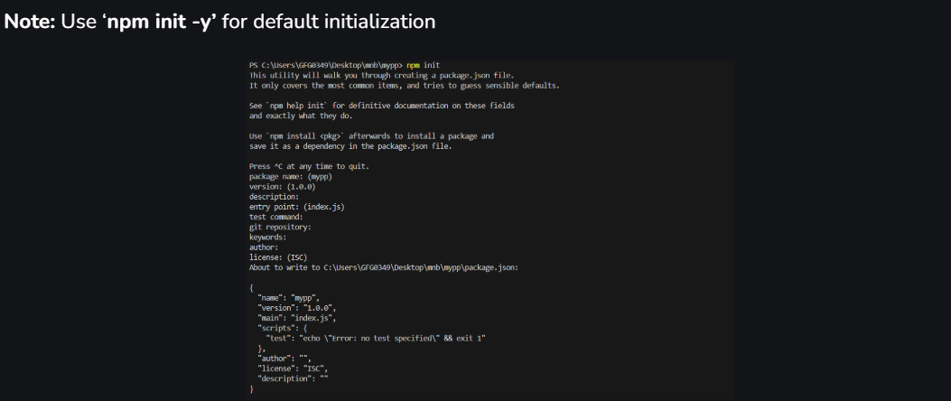
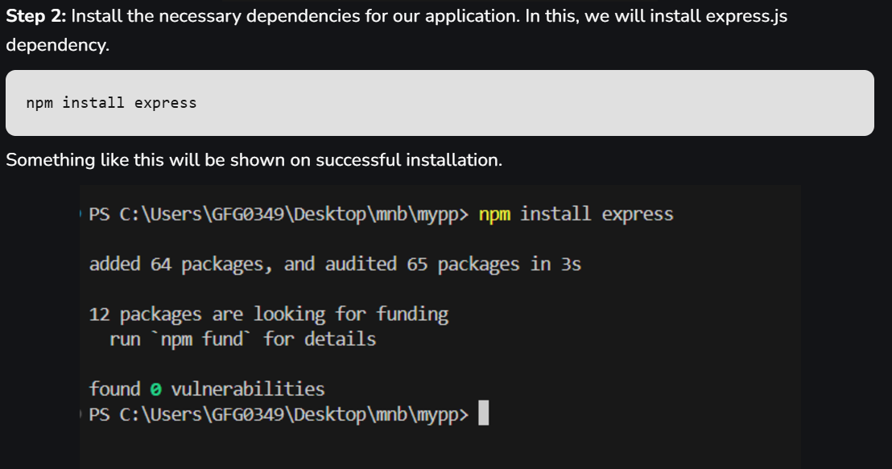

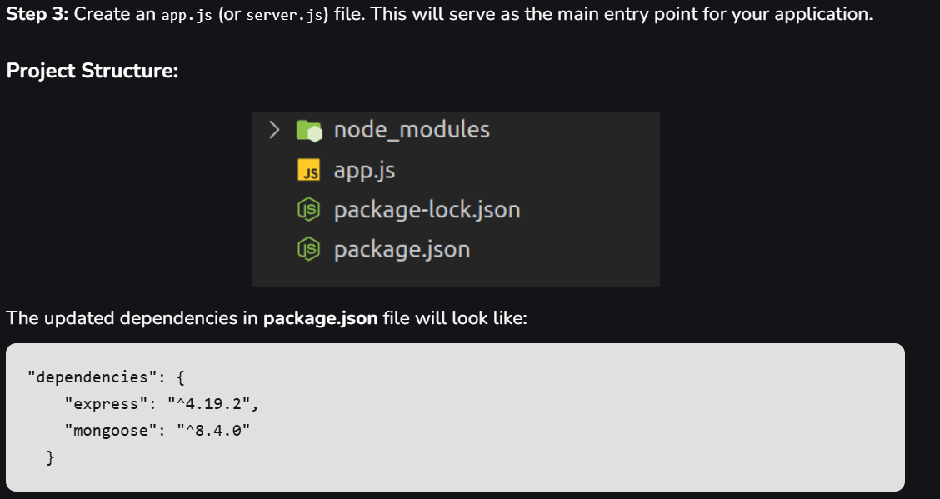
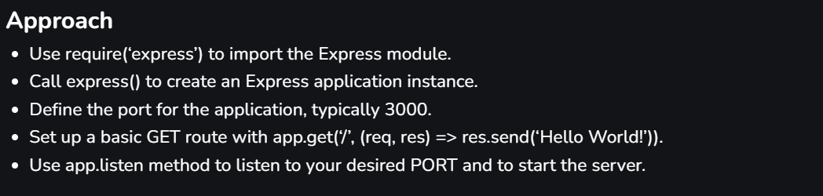
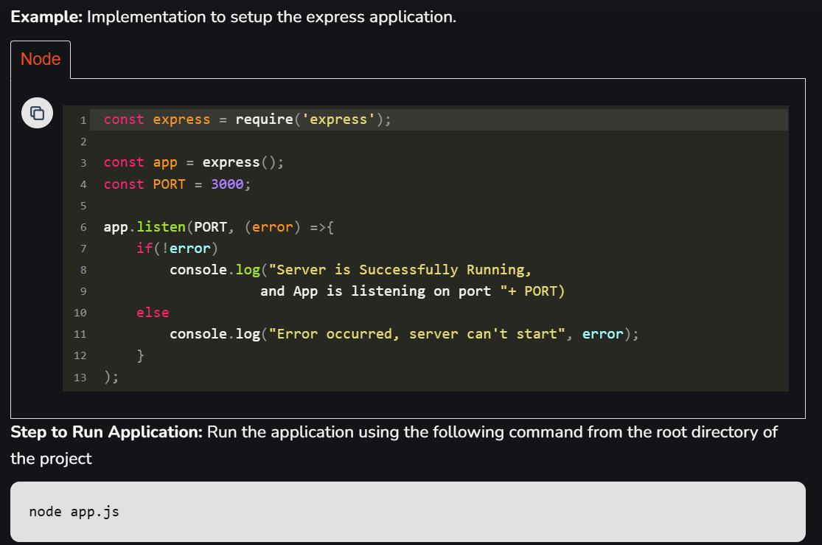

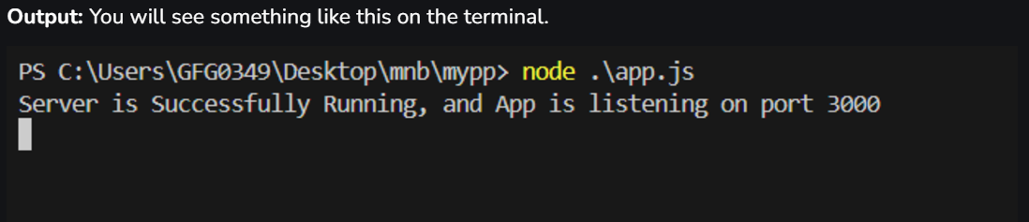

NODEMON

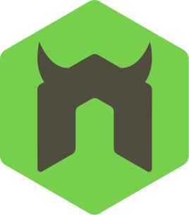
-nodemon is a tool that helps develop Node.js based applications by automatically restarting the node application when file changes in the directory are detected.
-nodemon does not require any additional changes to your code or method of development. nodemon is a replacement wrapper for node. To use nodemon, replace the word node on the command line when executing your script.
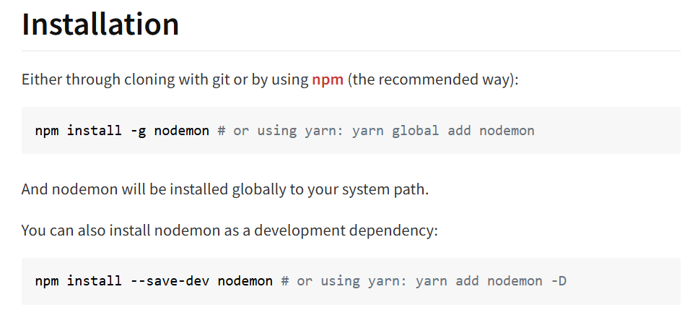

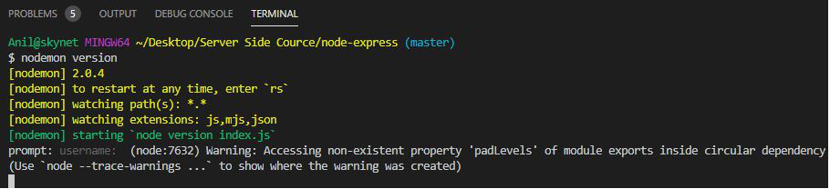
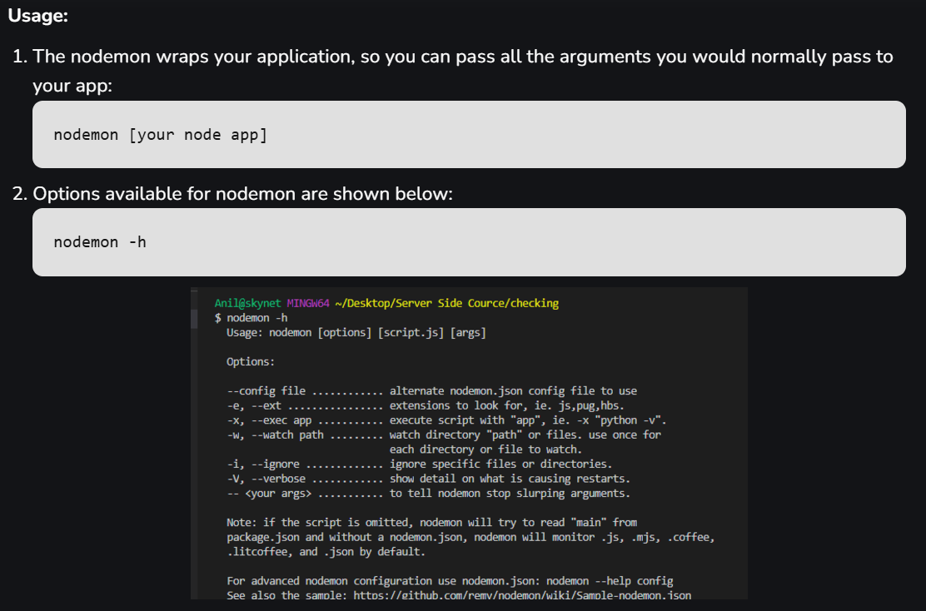

TEMPLATE ENGINES
In Express.js, a "template engine" is a tool that allows you to dynamically generate HTML pages by inserting variables from your application data into pre-defined static template files, effectively separating the presentation logic from the application logic, making it easier to manage and maintain your website structure; popular template engines used with Express include Pug, EJS, and Mustache.
Key points about template engines in Express:
- Dynamic content:
You can embed variables within your HTML templates, which are then replaced with actual data when the template is rendered on the server.
- Separation of concerns:
Keeps your HTML clean by separating the presentation layer from the application logic.
- File extension:
Each template engine usually has a specific file extension (e.g., .pug for Pug, .ejs for EJS).
How to use a template engine in Express:
- Install the engine:
Use npm to install the desired template engine package.
- Configure Express:
Set the view engine property in your Express application to specify which template engine to use.
- Create templates:
Write your HTML templates with placeholders for variables using the engine's syntax.
- Render the template:
In your route handler, use the res.render() method to pass the necessary data and render the template to the client.

1.EJS[Embedded JavaScript templating]
Get Started

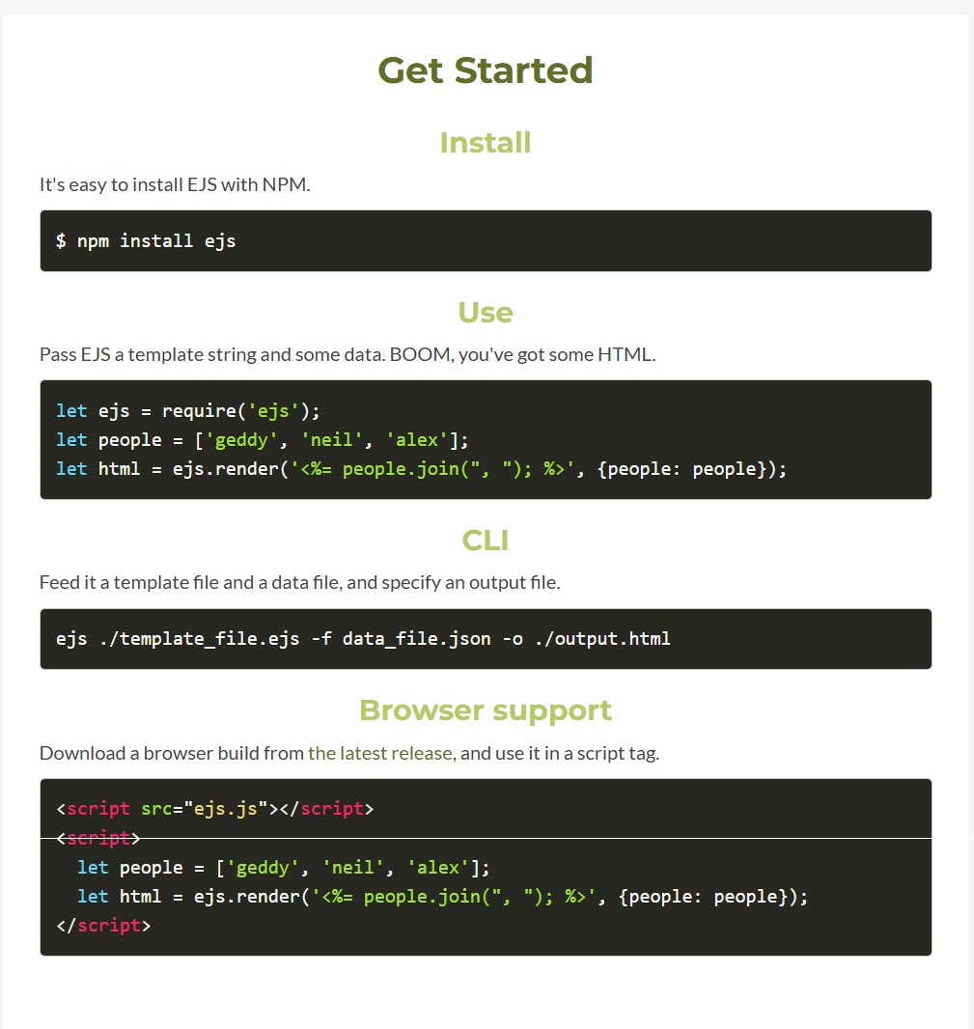

PASSPORT LOCAL

-It is Popular authentication middleware for the NodeJS.
-Passport Local" refers to a strategy within the Passport.js authentication library for Node.js applications, specifically designed to handle user authentication using a traditional username and password combination, allowing users to log in to a website by providing those credentials directly to the system; essentially, it's a way to implement basic local login functionality within your application.
-Key points about Passport Local:
- Function:
It verifies user credentials against a database by comparing the provided username and password with stored user data.
- Implementation:
To use Passport Local, you need to install the "passport-local" package and configure a "LocalStrategy" which defines how to validate the username and password against your database.
- Benefits:
  - Simple to use: Provides a straightforward way to implement basic username/password login.
  - Flexible integration: Can be easily integrated into various Node.js frameworks like Express

IMPORTATANT NOTE

1.( ) => { }
2.( ) => ( )

-In JavaScript, both => () and => {} are part of arrow function syntax, but they have different meanings depending on whether you use parentheses () or curly braces {}. Let's break them down:

